Degree IN TEACHER OF PRIMARY EDUCATION.
Subject: Didactics of Experimental Sciences
Course: 2019-20

Chapter 4. Scientific Knowledge to teach Science in Primary Education

1. Introduction 2

2. Contents 2

3. Methodological strategies in Science Education 6

4. References 17

- Introduction
In this chapter, first, we are going to deal with the contents included in the curriculum and which establish the scientific knowledge necessary to teach science in primary education. Secondly, we will see how to approach the teaching of these contents in the classroom, namely, methodological strategies.
- Contents
The contents of the curriculum are the objectives of the teaching-learning process. They can be of many kinds and encompass very diverse realities from their character and their properties. Questions such as What is knowledge, and what are the main valuable aspects to include in the curriculum? have had practically stable answers in the pedagogical tradition but these answers are currently changing, and specialised literature is trying to respond by adapting itself to the new generations, which means asking many more questions such as:
How is knowledge built?
Is there a single way to select, organise, evaluate and distribute it?
How is it structured?
Is it essential that all students have access to a standard and fundamental core of contents?
Who determines and what are the components of that core?
Traditionally, the contents were, exclusively, a selection of scientific knowledge, structured into academic disciplines that gave us the ability to offer us a proper understanding of the world. At present, there has been a change in how we understand the contents about the conception of the school as an agency of cultural transmission and the curriculum as the cultural project of society. This approach is congruent with the extension and universalisation of compulsory schooling, where we consider the curriculum as a selection of the culture of a society.
However, what is the basic scientific concepts today? How does the school curriculum interact with these demands? How do analyses of compelling content come about in this framework of emerging and growing content? Which of these should be studied by the compulsory primary students who will be the citizens of the future? Among the contents to be incorporated into the curriculum, we can highlight the following:
- Analyse aspects related to the nature of science
- The necessary concepts to understand the physical world, the living environment, the human organism and the interrelations of these aspects with society.
- The necessary mathematical concepts.
- The development of positive attitudes towards science, towards the value of the rational argument, respect for evidence.
Considering these purposes of science education, the curriculum incorporates contents that fulfil different functions:
- Academic content as opposed to relevant to personal and social life.
- Contents of science processes and on the nature of science.
- Contextualised contents.
  - Types of contents
In order to cover these educational purposes, we can establish three different types of contents in Science Education:

Types of contents | More Specifics |  | More General
Conceptual | Facts/Data | Concepts | Principles
Procedural | Technique | Skills | Strategies
Attitudinal | Attitudes | Rules | Values

The differentiation of these three types of content is a didactic distinction, but this does not mean they are going to present and work in class separately, or there are no relationships between them. It is a way of expressing that, within the set of knowledge or cultural forms that we want our students to learn, there are aspects of a different nature that will require different teaching-learning strategies.
Classification of procedures
One of the first classifications:
- Basic processes: observation, space-time relationship, quantification, measurement, classification, communication, prediction, inference.
- Integrated processes: data interpretation, hypothesis emission, variable control, operational definition, experimental design.
Depending on the skills put into play to acquire knowledge (De Pro, 2003) are classified in:
- Technical skills: assembly, apparatus construction, model construction, use of computer techniques.
- Basic skills: observation, classification, serialisation, measurement, tabulation, data representation
- Research skills: identification of problems, emission of hypotheses and realisation of predictions, the relationship between variables: control and exclusion, experimental design, analysis and interpretation of data and situations, use of interpretative models, the establishment of conclusions.
- Communicative skills: symbolic representation, identification of ideas in written or audiovisual material, search for information, use of various sources, preparation of reports or materials.
Classification of attitudes
We consider two types of attitudes:
- Attitudes towards science: are highly related to the valuation of science in a given society (media, family environment).
- Scientific Attitudes: are more linked to a particular way of working in the classroom with an emphasis on aspects such as respect for the opinions of others, rational argumentation, respect for evidence,..., linked to activities that move away from methodologies based mainly on the teacher's presentations. In definition, they are those where, without being exclusive to science, underlie the most outstanding characteristics of scientific work, such as curiosity, honesty, scepticism, objectivity. In the field of school science, they can be understood as predispositions to interact in a certain way with the activities involved in the sciences. That way, they are essential:
- attitudes towards the use of evidence,
- to the creation and revision of ideas,
- flexibility and open mind and the treatment of the environment.
  - Content blocks in Nature Sciences.
In the area of Nature Sciences, we can distinguish five different fundamental blocks:
● Block 1. Initiation to scientific activity. The students must initiate in the knowledge and use of some of the strategies and techniques usual in scientific activity, such as: observation, identification and analysis of problems, collection, organization and processing of data, the emission of hypotheses, design and development of experimentation, the search for solutions, and the use of information sources. They should also acquire autonomy in the planning and execution of actions and tasks and develop initiatives in decision-making in each of the projects it develops throughout the stage of Primary Education. They will also develop strategies for individual and teamwork, showing skills for the peaceful resolution of conflicts. They must know and respect the rules for the use and safety of instruments and working materials.
● Block 2. The Human Being and Health. It integrates knowledge, skills and abilities to, from the knowledge of one's own body, prevent risk behaviours and take initiatives to develop and strengthen responsible behaviours and healthy lifestyles.
● Block 3. Living Beings. It is oriented to the knowledge of the multiple forms of life of the environment and the study and valuation of the main ecosystems in order to promote the acquisition of behaviours in the daily life of defence and recovery of the ecological balance, developing values of responsibility and respect towards the environment.
● Block 4. Matter and Energy. It integrates contents related to physical phenomena, substances and chemical changes that will lay the foundations for later learning and the rational use of resources.
● Block 5. Technology, objects and machines. It includes as a novelty the contents that refer to literacy in information and communication technologies, as well as others related to the construction of devices with a previously established purpose, based on the knowledge of the elementary properties of their components.
- Methodological strategies in Science Education
  - How to teach? The methodology
Once, we have defined the objectives, and contents (what for and what to teach), the next stage in the planning of teaching and learning processes consists of answering the question: how to teach?
When we ask this question, we are referring to teaching methodology, pedagogy or didactics. In the field of education, merely the "methodology". Answering this question implies specifying the methods, procedures, strategies that we can use so that our students learn by the objectives and contents raised. There are many and varied factors that can influence decisions about "how to teach" (see Figure 1). These factors come from four key areas:
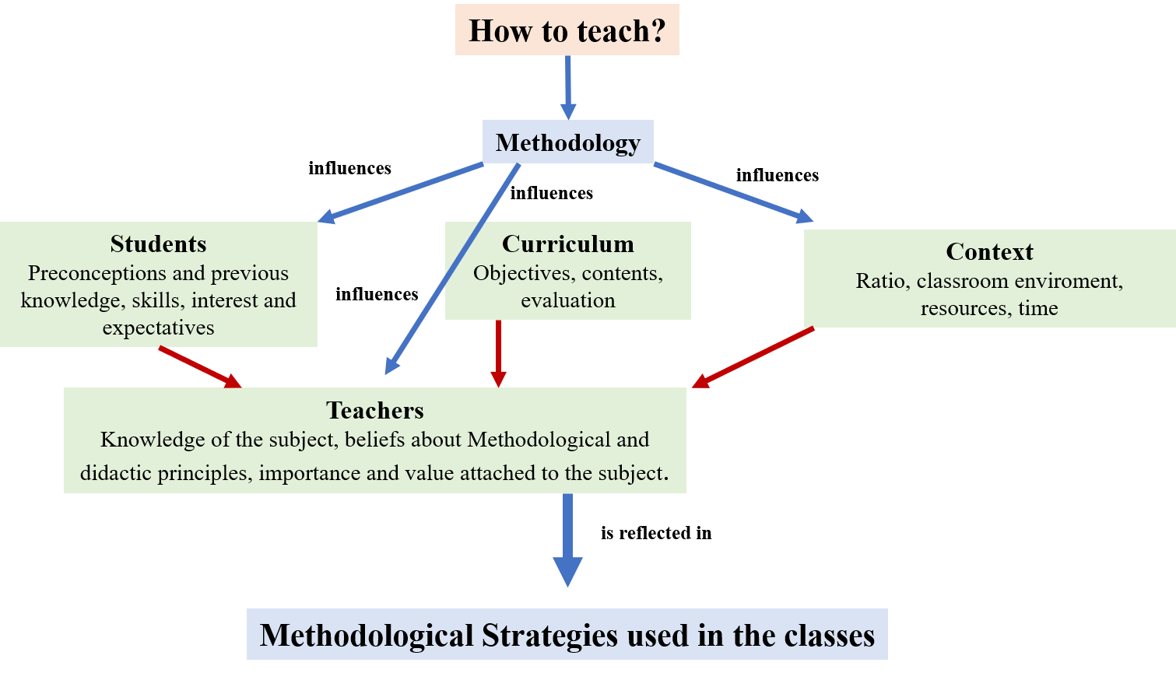
Figure 1. Representation of the factors influencing the methodology.
All these factors condition and mediate the decisions that teachers make in the process of transferring theory to practice and that, finally, are materialised in the different ways of working with students in the classroom, that is, in the more or less broad of methodological strategies used in their classes. They represent, therefore, the practical concretion of the teachers´ thoughts and decisions, some of them explicit and others implicit.
  - Concept of the methodological strategy
By definition, a methodological strategy indicates the types of activities that teachers use in their classes to promote specific learning. Also, we can understand this concept as the "structure" that supports the activity carried out in a class. Three main components determine mainly a specific strategy:
- The objectives and contents to work on in class.
- The role of students: the type of work required and the relationship with the content.
- The role of the teacher.
  - Different methodological strategies
In the following, we will comment on some of the most relevant methodological strategies. In this case, we can highlight:
- Cooperative and collaborative learning
Cooperative learning and collaborative are approaches that are similar in form as both works with groups of students.
Nevertheless, such as their objective, structure or the role of the teacher differentiate them. Cooperative learning expects social-affective skills, which means that the students help themselves to achieve a goal. On the other hand, collaborative learning intends to develop personal and social skills; the contributions of the members achieve a goal.
Cooperative learning
Cooperative learning is an approach that enhances learning among students, that is, it allows students to teach and learn in cooperation, instruction not only comes from the teacher but falls to them as active participants in the process. Since the performance of the group depends on its members, a student will make sure that the other members of the group perform well as well. This type of learning lies in shared instruction; it is the students themselves who will play roles as helpers or tutors. This approach changes the former role of the teacher from the direct delivery of instruction to a co-operative working group advisor teacher and is responsible for creating the structures that will lead to co-operative learning. Cooperative learning requires a division of tasks between the components of the group. For example, the teacher proposes a problem and indicates what each member of the group should do, each taking responsibility for solving a part of the problem. The teacher is the one who designs and maintains almost entirely the structure of interactions and the results to be obtained. On the other hand, each student takes charge of an aspect, and then the results are put in common. Cooperative learning is the educational use of small groups in which students work together to maximise their learning and that of others.
The structures that the teacher creates for cooperative learning are activities that cannot be carried out without the collaboration of the members of the group; it is not possible to be successful if the rest of the group does not have it, this leads the students to attribute their achievements to the achievements of the group.
Examples of cooperative learning
This type of learning requires a change in the structure of the class. Also, the teacher predetermines workgroups, where the students with difficulties will join to those average students and those advantaged and will assign a role to each member. The next activities will allow students to cooperate among themselves and thus achieve the expected result:
- Analysis of a text (role 1: reads and underlines relevant ideas, role 2: summarises and analyses ideas, role 3: organises and interprets ideas, role 4: presents the essential ideas of the text).
- List of exercises (Student 1: Solve the first exercise, Student 2: review and correct or congratulate, then solve the second exercise, student 2: review and correct or congratulate, repeat depending on the number of exercises)
- Evaluation of a topic: Rotation (1. Each student in a group of three or four has a topic or question; 2. Each student with a different coloured pencil answers everything he/she remembers about the question or topic; then 3. The teacher says "rotation", and the students should continue the previous idea and continue it until the original topic or question reaches their hands).
Collaborative Learning
Collaborative learning is an approach that focuses on the interaction and contribution of the members of a group in the construction of knowledge, in other words, the achievement of learning requires the participation of parts that form a whole. Collaborative learning is a carefully designed system of interactions that organises and induces reciprocal influence among team members. The development of the process is gradual where each member and all feel mutually committed to each other's learning, generating a positive, non-competitive interdependence.
In this learning, it seeks to share authority, to accept the responsibility and point of view of the other, to build consensus with others within the group. For this to take place, it is indispensable to share experiences and knowledge and to have a clear group goal where feedback plays a fundamental role. Learning can only happen if the work of the group is done collaboratively. It is the group that decides how to carry out the task, what procedures to adopt, how to divide the work, the tasks to be carried out.
This approach seeks to develop personal and social skills in the learner, making each member of the group feel responsible not only for his or her learning but also for that of the other members of the group. The role of the teacher is to design the proposal carefully, define the objectives, the work materials, divide the topic to be dealt with into sub-tasks, be a cognitive mediator in terms of proposing essential questions that really aim at the construction of knowledge and not at the repetition of information obtained and, finally, monitor the work solving individual or group-specific issues according to the emerging one. After this, the responsibility of learning falls on the students since they are the ones who make decisions about how to organise and look for strategies on how to solve the task.
Examples of collaborative learning
As previously stated, students must make contributions from their own experience and knowledge in order to join efforts and thus achieve a common good. In other words, the knowledge and experience of those who participate are fundamental in achieving the common good. The following activities could be examples of collaborative learning:
- A play (in this activity each student contributes from their character to the execution of the play)
- Creation of a story (the teacher can propose characters, the theme, or the scenario, but the students create the story)
- A research work (where each student goes more in-depth in a part of the subject, from their expertise makes contributions and together conclude)
- A pedagogical forum (where each student from his area contributes with his experience the understanding of a topic or task).
- Puzzle (the teacher divides an activity, text, or chapter into different parts or themes, students form teams. Each member of the team is assigned one of the topics or parts in which to train. Each student forms a group with members of other teams with the same topic. These students form expert groups, discuss the topic, and plan how to teach it to members of their original teams.)
Differences and similarities cooperative and collaborative learning
There are three fundamental points at which cooperative and collaborative learning differ:
- Cooperative learning aims to build new ideas with the contribution of peers, which especially favours those students who have more difficulties and enriches those who are more advantaged. On the other hand, collaborative learning has as its objective that each student develops new ideas and believes together with the work in pairs, this type of methodology seeks that the students make their best contribution to a common goal, which will not necessarily include those students with learning difficulties.
- Another fundamental point is the responsibility of the teacher, in cooperative learning is the teacher who proposes a problem and determines the role of each student to solve it, so that each student is responsible for a part of the solution of the task. In collaborative learning, the teacher proposes the activity and becomes a guide, i.e. he/she accompanies the students in their work, but they are responsible for its outcome. He/she is not in charge of determining the roles or predetermining the steps of the process.
- Finally, the collaborative approach is one that requires more advanced preparation to work with groups of students. In other words, cooperative learning is a methodology used in heterogeneous groups of learners in their abilities. This difference can delimit its use, that is, it is necessary to diagnose the group, it is imperative to know what level of responsibility, motivation and preparation is available for the teacher to decide on learning (cooperative and collaborative).

- Gamification
Traditional schooling is perceived as ineffective and annoying by many students. Although teachers continuously seek novel instructional approaches, in general, one of the main problems of today is the motivation and compromise of students. The use of educational games as learning tools is a promising approach due to their abilities to teach and reinforce not only knowledge but also essential skills such as problem-solving, collaboration, and communication. Games have remarkable motivational power; they utilise several mechanisms to encourage people to engage with them, often without any reward, just for the joy of playing and the possibility to win. In addition, the use of educational games can also encourage and stimulate certain moral qualities in students such as self-control, honesty, safety, attention and concentration on the task, reﬂection, the search for alternative ways to win, respect for the rules, initiative, common sense, a sense of solidarity with colleagues, and, above all, fair play.
We can consider that educational approaches based on games are within a constructivist theory of learning since one of its requirements is the challenge to students, which means that they engage with the knowledge that is considered severe. These challenges allow each student to build their knowledge, but they will also require alternative teaching methods. One of the possible ways to involve students and facilitate learning may be the use of these educational games.
One of the fundamental aspects of education and the construction of knowledge is critical thinking. In this sense, students can arrive at the truth for themselves by performing activities (sensation) and then applying reason (reflection), i.e., through experience. Therefore, although the application of approaches involving play may require activity and sensitivity, the experience must be linked to critical thinking in order to convert experience into learning.
An inherent characteristic of games is the challenging nature of their rules and aims, which often consist of a personal challenge or some ambitious goal, so games can also be used to raise levels of interest and to ensure that students participate actively in the learning process.
For education, the pleasure or recreation of play should have mainly a didactic function. Games can act as a bridge to link the formal teaching of science with science in more informal contexts. In this sense, we can define a set of qualities and requirements that games must have in order to be useful in the development of teaching and learning:
- Games should help boost student activity and, once motivated; students should develop their cognitive activity, consolidating more effective learning.
- Games should indirectly improve the efficiency of the educational process as they require greater reflection on the part of the teacher to choose them.
- Games must be carried out in a well-planned manner in keeping with the educational targets and their implications in the classroom.
In this context, methods based on play, game, or videogames are particularly applicable as they encourage and facilitate alternative ways to view a given topic. Moreover, the use of educational games could improve the students’ motivation in science education and thereby contribute to the development of positive perceptions toward science, which is an essential aspect of the learning of science. Indeed, feelings and emotions greatly influence cognitive processes and, as a result, there is a profound relationship between emotional variables and the learning process. It is evident that attitudes play an essential role not only in learning science at a basic level, but they are also a critical factor in the development of scientiﬁc vocations among students.
In short, the acquisition of knowledge through games arises from opportunities to create and develop a range of mental structures, thus opening the way to the development of abstract thinking. Additionally, we can consider that games are an inherent part of a constructivist theory of learning, they can generate student motivation, and they require experience and reﬂection as part of the learning process. In this respect, educational games can be a powerful tool in the learning process for students.
- ICT audiovisual resources (televisión, internet…)
Nowadays, we can find in the literature many different educational resources to motivate and improve the learning of science and scientific attitudes of students. Among these are the media, and particularly television, a medium which, along with the Internet, is one of the most widespread in the current population due to its diffusion, power, influence and consumption (AIMC, 2018).
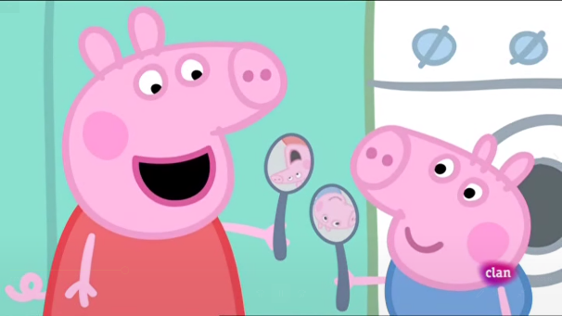

Different studies have explored the use of fictional resources (films, television shows or novels) in formal and informal science education settings to teach science concepts or enhance critical-thinking skills (Li and Orthia, 2016). The educational use of TV shows, as the primary preference of adolescents, is shown as an attractive alternative since it can make science learning more effective and motivating, can be a right way of getting students interested in science (Allday, 2003) and can contribute to the scientific and television literacies. Despite its potential, the number of researches carried out to teach science or to create positive attitudes toward it are considered insufficient. The teacher’s role in implementing the resource into practice is also crucial, as he or she must be aware of its educational possibilities, as well as know how to guide the students discussing the science implied in the TV shows. Some used examples used in the science classrooms are:
Peppa Pig
The Big Bang Theory


In the case of the Game of Thrones Show, we can use it to propose the students some scientific driven questions about physics, chemistry, biology and geology. For example, we can ask them to watch several sequences from the episode 7x06, totalling no more than 3 minutes of duration, including the ambush of the white walkers on Jon Snow in a frozen lake, and the rescue of the dragon from the bottom of the lake by the white walkers. Working in groups, the students should prepare a report trying to answer the driven questions:
Game of Thrones
- Discipline: Physics
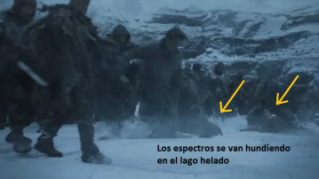
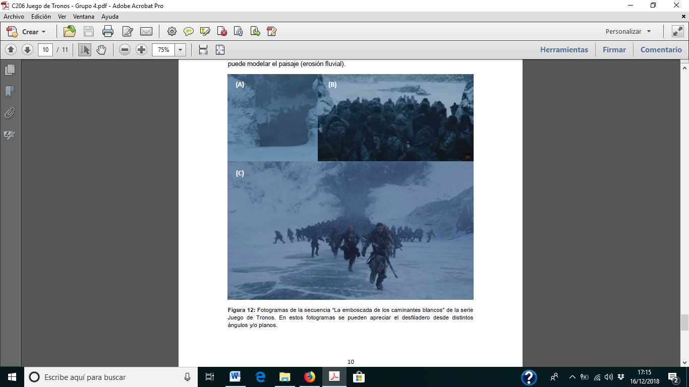
Sequence: Jon Snow´s group crosses the icy lake. In their chase, the horde of walkers fails and break the ice

Scientific content: Forces
Driven question: Why Jon Snow and his friends manage to cross the frozen lake and when the white horde walkers pass, they brake the ice?
- Discipline: Chemistry
Sequence: Jon snow seems to be having difficulty breathing during the chase
Scientific content: Oxygen concentration
Driven question: Why Jon Snow has difficulty breathing in the mountains?
- Discipline: Biology

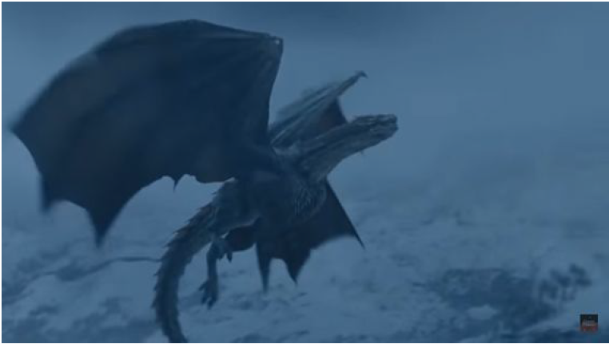
Sequence: When rescuing the dragon from the ice you can see that the colour of his eyes has changed to blue

Scientific content: Genetic
Driven question: Why do some dragons have blue eyes and other blacks?
- Discipline: Geology
Sequence: The horde of walkers appears from a narrow gorge
Scientific content: Formation of relief
Driven question: How could a crack have formed in the middle of the mountain? Why isn't a mountain a perfect, smooth, seamless mass?
- Based-context Teaching
By contextualising science, we mean to relate it to the daily lives of students and make them see their interest in their future lives in the personal, professional and social aspects. The way of using context - the applications of science and the interactions between science, society and the environment - makes it possible to differentiate two STS (science-technology-society) approaches to science teaching; in one, the concepts are used to interpret and explain the context, and in the other, the context is used to introduce and develop concepts and models. This latter approach, which is appropriately called the context-based approach, is being widely used in new approaches to science education and is beginning to be introduced with different emphasis on curricular reforms in many countries.
From the theoretical point of view, the base of a contextualised teaching is the vision of situated learning. While cognitive theories consider knowledge as an abstract entity found in the minds of individuals, "situated" approaches emphasise the situation and context in which learning takes place. The main thesis of situational learning is that the transfer of knowledge occurs because its acquisition takes place within a self-reliant and active process and an authentic context. We can consider six basic characteristics of learning that emerge from a constructivist perspective:
1. Learning is a process of active construction (with the free and active participation of the learner).
2. It is a constructive process based on prior knowledge and interpretation of individual experiences.
3. It is an emotional process (the acquisition of knowledge requires positive feelings in the learning process).
4. It is a self-directed process (the learner must control and direct his or her learning process).
5. It is a social process (occurs in interaction with others).
6. It is a "situated" process (the acquisition of knowledge always takes place in a specific context or situation).
Problem-solving-based learning integrates the cognitivist and situationist approaches and gives importance to both the teacher's instructional process and the student's knowledge-building process. The learning process is conceived as a self-directed and constructive process but facilitated and enhanced by appropriate instructional assistance. The didactic sequences in context, of STS character, in general focus on the investigation or discussion of problems of applied science or science and society, but generally provide the concepts and models already elaborated, without incorporating their construction in the sequence of activities. On other occasions, as they focus only on current technological contexts, they ignore any historical consideration of the origin and evolution of the concepts involved.
Next, we will analyse a concrete example of context that can be used in classes, not only in science but also in other disciplines, the sardine spit (espeto de sardinas). As we have commented, starting from this context, we can work contents in different disciplines such as:
- Discipline: Geography: In this case, it could be raised in class what factors influence the development and growth of sardines, which would result in being able to work the essential elements of physical geography, initially centred in this case in the province of Malaga.
Starting from the topographical map of Málaga, we can work on the different types of mountains, the diversity of landscapes, orography, types of winds, ... This variety of concepts related to geography can be the starting point to extrapolate them to other areas of Spain, and even beyond our borders.
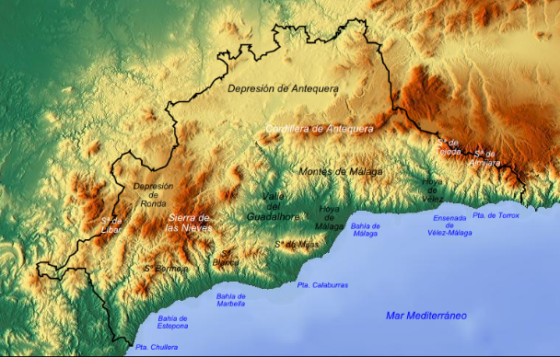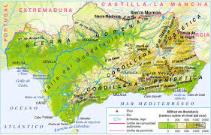
Topographic maps of the province of Málaga and Andalucia
- Discipline: Biology: In this discipline, as in geography, sardines can be used to treat aspects related to animal physiognomy and biology. For example, in science class, the teacher can teach the physical characteristics of sardines, and extrapolate them to other types of fish to find similarities/differences, and even cover more parts of the animal kingdom. Based on these physical characteristics, the teacher may ask questions in class about why sardines used in this area are suitable for spits since in other parts of our geography, we can find sardines as well. This type of questions can help us to deepen in aspects related to the size, weight and breeding of sardines.
On the other hand, we can treat in class, the nutritional context, presenting the number of nutrients that have a sardine for every 100 grams, reason why we could work aspects related to the healthy habits in the feeding, in addition to taking advantage of this aspect, to work transversally chemical contents as the chemical composition and its forms to express it.
- Discipline: Physics: The teacher can use the preparation of the spits to explain specific contents related to physics. Concepts such as concavity, heat propagation, gravitational effect are present in this preparation since one of the main reasons for the use of the cane is because the concavity it presents facilitates the propagation of heat and that fat slips by gravitational effect.

Also, the teacher can use the position of the cane with the sardines ready to be cooked. In this case, the teacher can explain that the spikes need an inclination of 60-70º in a sand mountain and with a heat source at about 20 centimetres so that between the spit and the flame a chamber of hot air is generated, called flame. In this way, and considering the wind, the spit receives the heat and not the smoke, and the flame is not in contact with the sardine, so the sardine is roasted and does not burn. The action of the thermal gradient, generated between the spit and the flame, produces the roast. In this way, the teacher can introduce concepts such as inclined plane, slope, heat transmission by radiation and conduction, thermal gradient, among others, which are involved in the cooking process of the sardines.

- References
Bibliography:
AIMC, Asociación para la investigación de medios de comunicación (2018). Resumen general 2018. Madrid: AIMC.
Allday, J. (2003). Science in science fiction. Physics Education, 38(1), 27-30.
De Pro, A. (2003). The construction of scientific knowledge and science content. In Jiménez, J. et al., Teaching Science (pp. 33-54). Barcelona: Graó.
Li, R. & Orthia, L.A. (2016). Communicating the Nature of Science Through The Big Bang Theory: Evidence from a Focus Group Study. International Journal of Science Education, Part B, 6(2), 115-136.

