A STUDY ON THE ACTUAL USE OF DIGITAL COMPETENCE IN THE PRACTICUM OF EDUCATION DEGREE

Abstract
Despite the existence of many programs and training projects in the field of ICT, in post-secondary education, the teaching and learning process continues to be supported by traditional classroom methods. This phenomenon can be particularly observed in education degrees, even though future teachers are expected to acquire the necessary digital skills in order to carry out their work properly.
The purpose of this study is to explore in greater depth the use of 2.0 applications in the education training of future teachers, as well as to outline the different correlations between the use of these 2.0 tools and their perceived level of digital competence, age and their level of motivation. For it, a quasi-experimental, ex post facto research was carried out with a sample of 108 future teachers from the Faculty of Education, Pontificia University of Salamanca (UPSA). The results have shown that future teachers have a low level of attitude of use towards ICT in the classroom, with an average of 2.29 based on five points. Furthermore, the results have revealed that the level of digital competence and the motivation to use ICT are two variables that correlate positively, while other variables do not show any correlation, such as age.

Keywords: new methodologies, ICT competence, future teacher, new technologies, educational innovation.

- Introduction
Nowadays, ICT is gaining more and more prominence in society. For this reason, it is important for the educational community to move in the same direction. In order to embrace new technologies, the field of education requires the incorporation of new methodologies in the classroom, and therefore, proper training for future teachers. According to Krumsvik (2014) and Philip & Garcia (2013), teachers should be digitally competent to ensure that they respond to this demand (and are able to face this new educational challenge). However, the current trend shows an alarming difference between the skills that teachers should have to develop the digital competence of their students and the skills that they really have (Fernández-Cruz, 2016). Thus, there is still a large gap between future teachers and current digital natives.
ICT offers many possibilities for the development of flexible and diversified teaching (Talebian, Mohammadi & Rezvanfar, 2014). However, its use in the teaching-learning process is currently not being exploited by the different members of the educative community, consequently resulting in unequal progress among those involved (Tondeur, Forkosh-Baruch, Prestridge et al., 2016).
As Albion, Tondeur, Forkosh-Baruch et al. (2015) affirm, society is constantly changing and is full of uncertainties. For this reason, the teacher is obliged to update their training regarding new technologies. Thus, they must develop digital competence and acquire new responsibilities that are now being demanded in the field of education in order to offer students a high-quality education. This is particularly important given that today’s students are digital natives who use technology in everyday life and would benefit vastly from the implementation of these applications in the teaching-learning process.
The use of resources that is offered by Web 2.0 allows an innovative technological learning process where users have access to an excellent variety of information, and are able to collaborate with other users with similar interests, no matter the geographical distance nor the software (Dönmez, Odabasi & Kabakci, 2016). Thus, it is important to ask oneself whether teachers are taking advantage of these resources and, more importantly, whether future teachers are being trained in ICT when studying Education at university.
Recent technological advances mean that ICT tools are increasingly being regarded as essential in higher education. E-Learning is a teaching-learning process that is carried out through ICT, allowing teachers to get closer to students through a direct, open, enriched and participative methodology, which in most cases, helps to improve acquisition of knowledge. Nowadays, a significant percentage of students are demanding this type of education, as it helps them to balance their studies with their jobs and family obligations (Lara, Lizcano, Martínez et al., 2014). This is even more important for those studying Education, as future teachers must be able to teach in different but complimentary areas, promoting the realization of multiple specialties, which would be very difficult to adopt without online training or blended learning.
In this formative context, future teachers must be able to develop the teaching-learning process according to the environment around them, and in relation with the resources and training they have and their students’ characteristics. This will ensure an optimal training process. In order to achieve this objective, teachers must adopt didactic methodologies which include innovative technologies in all areas (Hollinderbäumer, Hartz & Ückert, 2013). From the existing literature, it can be seen that web 2.0 offers an excellent range of possibilities and benefits, some of which are shown in Figure 1.
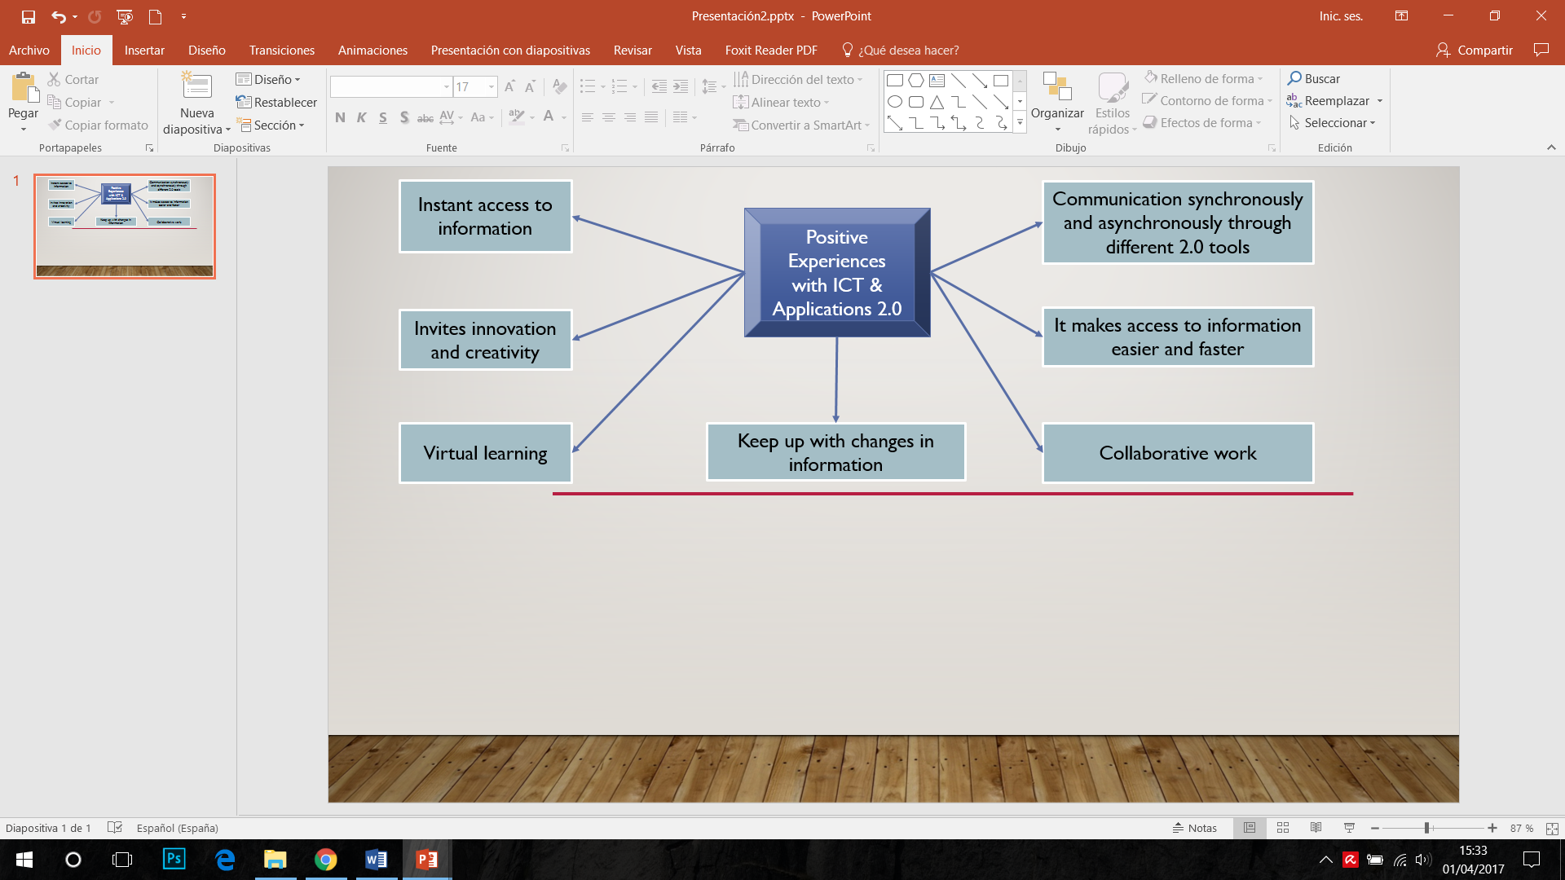
Figure 1 Benefits and positive experiences with the use of ICT (Own elaboration).
In this sense, Nikolopoulou & Gialamas (2016) affirm that teachers are obliged to be trained in the use of ICT as part of their learning process. In order to achieve this aim, teachers must gain experience with computers or laptops to build self-confidence and eliminate any barriers or negative personal beliefs that hinder their teaching. In this way, teachers will have the possibility of using ICT in the classroom ensuring an optimal performance (Figure 2).
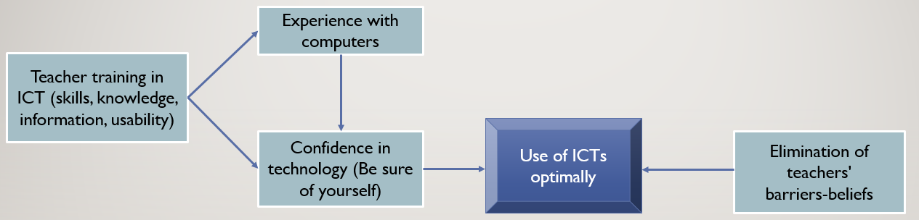
Figure 2 Training process of teachers for the use of ICT (Nikolopoulous & Gialamas, 2016)
Although the use of ICT has shown to be beneficial for teachers and students, some studies have been focused on determining why certain teachers do not include ICT in their daily teaching activities (Levin & Wadmany, 2008; Wong, Li, Choi et al., 2008).
Dede (2005), for example, wonders whether schools, and specifically universities, are ready to face this situation of changing methodologies. He asks whether the necessary tools and resources are being provided to students (future teachers) in order to understand this new globalized world headed by ICT (i.e. the sufficient digital skills to face current social demands). Digital skills not only involve having the knowledge, skills and attitudes, but also the capacity of putting them into action, combining and transferring them in order to act consciously and effectively with a purpose (Ferrari, 2013; Janssen, Stoyanov, Ferrari et al., 2013; Gallardo-Echenique, de Oliveira, Marqués-Molias et al., 2015). The need to have this digital skill or not makes one wonder whether future teachers are capable of responding to the needs of what is known as “knowledge society”.
Taking into consideration this context, the main purpose of this study is to detect correlations between the didactic use of ICT in relation to the personal and professional characteristics of students, such as age, level of digital skills, motivation in their profession and the level of use of 2.0 resources and applications in their educative training.

2. Related Works
Technology is gradually being adopted into the practice of teachers in order to improve the quality of education. However, ICT is not being implemented at the same speed across all institutions and countries, meaning that there is a risk of a digital gap not only between the members of an educational community, but also between countries and societies (Dornisch, 2013; Krumsvik, 2014; Røkenes & Krumsvik, 2014). It is generally believed that the causes for this slowdown mainly come from two agents: teachers and/or the resources. Thus, it is clear that future teachers must be prepared to adapt their daily practices to the new technological world.
This section is divided into two subsections. The first discusses articles related to professional training and the attitudes 2.0 of teachers, while the second concerns the technological resources that are available for education training.
2.1 Training and attitude 2.0 of teachers
Guo, Dobson & Petrina (2008) examined the correlation between the age of pre-service teachers (students enrolled in a one-year post-baccalaureate teacher education program) and their level of ICT skills. Using a quantitative analysis, the authors carried out two surveys (pre- and post-program) with more than 2.000 teachers from the education faculty of the University of British Columbia. They also carried out direct classroom observations in four different locations: University of British Columbia, University of Ottawa, Buffalo State College and the State University of New York. The results of this study showed that there was no statistically significant difference regarding ICT skills between the different age groups.
Despite the same context, Scherer, Siddiq & Teo (2015) found different results. They carried out a study with the purpose of establishing correlations between the attitude, the use of ICT and the age of teachers. They used a sample of 1.190 teachers from thirty-two schools who were asked complete a survey on the aforementioned parameters. The authors revealed that there were positive relations between self-efficacy and the use of ICT, but there was a negative relation with the age of teachers (the older the teachers, the more problems and barriers they had with the use of ICT).

On the other hand, it is necessary to highlight the importance of the attitude and beliefs of teachers regarding the use of ICT. Ramírez-Orellana, Cañedo-Hernández & Clemente-Linuesa (2012), for example, used a sample of 1.721 teachers who filled in a questionnaire about several ICT dimensions. Amongst the obtained results, they highlighted the relation between the attitude of teachers and the use of ICT resources in their training, as well as the role that the age and gender of teachers played in this process. It was revealed that there were significant relations between the attitude variable and other variables, such as the years of experience and the academic specialty.
In general terms, it can be assumed that the effect of age on the use of ICT could also be negative and is determined by the anxiety of teachers about its use in the classroom (Mac-Callum & Jeffrey, 2014). Taking into consideration these variables, it is clear that some difficulties exist with teachers’ use of ICT resources in the classroom. It is important to take into consideration the reasons why teachers have such difficulties.
Measuring the motivation of students regarding the use of ICT in education is a complex research topic. Despite this, different authors consider that motivation increases the use of ICT (Ruthven, Hennessy and Deaney, 2005; Karsenti, Villeneuve and Goyer, 2006; Schulz, Isabwe and Reichert, 2015). For example, Uluyol and Şahin (2016) carried out a study with 101 elementary school teachers in Turkey. The purpose of the research was to find out how often teachers use ICT in the classroom, as well as their motivation for using these 2.0 tools. The findings showed that the greater use of web 2.0 resources was due to the motivation of the students. Despite these results, the researchers concluded that it is necessary to provide stimuli, support and opportunities to increase motivation and therefore improve the quality of use of ICT in the classroom.
In the same context, Harandi (2015) carried out an investigation to determine whether the motivation of students influences the use of e-learning in higher education. With a sample of 140 students from Tehran Alzahra University, the results showed a significant relationship between e-learning and student motivation, making it more likely for students to use LMS when they are more motivated, which corroborates the results obtained by Kim and Frick (2011).
2.2 Resources and technological applications available for education training
Regardless of the formative knowledge that teachers must have in order to use 2.0 resources and applications, it is useful to analyze whether future teachers who are trained in the use of ICT have enough technological resources to develop their knowledge, as well as how often they access these resources in the classroom.
For example, Sadaf, Newby & Ertmer (2016) investigated the intentions of teachers and their real use of 2.0 tools. They used a sample of 189 users who filled in a survey. The results showed that the teachers generally had a positive attitude regarding the use of ICT in the classroom. However, most of the time, they used 2.0 tools that were well-known in society (e.g. blogs, wikis, social networks, web search engines) instead of focusing on other 2.0 tools with better pedagogical value.
Costa, Alvelos & Teixeira (2016) statistically analyzed and compared the use of 2.0 tools in learning and leisure contexts. They carried out a survey on 234 students from Aveiro University (Portugal). The results showed that the most used tools in the classroom were videos, social networks and wikis. Furthermore, the study determined that 42% of students did not further their use of tools and 2.0 applications, neither in the learning nor leisure context.
The use of 2.0 resources not only offers benefits to teachers in the teaching-learning process, but also the use of 2.0 applications through mobile devices (apps) could improve other teaching aspects (Domingo & Gargante, 2016; Çakır & Aktay, 2016).
It is necessary to point out that when comparing these studies compared with current study, there is one main difference. The intention of the current study is to discover future teachers’ use of the resources and applications that web 2.0 offers. The majority of investigations that have been carried out until now have only focused on other tools with a great educational wealth. Furthermore, this study will analyze the correlations that may exist when relating different types of variables, such as age, level of digital skills and level of motivation regarding training with different tools and 2.0 applications. For this, the following hypotheses were formulated:
- The use of resources and 2.0 applications is associated with the user's age
- Students who claim to have greater digital competence use ICT more frequently.
- The use of 2.0 tools is associated with the level of motivation that a future teacher has in their teaching practice
- The students’ attitude of use towards ICT is high.

3. Method
Design. To carry out this research a non-experimental design is used in which no treatment has been modified or applied to any of the variables, but simply has been selected, observed and collected the information needed to solve the research questions. A data analysis of descriptive-correlational type has been carried out in order to detect associations between the didactic use of ICT in relation to the personal and professional characteristics of future teachers, such as age, level of digital skills, motivation in their profession and the level of use of 2.0 resources and applications in their teacher training. In order to carry out the study, a quantitative methodology, based on a survey, was adopted. The correlations have been studied statistically through the Pearson coefficient.
Instrument. In this investigation, a self-made questionnaire composed of four sections of questions has been used. The first section is made up of related questions about the use of electronic devices in teaching practice (maximum 35 points); the second section is composed of items related to the use of 2.0 tools (maximum 35 points); the third section consists of items related to the use of LMS (maximum 30 points); and the last section includes items related to the use of other 2.0 resources (maximum 30 points). The maximum total score of the questionnaire is 130 points. The questionnaire consists of 26 Likert-type questions based on the use of ICT, which consists of five grades. Value 1 is the lowest valuation and 5 is the highest valuation.
In addition to the questionnaire, an initial section of general questions, such as age, gender, level of motivation in their teaching practice and level of digital competence according to their own perception, were included, and both items have been rated with a score based on the previous Likert scale of 5 degrees. This self-perceived level of digital competence is taken into account and then counteracted with the results obtained in the instrument.
The reliability index of the questionnaire has been obtained through Cronbach's alpha, which is α = 0.860, considered very high. Regarding validity, an expert judgment by three evaluators has been responsible for assessing the validity of content.
Participants. The sample is of a non-probabilistic nature (Bisquerra, 2004, Kerlinger, Howard, Pineda and Mora Magaña, 2002). The sample consisted of a total of 166 students, of which 108 responded to all the questionnaire questions with a response rate of 65.06%. The investigation was carried out with students from the second course of degree (teachers who are studying an education degree with at least a previous upper degree) from Pontificia University of Salamanca (UPSA). The students were registered in the Faculty of Education in the subject of Practicum II: Integration, participation and analysis of the Education Degree. The majority sex is female (75%) compared to the male sex (25%). Regarding age a 17.59% were students under 25; 24.07% were between 26 and 30 years old; 28.70% between 31 and 35 years; 12.04% between 36 and 40 years; and finally, 15.74% over 40 years.
Method. The instrument was applied in paper format in one hour of class at the end of the academic year 2016/2017In the header of the questionnaire the objective of the research was explained in which the participation of the students was requested, guaranteeing the anonymity in the treatment of the data.
Software. The data analyzes have been done in SPSS v.24 (IBM, 2017)
4. Results
To begin the analysis, it is necessary to take into account the items related to the perception of the students regarding their ICT level and the motivation in their teaching practice. Figure 3 presents that most students believe that their ICT level ranges between acceptable and good (78.71%). Figure 4 shows ghat the majority of students state that they are highly motivated in their teaching practice (87.04%).
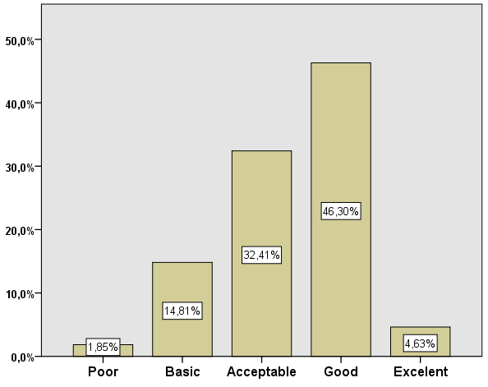 | 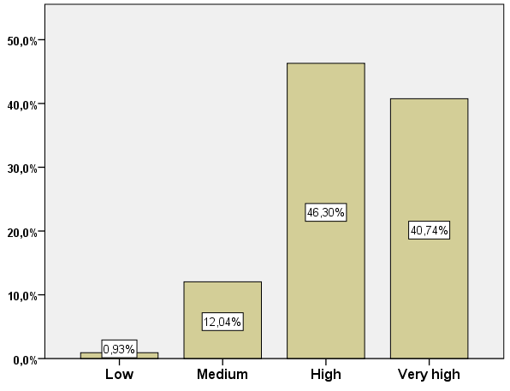
Figure 3. Students' perceptions of their level of ICT | Figure 4. Students' perceptions of their level of motivation in their educative training
Figure 5 shows the data obtained from the respondents related to the time dedicated to the use of ICT inside and outside of the classroom. A scale with six grades of time of dedication was used. The respondents determined that teachers typically use ICT an average of more than two-three hours per week. Regarding the perceptions of teachers about students’ use of ICT, there is no concrete average, due to the fact that the data collected varied significantly amongst participants.
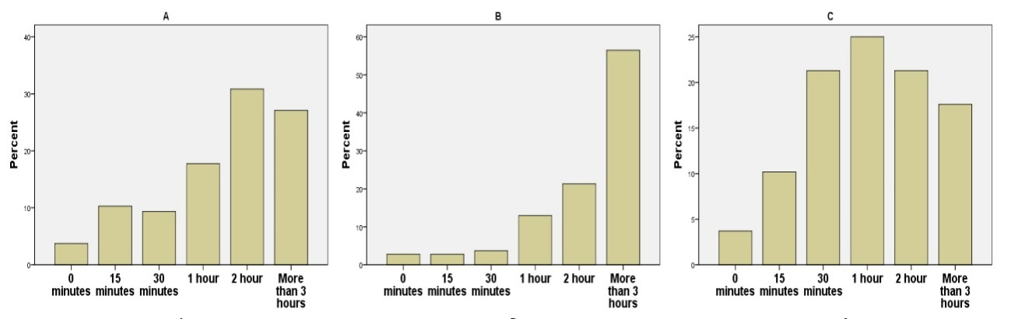
Figure 5 Statistical descriptive data about: a) use of ICT inside the classroom; b) use of ICT outside the classroom in order to prepare the lessons (teacher); c) use of ICT in order to carry out the educative tasks (students)
For the following descriptive analysis, the scale used five points marked by numerical values: (1) Never, (2) Almost never, (3) Sometimes, (4) Most of the time and (5) Always.
Table 1 Use of electronic devices that teachers use in the classroom
 | Digital board | Laptop | Tablets | Searchlight | Music players | Video Players | Smartphone
Mean | 3.26 | 3.98 | 2.07 | 3.79 | 3.27 | 2.57 | 1.97
Median | 4.00 | 4.00 | 2.00 | 4.00 | 3.00 | 3.00 | 2.00
Mode | 4 | 4 | 1 | 4 | 3 | 3 | 1
SD | 1.355 | 1.014 | 1.253 | 1.190 | 1.220 | 1.038 | .956
In relation to the different blocks that make up the questionnaire, table 1 shows the use of different electronic devices more common in the classroom. It is observed how the most used devices are: laptop (M = 3.98), Searchlight (M = 3.79), music players (M = 3.27), and digital board (M = 3.26), and against the use of smartphones (M = 1.97) and tablets (M = 2.07).
Table 2 Correlations of electronic devices
 |  | Age | ICT level | Mot. level | Digital board | Laptop | Tablets | Searchlight | Music players | Video Players | Smart phone
Age | Correl. | 1.000 | -.154 | -.029 | -.315 | -.048 | -.047 | -.093 | -.092 | .084 | .069
Age | p-value | . | .110 | .764 | .001 | .624 | .633 | .341 | .345 | .392 | .480
Age | N | 108 | 108 | 108 | 107 | 108 | 107 | 107 | 108 | 107 | 107
ICT level | Correl | -.154 | 1,00 | .272 | .279 | .231 | .070 | .149 | -.037 | .023 | -.138
ICT level | p-value | ,110 | . | .004 | .004 | .016 | .471 | .126 | .707 | .814 | .157
ICT level | N | 108 | 108 | 108 | 107 | 108 | 107 | 107 | 108 | 107 | 107
Mot. | Correl | -.029 | .272 | 1.00 | -.048 | .213 | .022 | .141 | .128 | .025 | -.060
Mot. | p-value | .764 | .004 | . | .622 | .027 | .819 | .147 | .187 | .800 | .541
Mot. | N | 108 | 108 | 108 | 107 | 108 | 107 | 107 | 108 | 107 | 107
Regarding age, Table 2 shows that there are only significant differences with the use of the digital board at a significance level of lower than 0.05 (p-value = 0.001) and not with the rest of the devices. Between age and said device, there is a low negative correlation (r = 0.315), that is, the older the student, the less he uses this 2.0 tool. On the other hand, the level of digital competence is significant regarding student motivation (p-value = 0.004), use of digital boards (p-value = 0.004) and use of laptops (p-value = 0.016). The correlation of both variables with the self-perceived level of digital competence is low (r = 0.272, r = 0.279, r = 0.231). Positive values ​​indicate that the higher the level of ICT , the greater the motivation and use of these devices.

Table 3 Use of 2.0 tool
 | Search engines | Online presentations | Educational social network | Blogs | Wikis | Forums | Webquest
Mean | 3.81 | 3.12 | 2.08 | 2.51 | 2.08 | 1.78 | 1.67
Median | 4.00 | 3.00 | 2.00 | 3.00 | 2.00 | 2.00 | 1.00
Mode | 5 | 3 | 1 | 3 | 2 | 1 | 1
SD | 1.072 | .924 | 1.275 | 1.140 | .927 | .805 | .855
Table 3 shows teachers’ use of different 2.0 tools and applications in their education training. Search engines (M=3.81) or online presentations such as Power Point or Prezi (M=3.12) are the most used web resources. Other collaborative tools, such as blogs (M=2.51) or social networks and wikis (M=2.08) are not used as educational resources.

Table 4 Correlations of tools 2.0
 |  |  | Age | ICT level | Mot. level | Search engines | Online Presentat. | Social Net. | Blogs | Wikis | Forums | Webquest
 | Age | Correl. | 1.00 | -.154 | -.029 | .017 | -.121 | .103 | .007 | -.067 | .099 | -.010
 | Age | p-value | . | .110 | .764 | .862 | .213 | .289 | .943 | .496 | .311 | .919
 | Age | N | 108 | 108 | 108 | 108 | 108 | 107 | 108 | 106 | 107 | 107
 | ICT level | Correl. | -.154 | 1.00 | .272 | .014 | .120 | .013 | .095 | .244 | .151 | .171
 | ICT level | p-value | .110 | . | .004 | .883 | .215 | .892 | .330 | .012 | .120 | .079
 | ICT level | N | 108 | 108 | 108 | 108 | 108 | 107 | 108 | 106 | 107 | 107
 | Mot. level | Correl. | -.029 | .272 | 1.00 | -.095 | .084 | -.127 | .070 | .130 | -.082 | -.063
 | Mot. level | p-value | .764 | .004 | . | .330 | .388 | .193 | .469 | .185 | .400 | .517
 | Mot. level | N | 108 | 108 | 108 | 108 | 108 | 107 | 108 | 106 | 107 | 107
Table 4 shows the levels of correlations obtained in relation to the 2.0 tools. The data indicates that there is no lineal relationship with age, nor with ICT nor motivation. There are only significant differences between the level of technological skills and the use of wikis (p-value=0.012). Both variables show a low positive correlation (r=0.244).
Table 5 Use of virtual platforms
 | Moodle | e-Twinning | Glogster | Blackboard | Adobe connect | Platform of the center
Mean | 2.50 | 1.35 | 1.21 | 1.68 | 1.82 | 3.11
Median | 3.00 | 1.00 | 1.00 | 1.00 | 1.00 | 3.00
Mode | 2 | 1 | 1 | 1 | 1 | 3
SD | 1.355 | .765 | .548 | 1.022 | 1.118 | 1.342
The virtual learning platforms offer an excellent choice with many benefits for students. However, Table 5 shows how most platforms are seldom used by them in their schools, with the exception of their own school’s platform (M=3.11). Although Moodle is considered to be one of the most used educative platforms, the students surveyed for this study barely used this platform (M=2.50). Although the rest of the platforms are hardly used, Moodle is considered the second most used platform according to the student.
 |  |  | Age | ICT level | Mot. level | Moodle | e-Twinning | Glogster | Blackboard | Adobe connect | Platform of the center
 | Age | Correl. | 1.00 | -.154 | -.029 | -.105 | -.001 | .095 | -.143 | .021 | -.158
 | Age | p-value | . | .110 | .764 | .280 | .994 | .330 | .141 | .831 | .103
 | Age | N | 108 | 108 | 108 | 107 | 108 | 108 | 108 | 108 | 108
 | ICT level | Correl. | -.154 | 1.00 | .272 | .242 | .117 | .257 | .042 | -.006 | .147
 | ICT level | p-value | .110 | . | .004 | .012 | .229 | .007 | .667 | .948 | .129
 | ICT level | N | 108 | 108 | 108 | 107 | 108 | 108 | 108 | 108 | 108
 | Mot. | Correl. | -.029 | .272 | 1.00 | .121 | -.079 | .003 | .059 | .084 | -.039
 | Mot. | p-value | .764 | .004 | . | .216 | .414 | .971 | .543 | .388 | .687
 | Mot. | N | 108 | 108 | 108 | 107 | 108 | 108 | 108 | 108 | 108
Table 6 Correlations of virtual platforms motivation
Table 6 shows the levels of correlations obtained in relation to different virtual learning platforms. The data indicates that there is no lineal relation with age, nor with ICT skills, nor the motivation with any LMS. It is observed that there are only significant differences between the level of ICT with Moodle (p-value=0.012) and with Glogster (p-value=0.007). Both correlations maintain a positive weak correlation with this variable (Moodle, r=0.0242; Glogster, r=0.257).

Table 7 Other resources 2.0
 | Dropbox - iCloud | Qr codes | Google + | Augmented reality | e-Porfolio | Moocs
Mean | 2.49 | 1.38 | 2.07 | 1.73 | 1.73 | 1.24
Median | 3.00 | 1.00 | 2.00 | 1.00 | 1.00 | 1.00
Mode | 3 | 1 | 1 | 1 | 1 | 1
SD | 1.168 | .709 | 1.231 | 1.010 | 1.010 | .609

Table 7 offers a vision of the use of other technological resources in the classroom. It is observed that the 2.0 resources most used in the classroom are virtual storage applications (M = 2.49) and Google + (M = 2.07), although their means show an intermediate level with respect to the Likert scale of 5 points. The rest of 2.0 resources have an average of less than 2 points, being unusual their use in the classroom.

Table 8 Correlations of different resources 2.0
 |  |  | Age | ICT level | Mot. level | Dropbox - iCloud | Qr codes | Google drive | Aug. reality | e-Porfolio | Moocs
 | Age | Correl. | 1.00 | -.154 | -.029 | -.022 | .020 | -.031 | .034 | -.103 | .023
 | Age | p-value | . | .110 | .764 | .821 | .835 | .753 | .730 | .287 | .816
 | Age | N | 108 | 108 | 108 | 107 | 107 | 107 | 108 | 108 | 108
 | ICT level | Correl. | -.154 | 1.00 | .272 | .129 | .210 | .028 | .184 | .136 | .274
 | ICT level | p-value | .110 | . | .004 | .186 | .030 | .773 | .057 | .161 | .004
 | ICT level | N | 108 | 108 | 108 | 107 | 107 | 107 | 108 | 108 | 108
 | Mot. level | Correl. | -.029 | .272 | 1.000 | .115 | .024 | -.004 | -.012 | .034 | .071
 | Mot. level | p-value | .764 | .004 | . | .237 | .808 | .970 | .905 | .727 | .468
 | Mot. level | N | 108 | 108 | 108 | 107 | 107 | 107 | 108 | 108 | 108
Table 8 shows the correlations that exist between the educative use of several very common 2.0 resources in the “knowledge society”. No lineal relationships can be observed. There are only significant differences between the level of ICT with the use of QR codes (p-value=0.030) and Moocs (p-value=0.004). Similar to the previous blocks, the correlation levels remain low positive respectively (r=0.210; r=0.274).

Table 9 Level of use of ICT by blocks
 | Mean | SD
Use of electronic devices (35 points) | 20.79 | 4.129
Use of 2.0 tools (35 points) | 16.96 | 4.445
Use of LMS (30 points) | 11.65 | 3.904
Other resources 2.0 (30 points) | 10.18 | 3.371

Table 9 shows the global results obtained for each block, bearing in mind that every block is composed of the individual sum of scores for every 2.0 tool. When comparing the use of each digital tool by blocks, it is possible to estimate the presence of differences between them. The block of technological devices is the most used by students (M=20.79 points based on 35 points) in comparison with other resources 2.0 (M=10.18 points based on 30 points). It is remarkable how the average obtained in the use of 2.0 tools in the classroom (M = 16.96) is lower than the total average score (35 points), highlighting the little use that students make of these 2.0 tools.

Table 10 Total level of use of ICT of students
 | Mean | SD
Total in digital competition (130 points) | 59.58 | 12.98
Total on the five-point scale | 2.29 | 0.499

In order to obtain a global value determining the level of use of ICT by students, a general assessment of the digital competence has been carried out. Table 10 shows the level of use taking into consideration the sum of four blocks composing the abovementioned competence (maximum 130 points), as well as the level of use with regard to the Likert scale of five points used in the research. The results show that the level of use of new technologies by the students in the classroom is below average (M=2.29 based on 5 points), rejected the hypothesis null number 4.

On the other hand, an ANOVA with the age variable was carried out to check whether there are significant differences regarding the level of total digital competence between the established age groups. The Levene equality test determines that the variances of both groups are equal (sig 0.489). Table 11 shows the means obtained from the students in relation to the age group for the level of ICT use. It can be observed that there is a similar average in the different age groups. However, it can be seen that the group of students under 25 years of age have a slightly higher average (M = 2.413) than the group of students over 40 (M = 2.161).

Table 11 Descriptive analysis of total level of use of ICT by age groups
Age | N | Mean | SD | Std. Error | 95% Confidence Interval |  | Minimum | Maximum
 |  |  |  |  | Lower Bound | Upper Bound | Minimum | Maximum
>25 | 19 | 2.413 | .50974 | .11694 | 2.1673 | 2.6586 | 1.69 | 3.15
26-30 | 26 | 2.289 | .41854 | .08208 | 2.1194 | 2.4575 | 1.50 | 2.96
31-35 | 33 | 2.262 | .53141 | .09251 | 2.0738 | 2.4507 | 1.23 | 3.73
36-40 | 13 | 2.364 | .60826 | .16870 | 1.9963 | 2.7315 | 1.38 | 3.38
<40 | 17 | 2.161 | .46538 | .11287 | 1.9214 | 2.3999 | 1.31 | 2.96
Total | 108 | 2.291 | .49922 | .04804 | 2.1961 | 2.3865 | 1.23 | 3.73

Table 12 shows that there are no significant differences between the age groups of the students in relation to their attitude of use towards ICT (sig. = 0.620), rejecting the null hypothesis 1.

Table 12 Analysis of variance (ANOVA) of the use of ICT with respect to age groups
 | Sum of Squares | df | Mean Square | F | p-value
Between Groups | .668 | 4 | .167 | .662 | .620
Within Groups | 25.998 | 103 | .252
Total | 26.666 | 107

5. Discussion
The goal of this research is to detect correlations between the didactic use of ICT in relation to the personal and professional characteristics of students. In this research, it has been possible to verify that the use of 2.0 resources and applications is not associated with the age of students; therefore, hypothesis 1 of this study can be rejected. These results are corroborated with the results obtained by Guo, Dobson and Petrina (2008), which affirmed that there is no statistically significant difference between the age group and total level of ICT use, unlike the results obtained by Ramírez-Orellana, Cañedo-Hernández and Clemente-Linuesa (2012) and Mac-Callum and Jeffrey (2014), which found significant differences in ICT use according to age.
In addition, the results obtained by Scherer, Siddig & Teo (2015) are also confirmed it, since, in this study, positive correlations have been found between the level of use of ICT and the degree of motivation in their teaching education.
In this study it has been found that, although students claim to have a high level of digital competence, it has been shown that the use they make of the 2.0 tools is medium-low. Therefore, hypothesis number 2 can be rejected. The 2.0 tools most used by students have been web browsers, online presentations and blogs, corroborating the results obtained by Sadaf, Newby and Ertmer (2016). No similar findings were reported by Costa, Alvedos and Teixeira (2016), where wikis and blogs were shown as the least popular 2.0 tools.
Once the data has been analysed, the students affirmed that they have a very high level of motivation in their teaching practice. However, the data has shown that there are hardly any correlations between the degree of motivation and the use of 2.0 tools and resources, there being only a correlation with the use of laptops. These results are contradictory to the findings obtained by Schulz, Isabwe and Reichert (2015), Uluyol and Şahin (2016), and Harandi (2015). Therefore, hypothesis number 3 can be rejected.
Taking into account the total level of use of ICT, hypothesis number 4 can also be rejected due to the fact that the level of general use of students is medium-low.

6. Conclusions and Future Work
Due to the social changes produced by the advance of ICT, the development of the digital competence of students must become one of the principal aims of education for the 21st century (Griffin, Care and McGaw, 2012; Tristan-Lopez and Ylizaliturri-Salcedo, 2014). However, in spite of this, there are still some gaps related to ICT training and teachers’ use of ICT tools. In this respect, one must ask whether educational institutions are prepared for these changes.
In this work, it has been possible to verify how future teachers, the participants in this study, still do not have a solid digital education, although they believe that they do. It can be affirmed that, despite the opportunities offered by ICT, future teachers are still conditioned by their practical thinking, which leads them to reproduce the knowledge and ways of teaching classes that they have acquired throughout their schooling. In this sense, they continue to use more popular devices and tools, such as laptops, projectors or music players, web browsers and online presentations, among others, with the main disadvantage being that they continue to be used in a traditional way without producing any innovating changes in teaching practice.
Another conclusion of the study is that, although it may be thought that age is a determining variable in the level of use of ICT, due to the fact that younger students have been born and raised in the ICT era, this is not the case, since the motivation toward teaching practice has a greater influence than the age variable. It can be said that motivation and digital competence are two mutually reinforcing variables, given that they are positively correlated and decisively influence the use of 2.0 tools. Teachers who are motivated are more digitally proficient and vice versa. This means that teachers use digital platforms, such as Moodle or Glogster, use other ICT teaching strategies, such as QR codes or Moocs, and do not limit themselves to using tools that are traditionally employed in the teaching methodology: videos, projectors and computers. This implies that, from their initial training, the use of these technologies must be promoted to a greater extent, and above all, the students' motivation towards them.
A criticism resulting from this study is that when these teachers arrive at schools, if their level of motivation and level of ICT use is not increased, they will continue to practice traditional teaching, even though they use technological resources. Therefore, teaching innovation and the development of digital competence will depend on good teaching practice and on their positive predisposition towards this type of methodology.

In this sense, from the public administrations, the different state organisms and companies dedicated to the educative sector should develop more incentives, support and opportunities to increase the motivation of teachers to improve the level and the quality of ICT use in the classrooms (Uluyol and Şahin, 2016). It is advisable to train the teaching staff in charge of higher education, so that future students have direct referents on how to put into practice new teaching methods. As already mentioned, this is due to the fact that said motivation is dialectically related to digital competence and both variables together have a positive influence on educational quality.

This study has several limitations. First, the sample was small and not representative of the entire population. Therefore, the results are not applicable to all future teachers. In addition, because the sample has been mostly female, no statistical analyses have been carried out in relation to gender to verify any significant differences between both. Finally, another limitation of the research is that only one component of digital competence has been taken into account when it is composed of knowledge, use and attitude.

Based on the results obtained in this study, the future lines of research that can be proposed are: First, to carry out this same study taking into account the gender variable in order to find out to what extent gender influences or not the use of 2.0 tools. In addition, it would be interesting to correlate the years that teachers have been active with their motivation towards the use of ICT and their level of digital competence. It would also be relevant to find out through which procedures the faculty has acquired their real digital competence: through regulated permanent training, self-training, etc. The socio-educational contexts, resources and support that the centres have can also influence the implementation of innovative methodologies and the use of 2.0 tools. Therefore, it would be interesting to correlate the socio-educational contexts of the centres where the professors teach with their level of use of the 2.0 tools.

References
Albion, P. R., Tondeur, J., Forkosh-Baruch, A., & Peeraer, J. (2015). Teachers’ professional development for ICT integration: towards a reciprocal relationship between research and practice. Education and Information Technologies, 20(4), 655-673. Doi: https://doi.org/10.1007/s10639-015-9401-9
Bisquerra, R. (2004). Metodología de la investigación educativa. Madrid: Plaza.
Çakır, R., & Aktay, S. (2016). Primary School Principals’ Experiences with Smartphone Apps. Journal of Education and Training Studies, 4(12), 14-20. Doi: https://doi.org/10.11114/jets.v4i12.1869
Costa, C., Alvelos, H., & Teixeira, L. (2016). The use of Web 2.0 tools by students in learning and leisure contexts: a study in a Portuguese institution of higher education. Technology, Pedagogy and Education, 25(3), 377-394. Doi: https://doi.org/10.1080/1475939X.2015.1057611
Dede, C. (2005). Planning for Neomillenial learning styles: implications for investments in technology and faculty. Educause. Retrieved March, 28, 2018.
Domingo, M. G., & Gargante, A. B. (2016). Exploring the use of educational technology in primary education: Teachers' perception of mobile technology learning impacts and applications' use in the classroom. Computers in Human Behavior, 56, 21-28. Doi: https://doi.org/10.1016/j.chb.2015.11.023
Dönmez, F. I., Odabasi, H. F., & Kabakci Yurdakul, I. (2016). The Potential of Web 2.0 Technologies for Professional Development. In Society for Information Technology & Teacher Education International Conference, 1, 664-667. Retrieved from https://www.learntechlib.org/p/171748/.
Dornisch, M. (2013). The digital divide in classrooms: Teacher technology comfort and evaluations. Computers in the Schools, 30(3), 210-228. Doi: https://doi.org/10.1080/07380569.2012.734432
Fernández-Cruz, F. J. (2016). Los docentes de la Generación Z y sus competencias digitales / Generation Z's Teachers and their Digital Skills. Comunicar, 24(46), 97-105. Doi: https://doi.org/10.3916/C46-2016-10
Ferrari, A. (2013). DIGCOMP: A framework for developing and understanding digital competence in Europe. Scientific and Policy Report by the Joint Research Centre of the European Commission Doi:10.2788/52966
Gallardo-Echenique, E. E., de Oliveira, J. M., Marqués-Molias, L., & Esteve-Mon, F. (2015). Digital competence in the knowledge society. Journal of Online Learning and Teaching, 11(1), 1-16.
Guo, R. X., Dobson, T., & Petrina, S. (2008). Digital natives, digital immigrants: An analysis of age and ICT competency in teacher education. Journal of educational computing research, 38(3), 235-254. Doi: https://doi.org/10.2190/EC.38.3.a
Griffin, P., Care, E., & McGaw, B. (2012). The changing role of education and schools. In Assessment and teaching of 21st century skills, 1-15. Springer Netherlands. Doi: https://doi.org/10.1007/978-94-007-2324-5_1
Harandi, S. R. (2015). Effects of e-learning on Students’ Motivation. Procedia-Social and Behavioral Sciences, 181, 423-430. Doi: https://doi.org/10.1016/j.sbspro.2015.04.905
Hollinderbäumer, A., Hartz, T., & Ückert, F. (2013). Education 2.0-How has social media and Web 2.0 been integrated into medical education? A systematical literature review. GMS Zeitschrift für Medizinische Ausbildung, 30(1), 1-12. Doi: http://dx.doi.org/10.3205/zma000857
Janssen, J., Stoyanov, S., Ferrari, A., Punie, Y., Pannekeet, K., & Sloep, P. (2013). Experts' views on digital competence: Commonalities and differences. Computers & Education, 68, 473-481. Doi: https://doi.org/10.1016/j.compedu.2013.06.008
Karsenti, T., Villeneuve, S., & Goyer, S. (2006). The impact of motivation on prospective teachers’ use of information and communication technologies (ICTs). In Society for Information Technology & Teacher Education International Conference, 1659-1666. Retrieved March 29, 2018 from https://www.learntechlib.org/p/22300/.
Kerlinger, F. N. L., Howard, B., Pineda, L. E., & Mora Magaña, I. (2002). Investigation del comportamiento.
Kim, K. J., & Frick, T. W. (2011). Changes in student motivation during online learning. Journal of Educational Computing Research, 44(1), 1-23. Doi: https://doi.org/10.2190/EC.44.1.a
Krumsvik, R. J. (2014). Teacher educators' digital competence. Scandinavian Journal of Educational Research, 58(3), 269-280. Doi: https://doi.org/10.1080/00313831.2012.726273
Lara, J. A., Lizcano, D., Martínez, M. A., Pazos, J., & Riera, T. (2014). A system for knowledge discovery in e-learning environments within the European Higher Education Area–Application to student data from Open University of Madrid, UDIMA. Computers & Education, 72, 23-36. Doi: https://doi.org/10.1016/j.compedu.2013.10.009
Levin, T., & Wadmany, R. (2008). Teachers' views on factors affecting effective integration of information technology in the classroom: Developmental scenery. Journal of Technology and Teacher Education, 16(2), 233-263. Retrieved from https://www.learntechlib.org/p/22950/.
Mac-Callum, K., & Jeffrey, L. (2014). Comparing the role of ICT literacy and anxiety in the adoption of mobile learning. Computers in Human Behavior, 39, 8-19. Doi: https://doi.org/10.1016/j.chb.2014.05.024
Nikolopoulou, K., & Gialamas, V. (2016). Barriers to ICT use in high schools: Greek teachers’ perceptions. Journal of Computers in Education, 3(1), 59-75. Doi: https://doi.org/10.1007/s40692-015-0052-z
Philip, T., & Garcia, A. (2013). The importance of still teaching the iGeneration: New technologies and the centrality of pedagogy. Harvard Educational Review, 83(2), 300-319. Doi: https://doi.org/10.17763/haer.83.2.w221368g1554u158
Ramírez-Orellana, E., Cañedo-Hernández, I., & Clemente-Linuesa, M. (2012). Las actitudes y creencias de los profesores de secundaria sobre el uso de Internet en sus clases / Attitudes and Beliefs of Secondary Teachers about Internet Use in their Classrooms. Comunicar: Revista Científica de Comunicación y Educación, 19(38), 147-155. Doi: https://doi.org/10.3916/C38-2012-03-06
Røkenes, F. M., & Krumsvik, R. J. (2014). Development of Student Teachers’ Digital Competence in Teacher Education-A Literature Review. Nordic Journal of Digital Literacy, 4 (9), 250-280.
Ruthven, K., Hennessy, S., & Deaney, R. (2005). Incorporating Internet resources into classroom practice: pedagogical perspectives and strategies of secondary-school subject teachers. Computers & Education, 44(1), 1-34. Doi: https://doi.org/10.1016/j.compedu.2003.11.001
Sadaf, A., Newby, T. J., & Ertmer, P. A. (2016). An investigation of the factors that influence preservice teachers’ intentions and integration of Web 2.0 tools. Educational Technology Research and Development, 64(1), 37-64. Doi: https://doi.org/10.1016/j.sbspro.2015.04.905
Scherer, R., Siddiq, F., & Teo, T. (2015). Becoming more specific: Measuring and modeling teachers' perceived usefulness of ICT in the context of teaching and learning. Computers & Education, 88, 202-214. Doi: https://doi.org/10.1016/j.compedu.2015.05.005
Schulz, R., Isabwe, G. M., & Reichert, F. (2015). Investigating teacher’s motivation to use ICT tools in higher education. In Internet Technologies and Applications (ITA), 1, 62-67. IEEE. Doi: 10.1109/ITechA.2015.7317371
Talebian, S., Mohammadi, H. M., & Rezvanfar, A. (2014). Information and communication technology (ICT) in higher education: advantages, disadvantages, conveniences and limitations of applying e-learning to agricultural students in Iran. Procedia-Social and Behavioral Sciences, 152, 300-305. Doi: https://doi.org/10.1016/j.sbspro.2014.09.199
Tondeur, J., Forkosh-Baruch, A., Prestridge, S., Albion, P., & Edirisinghe, S. (2016). Responding to challenges in teacher professional development for ICT integration in education. Educational Technology & Society, 19(3), 110-121. Retrieved from http://www.jstor.org/stable/jeductechsoci.19.3.110
Tristán-López, A., & Ylizaliturri-Salcedo, M. A. (2014). Evaluation of ICT competencies. In Handbook of research on educational communications and technology (pp. 323-336). Springer New York. Doi: https://doi.org/10.1007/978-1-4614-3185-5_26
Uluyol, Ç., & Şahin, S. (2016). Elementary school teachers' ICT use in the classroom and their motivators for using ICT. British Journal of Educational Technology, 47(1), 65-75. Doi: https://doi.org/10.1111/bjet.12220
Wong, E. M., Li, S. S., Choi, T. H., & Lee, T. N. (2008). Insights into innovative classroom practices with ICT: Identifying the impetus for change. Educational Technology & Society, 11(1), 248-265. Retrieved from http://www.jstor.org/stable/jeductechsoci.11.1.248

