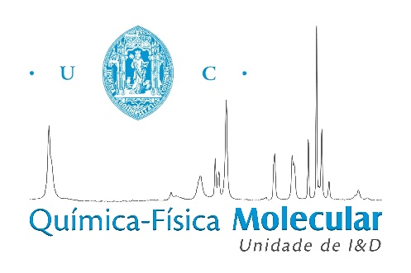
Probing Biosystems by Vibrational Spectroscopy – from Human Cells to Bones
The research activity of the R&D Group Molecular Physical-Chemistry of the University of Coimbra, Portugal (http://www.ci.uc.pt/qfm/ ), is focused on studies of biosystems by vibrational spectroscopy, from optical methods (Raman and infrared) to neutron scattering techniques (inelastic and quasi-elastic) – to yield both structural/conformational and dynamical information.
The present lecture reports results on:
- the impact of novel Pt- and Pd-anticancer agents on human cancer cells – aiming at evaluating their efficacy and identifying new therapeutic targets
- the normal-to-cancer transition, probing tissues resected from human patients (both tumour and non-malignant) – in order to allow a more accurate and early cancer diagnosis
- the effect of heat on human bones – for future applications in Forensic Science and Archaeology

