Trade between Minturnae and Hispania
in the Late Republic (2):The mines and societates of southern Hispania

Clive STANNARD, Alejandro G. SINNER,
Bartolomé MORA SERRANO y Gian Luca GRIGORI

BACKGROUND

In The Numismatic Chronicle of 2019, some of us published a comparative isotopic analysis of a number of lead pieces from Minturnae in Italy and the grandes plomos monetiformes from the area that became the province of Baetica under Augustus—which for simplicity we call ‘Baetica’—both of which use the Italo-Baetican iconography. This showed that in both cases lead from both the Sierra Cartagena/Mazzarón mines around Carthago Nova and the Sierra Morena mines in the interior was used, and in some cases mixed.
We suggested that Minturnaeans were among the first to exploit the riches of Hispania after the Second Punic War, in which the city seems to have played an important and until-now unappreciated role. They travelled and traded widely, with Massalia and south-western France and with Hispania Ulterior, as the Minturnaean lead pieces from a purse in the second-century Isla Pedrosa wreck off Estartit in Catalonia. The evidence of gentes known epigraphically from both Minturnae and Carthago Nova is clear.
The focus of our recent article was to use isotopic analysis to compare the lead used in making the grandes plomos monetiformes (plomos for short) with Italo-Baetican types with lead pieces from the river Gagliano at Minturnae. The plomos are found almost exclusively in the upper valley of the Guadalquivir river ( the ancient Baetis), in the area that became the Province of Baetica under Augustus. They all date to the second and first centuries. The mines of Baetica —particular of silver and lead—were extremely productive at this time, and heavily exploited by Italians. A natural misunderstanding of one of the main images used on the Italo- Baetican plomos—our man walking with a shovel on her shoulder—as a miner led to them being considered as plomos de la minas, but the man is in fact a furnacator, or stoker of hypocausts in the public baths; many of the images on these pieces point rather to agriculture; the iconography is also used in places outside the mining area, such as at Salacia (Alcázar do Sol) in Portugal.
There were undoubtedly strong contacts between Minturnae and the Baetican interior, shown by two Baetican plomos found in the River Garigliano at Minturnae: the evidence is strong, because these pieces are rare; three specimens only have been found outside the area of the plomos in Spain itself—essentially the upper valley the Guadalquivir, the ancient Baetis—two on the via Herculea near Śaitabi. We were also able to show epigraphic evidence linking the names on some of these plomos to gentes attested at Minturnae.
Our epigraphical study, however, was most fruitful in documenting contacts between Minturnae and the mining earlier on the coast around Carthago Nova (Cartagena) and Mazarrón, partly because we were able to benefit from the recent work of Michele Stefanile on contacts between Campania and southern Spain. We were, we believe, able to identify a societas active in the lead trade, which made an of small lead pieces at Minturnae, the members of which are signed individual dies as FVRI, C·BAIBI, L·NVM, C·NVM and C·SAM / IR; whereas all members of a societas are named together on Spanish lead ingots, this was, of course, impossible given small fields of these tiny pieces. The Furii, Baebii and Numisii are amongst the epigraphically most attested gentes in the city, with interests in lead.
In this paper, we will now wish to expand our discussion to a number of aspects of the mines of the Baetican interior, and the nature and roles of the societates that exploited them, relying mainly numismatic and sigillographic evidence.
There was a basic distinction in the legal regime working the mines of the coast and those of the interior: the coastal mines around Carthago Nova were largely exploited by small societates of a few named individuals, while those of the interior were, from the beginning, characterised by large-scale societates publicanorum, whose members are not named. On the coast—an area of early Italiot settlement—such anonymous societates appear in the late Republic and early Empire. Campanians continued to be active in the societates publicanorum throughout; there is, for example, a memorial from Capua of late Republican or early Imperial times to an overseer who worked for one of them; and the mines are well-attested in inscriptions from Capua, in the hinterland of Minturnae.
These societates existed for long periods of time, unlike the named societates of the coast, which seem not to have survived their members, and to have had well developed administrative structures; they worked a number of different mines throughout the area. We know many of them by objects they marked with abbreviations of their names, always with an initial letter S for societas followed by geographic indicator. These include S·C, most commonly glossed as societas Castulonensis, the largest and is the best attested, and seems to have worked a number of different mines; others have glossed S·C as societas Cordubensis; and we will discuss this later. The societas Sisaponensis, which Pliny said mined cinnabar at Sisapo (La Bienvenida, Ciudad Real province, near modern Almadén), and which Cicero mentioned, is also well attested, and signed S·S. Others proposed expansions of these names include S·B·A for societas B… argenti foedinarum, and S·BA for societas Bedrorensis, Baeculensis or Baetica (if S·B·A and S·BA are in fact separate societates); S·F·B for societas fornacensis Baeturiae. S·C·C has not been plausibly explained.
The societates marked a variety of objects, such as the copper bucket from the Roman workings in the El Centenillo mine and a lead weight, both marked S·C, and other buckets marked S·S and S·S·C from mines near Posadas, Córdoba. There are also to large groups of coins counter-marked S·C and SS which we document and discuss; as well as lead seals, probably used to close bags or boxes of ore or metal, which we will also the address below. Fig. 1 provides an overview of where objects with these marks have are known to have been found.

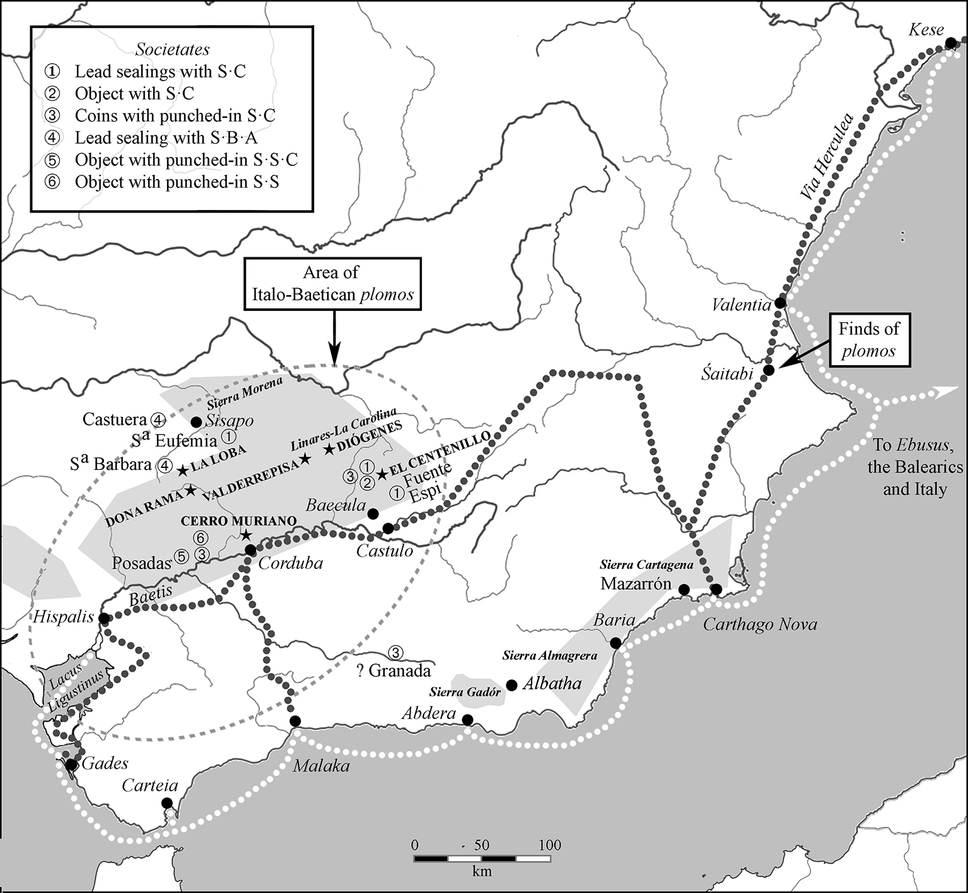

Fig. 1. The societates publicanorum of Baetica.

C·SAM / IR AGAIN, AND THE METALLUM SAMIARIENENSIS

While the Furii, Baebii and Numisii are identifiable amongst the signatories of the FVRI, C·BAIBI, L·NVM, C·NVM and C·SAM / IR issue, C·SAM was more difficult to interpret, and we suggested that he was a member of the Samiarii, a gens known from Minturnae, although at that stage we knew no trace of them in Spain.
Pliny, in his Natural Histories, records that mines could be more productive when re-opened after closure, and so command a higher rental. As examples, he mentions two such ‘black lead’ mines in Baetica, still identified by the names of the original owners; one of these is usually identified as the metallum Samariense. However, the relevant text is uncertain, and the name has been restored in at least six different ways, but Samariense cannot stand, as Samarius is not a known Roman nomen. Nothing therefore prevents the name being restored as Samiariense, including because the Samiarii used the praenomen Caius, as in C·SAM.
IR is more difficult to resolve. It does not appear to be a cognomen, because, while FVRI uses a nomen only, and C·BAIBI, L·NVM and C·NVM praenomen and nomen, none use a cognomen. If IR were a cognomen, the only possibility would appear to be IR(enaeus), from the Greek Εἰρηναῖος, commonly used by slaves or freedmen, and would resolve as Irenaeus, slave of Caius Samiarius, but this seems unlikely. Nor is there any sign of ligate letters AR, so as to read the legend as C·SAM / IARI. Pl. 1, 1 and 2, are the two best-preserved pieces. The part of the legend reading IR therefore remains inexplicable.
Pliny specifies that the metallum Samariense and the metallum Antonianum were in Baetica, and in his time the area of the mines of the coast around Carthago Nova were not part of Hispania Baetica, but of Hispania Ulterior. These mines are therefore the first case we know of societates with individual personal names in the interior, apart T·IVVENTI / M·LV…, known from an ingot of late Republican or early Imperial times found in the Córdoba area.
The societates publicanorum of the interior were still active in the 70s AD, when Pliny wrote, but we cannot know if the Samiarii were still involved in this mine, or whether this was merely a case of the original name continuing in use. It provides further evidence that gentes from Minturnae were active in the mining sector, not only at Carthago Nova, but in the interior as well.

A LEAD TESSERA FROM MINTURNAE WITH THE LEGEND S·C

A tessera was found during Brother Dominic Ruegg’s underwater investigations in the Garigliano river (the ancient Liris) at Minturnae, but has only now been recognised (pl. 1, 13):

Obv. ª C; stars below and inside C; a small triangle between the two letters.
Rev. Blank.
Pb 14 mm 1.17g Ruegg 1995, pp. 149, no. 9.10 = Overbeck 1998, pp. 121, no. 14

The piece shares many characteristics with the seals marked S·C; examples from a number of different sites (see tab. 1) are shown pl. 1, 3–12), pl. 5, 48–50, and pl. 7, 66–68. A very spindly style of lettering characterises all the legends, and both S and C can appear reversed; on palaeographic grounds, it made at first glance such lettering might appear to be early; but lettering on the coins of this part of Hispania in the second and first centuries is often clumsy, with archaic characteristics, and there is archaeological evidence of date: at Cerro del Plomo (El Centenillo mine), where there is no sign of activity before the end of the second century, seals with S·C have been found in archaeological contexts of the first half of the first century.
This tessera provides the first direct evidence of contact between the city and the mines of the interior; it is not inconceivable that whoever brought it to Minturnae was directly involved with the societas.

COINS MARKED WITH S·C AND SS

There are two separate and substantial groups of coins, one marked S·C, the other SS, which must be understood in the context of the overall coin stocks present at the various mines.
Francisca Chaves and Paloma Otero have shown that the coins involved are quite varied, with the mints of Ulterior—particularly Castulo and Obulco—naturally being the most common, but there are also coins from Citerior, to the north. Roman bronze is rare, unlike in coastal sites like Cabezo Agudo (La Unión) near Carthago Nova. It has sometimes been suggested that the non-local coins—for example, the Celtiberian issues present at La Loba—were brought in by workers coming from elsewhere. This needs consideration in the case of two particular, where the coins of Kese dominate among the non-local and regional coins: at Diógenes they account for nine of 19 coins, and are accompanied by other coins of the Catalan coast, but they are particularly common at El Centenillo, where are the account for fully 15 of the 19 coins, 37.25% of all the coins from the mine. None the less, in neither case did coins from Citerior constitute the majority of the finds. Substantial numbers of the coins of Ulterior were also present: there are also 20 at Diógenes, as well as four Roman asses, and 32 coins of Castulo and Obulco at El Centenillo.
Kese was a very productive mint, and its coins are found widely throughout Catalonia and abroad; they account for 14% of coins from the Cabrera de Mar valley, in the Laietani area further north, and 14% of Spanish coins in the river Garigliano (Liris) at Minturnae. It is therefore not surprising the considerable numbers of coins of Kese came with travellers and workers to the mining area, but that there is a crucial difference between the coins from these two mines: at El Centenillo they are often marked with S·C, not the case at Diógenes. It seems likely that the coins of Kese at El Centenillo were deliberately imported; less sure but still probable at Diógenes; it may be that the coins here were brought in earlier, before the phenomenon of counter-marking began.

Coins marked S·C (Appendix, ref. 1–37)

S·C on these coins was formed by a series of punched-in dots, in the same way as on the buckets marked S·C and SS, invariably on the obverse. We have found images of 37 such marked coins (Appendix). We illustrate examples on pl. 2, 14–19. None of the coins that we can attribute with certainty to a particular issue date to the first century; but S·C could of course have been applied later than the date of the coins’ issue, and in fact most of the coins seem to be quite worn by the time that were countermarked; a date in the mid-first century is probable. Not only coins of Kese were marked: one is over Abariltur (pl 2, 20), and a second over Kastilo (pl. 2, 21); both of these date to the second century.
S·C must again designate the societas Castulonensis, and the marked coins were presumably made, or at least issues at El Centenillo. Why the company made these pieces is not immediately obvious. Counter-marking can be used to authorise a coin to circulate—for example, a foreign or a worn coin—or to establish a value, often to retariff an earlier issue. No such motives are immediately obvious in this case: a variety of local and foreign coins were also available for use, in fact, the majority of coins on these sites. It seems more likely that they were used by the societas to establish a value in the context of a closed economy; for example, they may have being distributed as a part of pay, and then used to purchase food and supplies from a company shop.
From the little information we have, the presence of coins of Kese marked S·C seems to be largely limited to mining areas, in particular El Centenillo; Hill and Sandars mention six were found at El Centenillo, if these are part of the 15 coins of Kese reported from El Centenillo, this equates to about 40% of all Kese on this sire being marked. In no other case can we make such an estimation, as we know the provenances of very few specimens, and subsequent publications have usually simply reproduced those given by Hills and Sanders: Posadas (Córduba) and el Hoyo de la Campana (Granada). Another specimen is known from Toledo (Appendix, ref. 29), but was found in medieval levels, and so is of limited usefulness.

Coins marked both S·C and SS (Appendix, ref. 38–39)

There is another group of coins—most of which are not Kese—marked with SS; amongst these, we have identified two that are twice marked, once with S·C on the obverse, and another time with SS on the reverse (pl. 2, 22 & 23); these must have been coins of the issue we have just described, reused and marked a second time. This group which must therefore be later, and, in fact, many of the coins with SS are over issues of the first century.

Coins marked SS (Appendix, ref. 40–66)

Unlike the bucket with the inscription SS executed in a series of dots, this group uses another technique: a punch with the single letter S is struck twice into a coin to make SS; this is can be clearly see from the varying distances between the letters and their irregular lay-out in our illustrations (pl. 2, 22 – pl. 4, 39). SS seems to be the mark of the societas Sisaponensis, the best attested of the mining companies.
The SS group involves a wide range of mints from both Citerior and Ulterior; the evidence has not yet been presented systematically, so we illustrate specimens of all the different mints that we have being able to identify (fig. 2). The coins marked are a sample of what available in the mining area, which included the coins of Kese earlier marked by the societas Castulonensis. There is no evidence regarding the place of issue, nor as to whether the group was made in one g, or was spread over a period of time. The earliest coin is pl. 2, 25, Baria, of the late third century, and was already worn, as, indeed, well a number of them. The latest issues are from the first half of the first century. García-Bellido reports a coin of Iulia Traducta all the time of Augustus, marked with M·S·S; she suggests reading this as metalla societatis Sisaponensis or societas metallorum Sisaponensium; , she associates with the SS group, but it seems unlikely, including because of the different legend and the outlying date. Assuming that the two groups served a similar function in the management of the mines, they may be quite close in date, and the on balance, a date for the SS group in the first half on the first century seems likely.

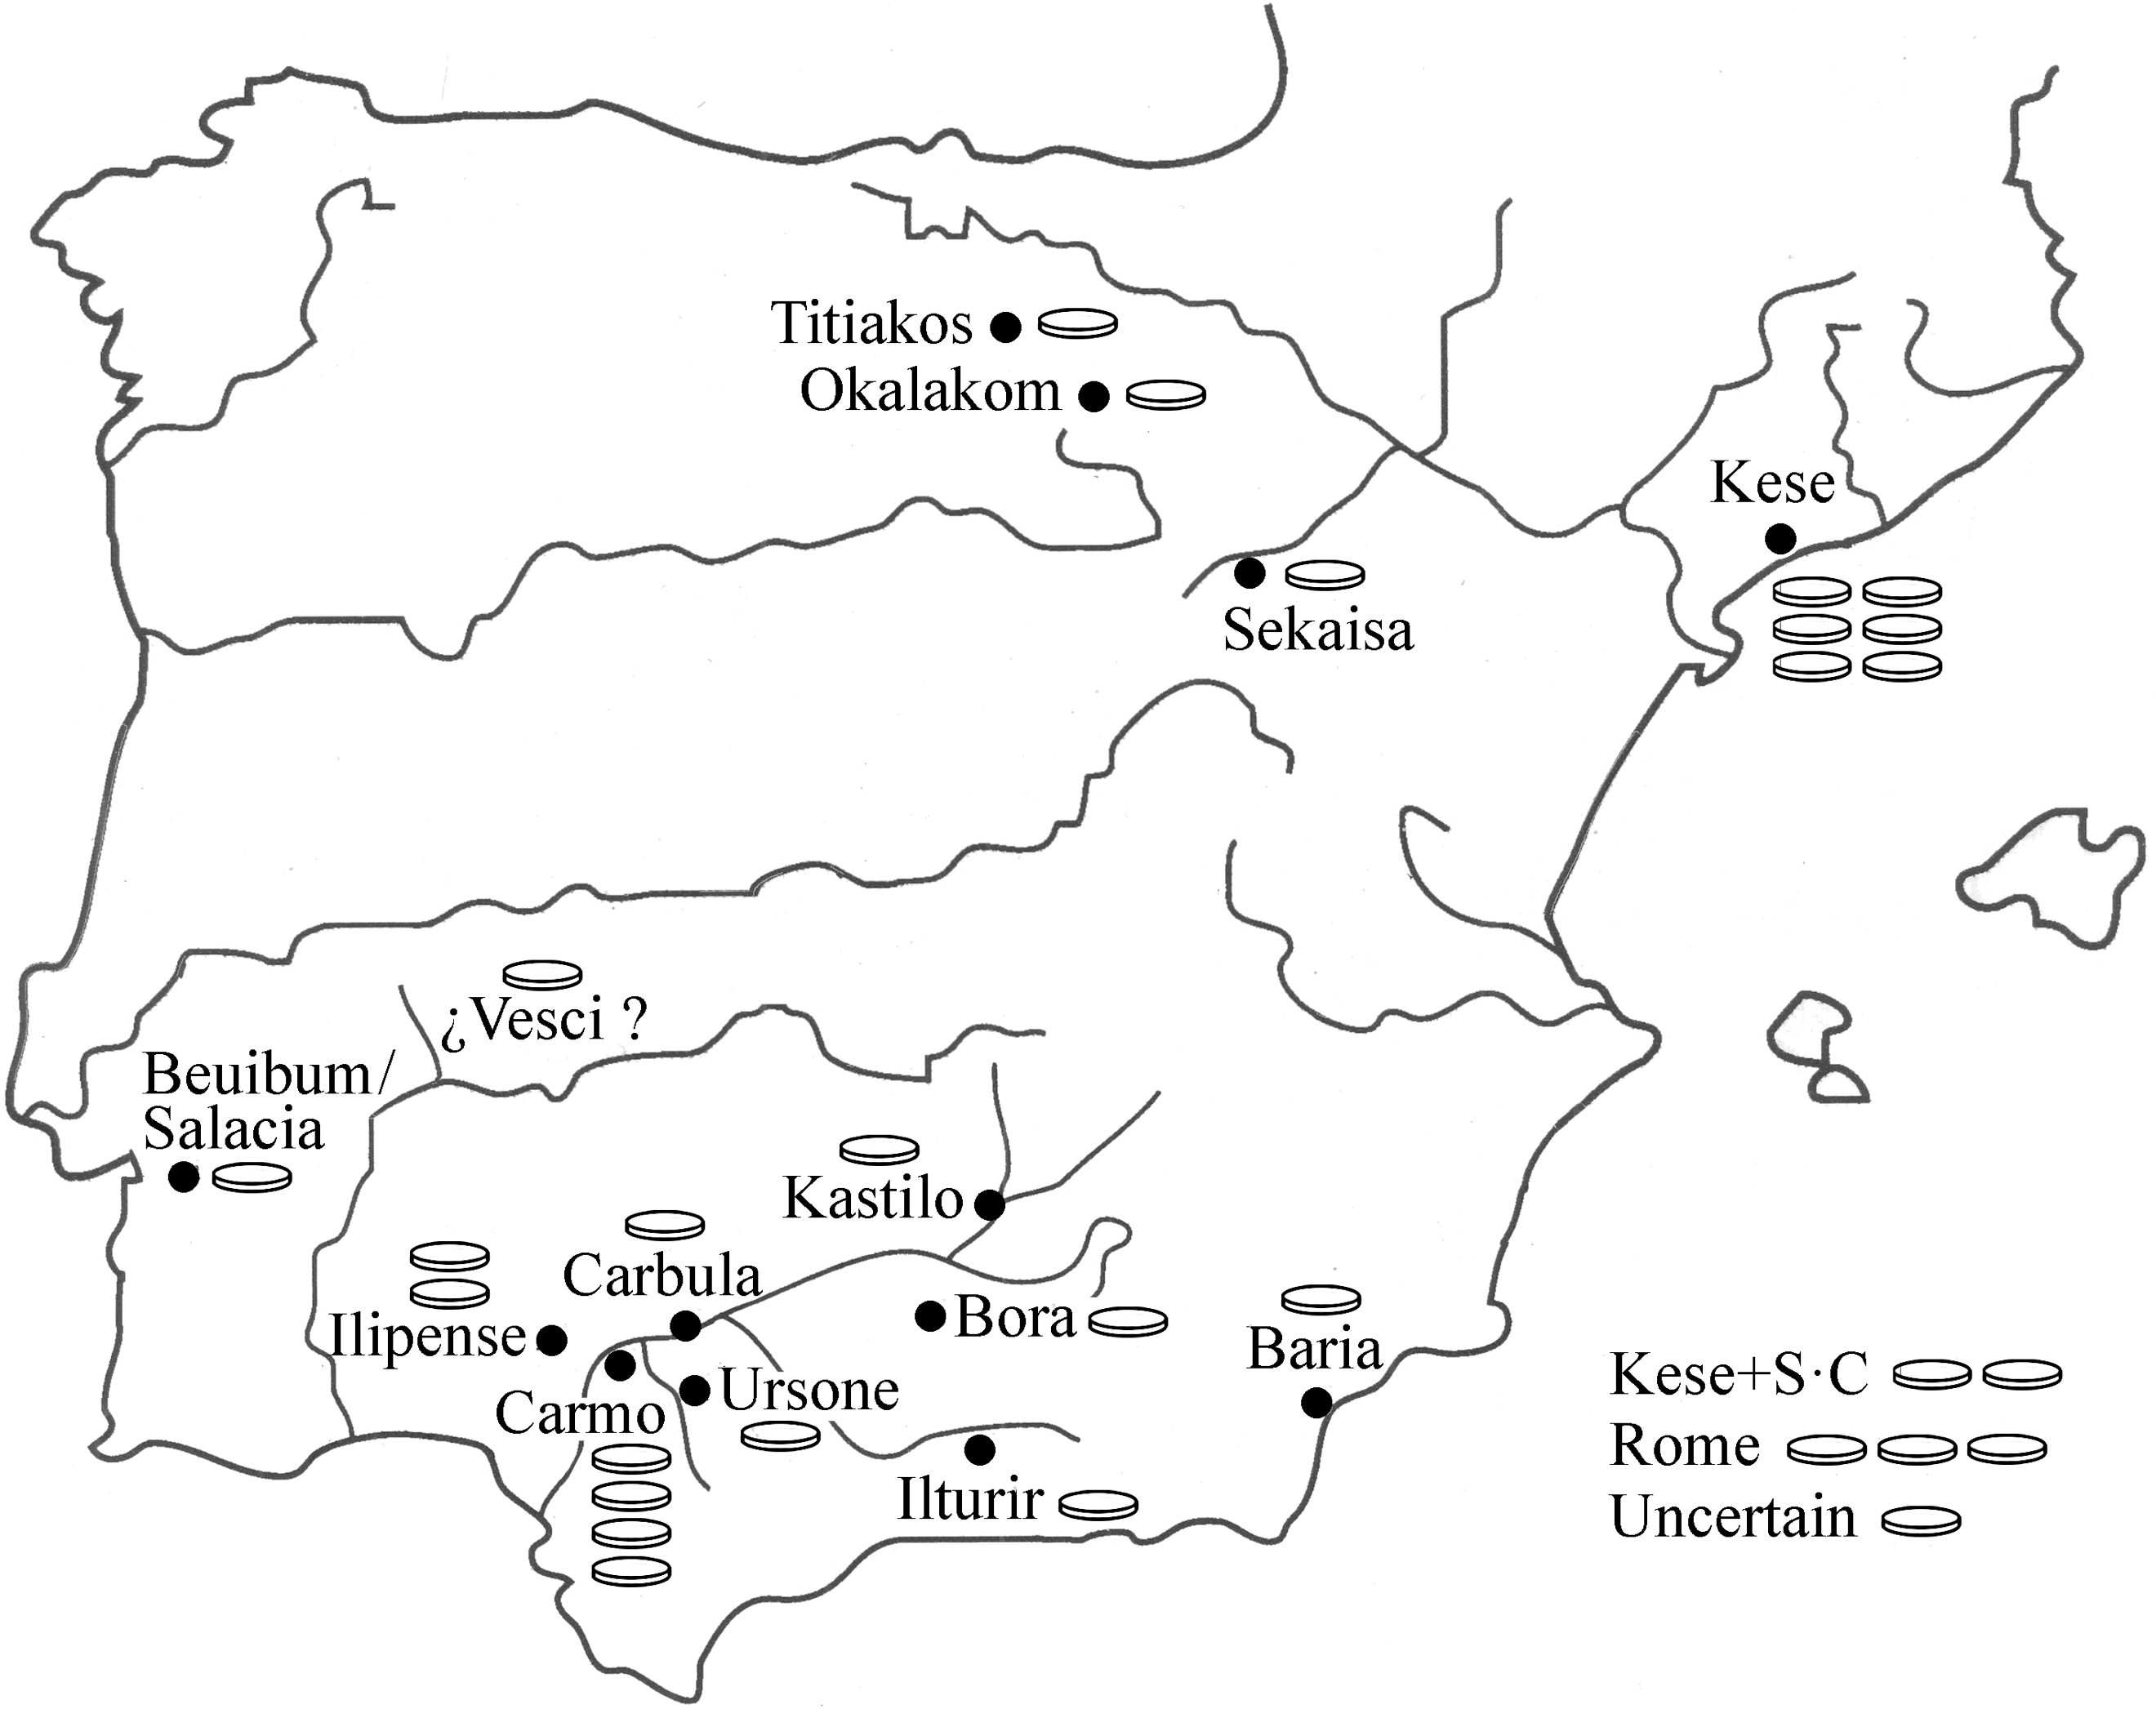

Fig. 2. Coins marked with SS.

A final category comprises lead seals with a variety of types and legends, found on various mines and foundries. Those from the El Centenillo (Cerro de Plomo) mine are best known. In 1911, Hill and Sandars reported that:

‘large numbers have been found in recent times, and which were mostly collected on or near the site, where remains of substantial buildings have been discovered. This was apparently the residence of the managers and overseers, and the site of a factory in Roman times. It is quite possible that the lead was cupelled here, as traces of furnaces have been found, and that the lead seals were used in connexion with the packing and the forwarding of the bullion, just as lead-seals are employed, at the present time, for closing the sacks in which the mineral is sent from the mines to the smelt mills of the district, and especially when it is valuable by reason of its high tenure in silver’.

There may also be other reasons for using such seals. In the few we have been able to examine, we have not seen signs of whatever they were closing, for example, sacks; beating the soft lead down heavily onto textured cloth, one would expect to see some impression of the material of the sack, and least until now, we have not found this. The thickness of what was being closed varies considerably, from few millimetres (pl. 5, 47, 52 & 54, & pl. 6, 58, & 64 & 65) to a few centimetres (pl. 5, 46 & 56, and pl. 6, 57 & 59), so it is likely that only one type of object was being sealed, and the thinner material sealed could not have been bags of ore. Some may not have functioned to close containers, but as markers, even perhaps attached to a label, rather than to a sack. Seals of a number of societates are sometimes found together on a single site or on the adjacent sites, and in such cases, they may have served to show to which societas owned the ore, metal, or objects sealed. Some could also have been markers for accounting or fiscal purposes. In this context, it may be significant that few are damaged, as they would have been, had they been levered or cut off sealed sacks.
An unused seal looked rather like a large tack with a wide head (pl. 4, 40 & 41); the rod was put through a hole, trimmed if necessary, and beaten down, like a rivet. This produced anonymous, blank seals, like pl. 6, 64 and 65; one side could then easily be marked with a simple punch, like pl. 1, 3, pl. 4, 42, and pl. 7, 72, or on both sides, like pl. 5, 45 and 46. In terms of practicality, it would have been more difficult to fix the seal the required stamping both sides at the same time, and this must have often been the case, because if one side had been stamped before the other, and the seal rested on something solid so to stamp the other side, the lead the underside must inevitably have been partially flattened. There is no sign of that dies were mounted in a pair of pincers, because the dies axes do not seem to be regular, as would almost certainly have been, if set in pincers. Whatever was being sealed could not have been not clumsy to handle, because riveting on a two-side seal would have meant placing the blank through the hole in the object, placing this on an anvil, placing the second die on the head of the rod the rod, and smacking in sharply with a hammer.
Claude Domergue published a number of specimens found in various archaeological contexts at El Centenillo (El Cerro del Plomo and La Fabriquilla) and La Carolina (Fuente Espí). The corpus of seal , however, has not expanded much beyond these materials, with—as in the case of the counter-marked coins—the same references are taken up and repeated again and again, and few new pieces appearing from excavations. Some museum holdings have been published—those of the Badajoz museum particularly well—as have those from of societas argentifodinarum Ilucronensium from the Coto Fortuna mine in the coastal Sierra Mazzarón.
All told, the published seals are few and of few types; we accordingly carried out an extensive search of Internet sales in Spain, and were able to identify only two groups: parcel α, which reached the market by 2013, and parcel β by at least 2015; since the parcels share types, we think that they were found on a single site, probably by a single detectorist. We call this ‘the Córdoba block’, as parcel α was sold there, and illustrate it from pl. 4, 42, to pl. 6, 65. We also searched collectors’ discussion forums and found a single seal (pl. 7, 72), which is the only known seal inscribed C·C·S. For comparability and completeness, we also illustrate a number of seals from various sites: seals marked S·C (pl. 1, 3–12, pl. 5, 48–50, and 66–68); seals marked S·BA and S·B·A (pl. 8, 73–76); seals of the societas argentifodinarum Ilucronensium from Cabezo del Castillo (Coto Fortuna) (pl. 8, 77 & 78); a seal marked S·A·B/BA from Fuente Espí (La Carolina) (pl. 8, 79); and seals illustrated in CMP, of which we have no other trace (pl. 8, 80 & 81). Appendix 2 lists all significant varieties of seals, with relevant find-sites, that we know of.
In addition to the bucket with SS inscribed by a series of points from the Santa Barbara mine at Posadas, García Romero reports that a seal marked SS was found there, but without reference or illustration; we know of no other. The Córdoba block is otherwise the first evidence of seals of the societas Sisaponensis (pl. 4, 42 – pl. 5, 47); 42 carries SS in relief, but all the rest are made with one or two blows of an S or Ƨ punch, exactly as the coins were countermarked, but the punches used on seals were larger than those used on coins. This suggests that coins and the seals are of a similar date, and, if not, considerable technical continuity over time.

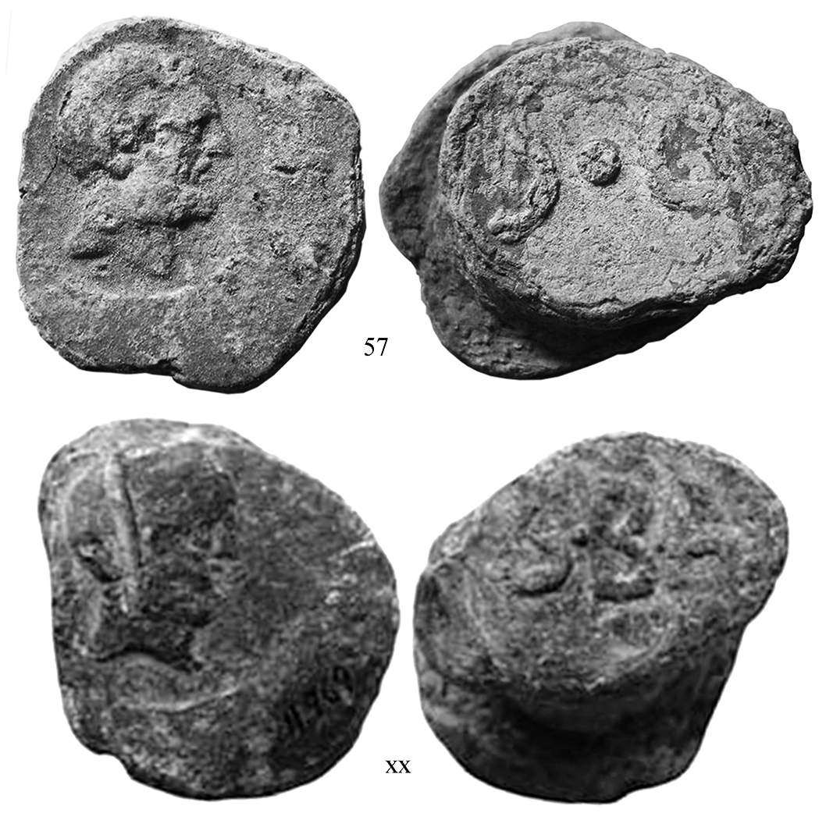
Fig. 3. Similar dies used by SS and S·BA (150%)

The Córdoba block includes seals marked S·C, but for pl. 6, 48 and 49, it is not possible to say whether they are single- or double-sided, and what might have been on a second side, because of damage. Domergue reported three S·C seals from La Canaleja (Santa Eufemia, Córdoba), one with a male head, but this seems to have been beardless, whereas pl. 5, 50, and pl. 7, 66–68) have a bearded head of Hercules on one side and S·C on the other. A Hercules of very similar style, on a seal the Badajoz Museum from Azuaga (Badajoz)—probably the work of the same engraver—is paired instead with S·BA (fig. 3); here it appears that a single workshop worked for more than one societas, perhaps in Corduba, the main city of the region.
Another ‘pictorial’ group of seals has images on both sides, but no societas legend; each type uses a number of dies, from which it appears that these are not private, one-off pairs of seal-dies, but that they were produced in numbers for wide use. The bull’s head/Apollo type (pl. 5, 51, and pl. 7, 69–71) was published by a drawing in CMP, but we had seen no actual specimens, before finding the Córdoba block. The style and imagery is close to that of some of the Italo-Baetican grandes plomos monetiformes, in particular the Apollo head on PLO 75, and the bull’s head on PLO 43–55 (fig. 4). A specimen of PLO 75 was found at Cerro Muriano, as were specimens of PLO 44 at El Maderero and Posadas. Recent iconographical analysis of the Italo-Baetican types confirms that plomos are directly linked to the mines or mining, but they were current in the same area, and the same culture and imagery. The Italo-Baetican types, on which the classification of the catalogue in PLO is based, are a phenomenon of the second and first centuries, which would seem to date the pictorial group to this time, probably the second half of the first century.
In Trade, the isotopic character of the lead of a specimen of PLO 75 (B11, which we now know was also part of parcel α) was analysed and described as of mixed origins, with an isotopic distribution ‘strung out along an axis that runs from ores from the Sierra Morena (in particular, those of Linares, Ossa Morena and the Alcudia Valley) to ores from Cartagena-Mazarrón. Such a distribution would be compatible with mixtures with varying percentages of the lead from these two areas’. Five other specimens of the bull’s head group (B6, B7, B8, B9, and B10) were also analysed: three were of the same mixed lead, and two of lead from Cartagena-Mazarrón ores; like B11, they all contained more than 0.01% tin, that is, more than could have derived from these ore bodies, and which must result from smelting scrap that contained solder. It is interesting that lead from the coastal mines around Carthago Nova seems to have reached as cities of Baetica, when local lead was also usually available. No comparable information on the lead used in the seals is yet available.
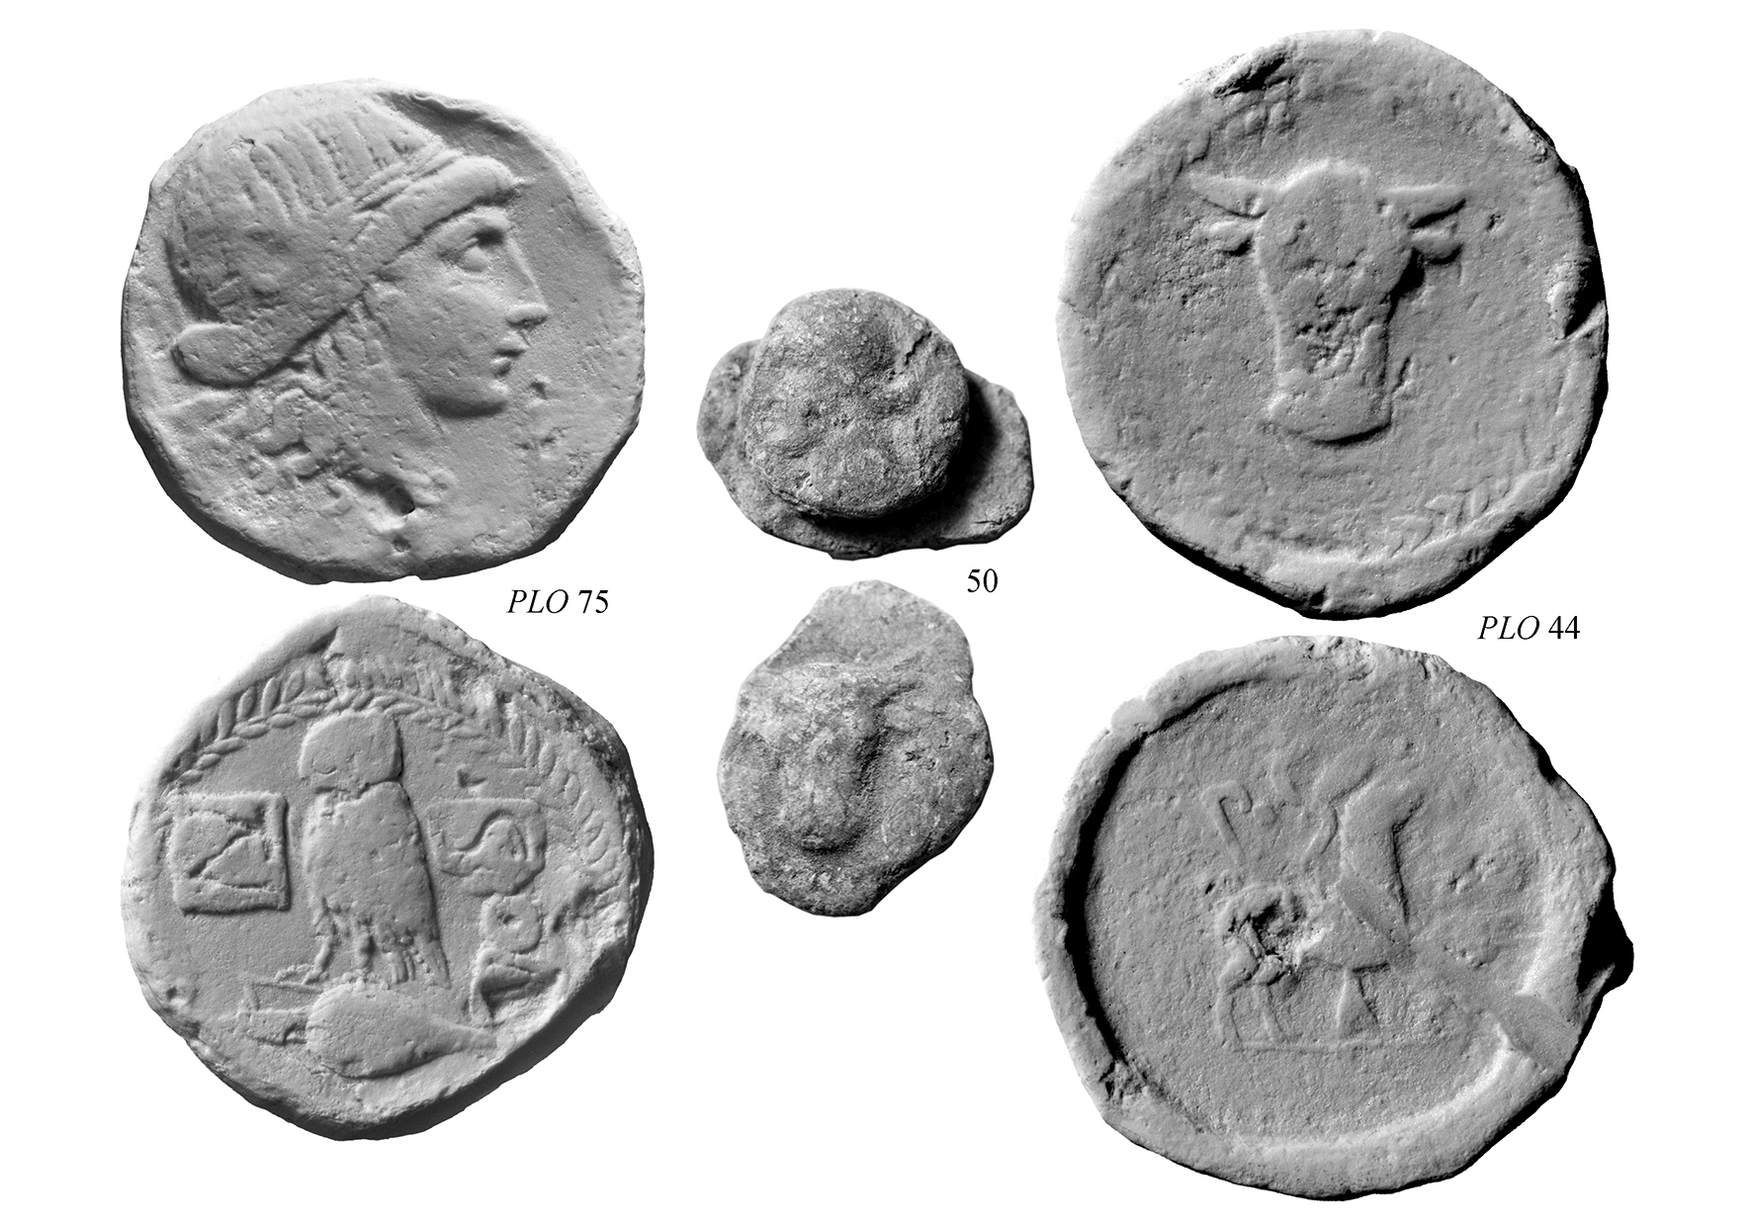
Fig. 4. The pictorial group seals and the Italo-Baetican imagery (100%)

The largest number of seals of any type in the Córdoba block pair a shorthaired, beardless male head on one side, and a head of Apollo on the other (pl. 5, 52 – pl. 6, 58). García-Romero reports a seal with head like that on PLO 42 from El Maderero mine, but again with neither description, nor illustration: it seems more likely that the head was that of this group of seals.

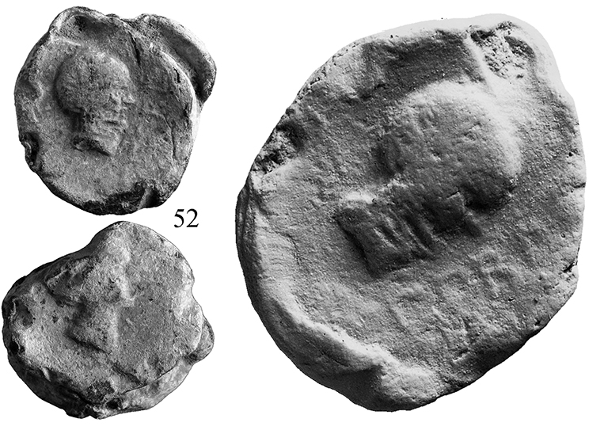
Fig. 5. The legend, CORD[uba]

On 52, it is possible to read CORD(uba). There has, in the past, been considerable debate as to whether S·C should be expanded to societas Castulonensis or societas Cordubensi
BARTOLOME, THIS IS WHERE I SUGGEST WE INTRODUCE A DISCUSSION OF WHAT S·C MEANS, AND THE IMPLICATIONS FOR THE HISTORY OF CORDUBA AND THE ADMINSTRATIVE HISTORY OF THE REGION.
My Comments are:
- I am not convinced that the ‘pictorial group’ in which we have the legend CORD, is made by the same societas as the S·C group. They may be two entirely separate entities. The reference to a servitude over a road from Corduba to Sisapo seems to me to be a possible support for reading societas Castulonensis, but I have not tried to understand this in any detail, and may be wrong.
- Is it possible that, in addition to the societates, Corduba exploited the mine in its own name? A pointer to this being possible may be fact that one ingot (Domergue 1990, p. 257, no. 1026) was signed NOVA CARTHAGO.
- Another possibility is that the CORD seal was used for fiscal purposes, marking something that was a part due to the city, or for which payment need to be made.
- A further question is whether S·C refers to the same thing at different times and in different places. I notice that the El Centenillo S·C seals are the only group where one has numbers.

The Córdoba group includes four seals that do not seem to denote societates (pl. 6, 60–64); we have not seen such seals reporting from elsewhere, but this may be due simply to the fact that they cannot be easily ascribed to a societas. A number of questions arise. Do these inscriptions relate to some function within the management of a mine? Are they perhaps the mark of contractors working for the societates? It is interesting to note that they may show secondary modification: Pl. 6, 61, seems to have been marked by a group of points perhaps rough lettering; and a large triangular point has been driven the number of times into both faces pl. 6, 63. There are also two uninscribed seals (pl. 6, 64 & 65).
Apart from the seals, the other probable components parcel α of the Córduba block are, as noted above, the grande plomo B11 (PLO 74) as well as two lead asses of o.ka.na.ka from an uncertain mint—the southernmost mint to have used an Iberian legend—which García-Bellido and Blázquez say imitate the types of Carbula (Almodóvar del Rio), and which they date to the second half of the second century.
All the evidence reviewed here points to the Córdoba block probably originating from one of the mines on the Posadas region.

FROM THE MINING AREA OF THE SIERRA MORENA TO THE PORTS OF THE SOUTH-EASTERN COAST

Trade concentrated on contacts between Carthago Nova and the coastal Sierra Cartagena and Sierra Mazarrón area, and to a lesser extent, contacts with the interior by way of the river Baetis. It noted, however, that Malaka is the best attested mint among coins of Ulterior from the river Garigliano at Minturnae (tab. 1).

 | No. | % |  |  | No. | %
Punic legends |  |  |  | Various
Albatha | 1 | 1.4 |  | Corduba | 3 | 4.2
Gadir | 3 | 4.2 |  | Carteia | 2 | 2.8
Malaka | 7 | 9.9 |  | Illici | 1 | 1.4
Ituci | 1 | 1.4 |  | Irippo | 2 | 2.9
Latin legends |  |  |  | Carthago Nova | 1 | 1.4
Ilipense | 1 | 1.4 |  | Plomos, PLO 16 & 24 | 2 | 2.8
Lastigi | 1 | 1.4 |  | Andalusian semis imitation | 1 | 1.4
Iberian legends |  |  |  | Total | 31 | 43.7
Ikalusken | 1 | 1.4
Kastilo/Castulo | 3 | 4.2
Obulco | 1 | 1.4

Tab 1. Coins of Ulterior among the 71 Spanish coins at Minturnae

It dominated the Alborán Sea, the westernmost portion of the Mediterranean, which lies between the Iberian Peninsula and North Africa; the Strait of Gibraltar, at its westmost point, leads into the Atlantic. Malaga, with its proximity to North Africa and Rusaddir (Melilla), was the most important port of south-eastern Hispania, as shown in some important though late geographies, such as the Antonine Itinerary, which lists it as the main destination and end point of the most trafficked roads of southern Hispania that linked it, in particular, to Castulo and Gadir. The importance it gives to the road between Castulo and Malaka (It. Ant. 404,7 Item a Castulone Malacam) raises the possibility that this was a major route for the export of Baetican metals through the ports of Abdera (Adra) and Portus Magnus (Almería). The Itinerary specifically mentions Albatha (Abla), which made an issue of coins struck over Ebusus, Campo’s group XIX, one of which is among the over 3,000 non-Roman coins from the river at Minturnae in the Liri database; it probably began to be struck c. 80. A further sign of contacts between Ebusus and this area lies in the first century imitations of Ebusus from southern Ulterior, which may also be imitating Baria. Road contacts between Albatha and Malaka were however not sufficiently well developed to make it likely that the coin from Albatha at Minturnae left through that port.
Most of the coins of Malaka at Minturnae date to the first century, and contacts between Malaka and Ebusus seem not to have been especially strong at this time; a study of 832 sporadic coin finds in Ibiza shows that Malaka accounted for eight of 25 foreign coins in second century, but only one of 11 in the first; nor did the coins of Malaka reach southern France: Feugère and Py do not report a single example. This, as well as fact that coins of the Pompeian pseudo-mint have not been found in Ibiza, coupled with the rarity of Ebusus XIX in Italy, compared to its relative frequency in southern France, points to direct trade between Campania and Ulterior that did not transit Ebusus.
These poor road connections would have made the export of the minerals of the Sierra Morena though Albatha to the coast costly. Other old itineraries describe the better roads that connected Malaka first to Corduba and then on to Castulo, so providing a route to the sea for the two large mining districts of the Sierra Morena. This has been proposed before, including because Malaka uses of the image of the metal working god, Hephaistos-Chusor, on its coins. Numismatic and ceramic data underline the importance of the road, at least until the time of Augustus. The evidence of the wide spread of the coins of Malaka, and the presence of coins of the interior—particularly of Kastilo/Castulo—along this route, is reinforced by finds of Italian oil amphorae, of Brindisi, and particularly early Tripolitan, types; these are commonest at Malaka and on La Loba mine.
There are two other major routes by which metals from the Sierra Morena could have been exported: down the Baetis and out by sea through Hispalis and Gadir, and north up the Via Heraclea and out through Carthago Nova. Strabo (III,2,3), at the end of the first century, noted that the Baetis had become navigable as high as Castulo, probably following works under Augustus; from this time, the river became the main export route, and Domergue has analysed, on the basis of marks on ingots, the steps by which lead ingots were collected, traded and shipped in the first century AD. This only became the preferred route, then, after the high period of Minturnaean trade with southern Hispania, in the second and first centuries. The fact that the prolific mint, Gadir, is not more common at Minturnae is probably evidence of this, and the few coins of Gadir that Feugère and Py report from southern France are all of an earlier period (c. 200–150).
As Melchor Gil notes, while it has often been thought that metals from the interior were brought out through Carthago Nova—after a voyage of some 303 Roman miles on donkey- or mule-back, or by ox-cart—this route was poor and hardly practicable until it reached its final shape in 8, as shown by the milestones that have been preserved. Nonetheless, the via Herculea was clearly a well-trafficked artery, as is clear from the plomos that travelled up it from the mining region, which have been documented from near Śaitabi, modern Xàtiva, between Carthago Nova and Valentia. There is only one coin of Carthago Nova at Minturnae, despite the contacts that were documented in Trade, by this was not a very prolific mint in the Republican period.

CONCLUSIONS
DO EITHER OF YOU HAVE ANY SUGGESTIONS FOR THIS SECTION?
One thing that has come to my mind is how contemporary most of the phenomena we have investigated seem to be: the use of pointed-in inscriptions on both coins and buckets, the use of seals in a large number of mines, and the use of punched-in letters S on both coins and seals. If there were no other evidence, particularly the archaeological evidence from Domergue’s excavations at El Centenillo, I would be inclined to date all of these phenomena to the first century, more probably BC. Comments and suggestions very welcome.
The societates publicanorum of the interior seem to have had a wide administrative authority; for example, in the second-half of the first century BC managed and had a servitude over a road 14 feet wide connecting it to Corduba. Their reach and power is clear from their many and widespread inscriptions, all of the form S·... Fig. 1 shows the find-spots of objects with these marks. first,
Note: Posadas is a key site to develop the idea of several societates working/collaborating in some way in the same mines.

APPENDIX 1

KEY TO THE PLATES

Plate 1

1 & 2 C·SAM / IR: The two best preserved examples of Stannard, Sinner, and Ferrante 2019, pp. 121 & pl. 26, no. M19: Liri 23.044 & 27.065

Lead seals, S·C and variants

Side 1. S·C on a square punch.
Side 2. Blank.
3 35/43? mm From El Centenillo mine, Museo Arqueológico de Linares (Jaén); image from Arboledas Martínez 2007, p. 283, fig. 79
Side 1. S·C.
Side 2. ª·C.
4 28/24 mm 150º 55.6 g From Azuaga; Antolinos Marín and Díaz Ariño 2015, pp. 218, no. 7, & 216 & 217, figs. 1 & 2, g; Badajoz Museum, inv. 11.968

Side 1. [S]·Ͻ.
Side 2. S·C.
5 28/21 mm 30º 36.0 g From Azuaga; Antolinos Marín and Díaz Ariño 2015, pp. 218, no. 8, & 216 & 217, figs 1 & 2, h; Badajoz Museum, inv. 11.974

Side 1 S·C.
Side 2. Blank.
6 20/28 mm From Fuente Espí (La Carolina, Jaén); Antolinos Marín and Díaz Ariño 2015, pp. 220, c

Side 1. S·C.
Side 2. Blank.
7 24/25 mm From Fuente Espí (La Carolina, Jaén); Antolinos Marín and Díaz Ariño 2015, pp. 220, d

Side 1. Ͻ·ª.
Side 2. Blank.
8 32/? mm From Fuente Espí (La Carolina, Jaén); Antolinos Marín and Díaz Ariño 2015, pp. 220, b

Side 1. Male head right.
Side 2. S·C.
9 20/? mm From El Centenillo (Cerro de Plomo); Domergue 1990, pl. XXX, no. 3

Side 1.
Side 2.
10 30/27mm From El Centenillo (Cerro de Plomo); Martínez 2007, p. 286, fig. 82; Museo Arqueológico de Linares, Jaén; drawing from Domergue 1990, p. 561, fig. 5, no. 5

Side 1.
Side 2.
11 19/23 mm From Fuente Espí (La Carolina, Jaén); Domergue 1990, p. 561, fig. 5, no. 8

Side 1. S·C
Side 2. Blank.
12 Size? From Los Pinares (Cerro Muriano, Córdoba); Rodríguez Pérez and Penco Valenzuela 2019, pp. 240, fig. 2; Museo del Cobre, Obejo, Córdoba

Obv. ª C; stars below and inside C; a small triangle between the two letters.
Rev. Blank.
13 14 mm 1.17g Ruegg 1995, pp. 149, no. 9.10 = Overbeck 1998, pp. 121, no. 14

Plate 2

COINS COUNTER-MARKED BY THE MINES
 | CNH /  ACIP | Value | Date | Reference
SC over Kese
 | / ? | / | 2nd-1st c. | - https://servimg.com/view/19542888/2986
 |  |  |  | - https://servimg.com/view/19542888/3098
14 | 23 / 1129 | Half | Early 2nd c. | - https://servimg.com/view/19542888/7251
 |  |  |  | - www.tesorillo.com
 |  |  |  | - https://www.tesorillo.com/oca/iberos/iberos.htm (pueblos ibéricos 10)
 |  |  |  | - Datzira i Soler k-1
 |  |  |  | - Datzira i Soler k-2
15 | 55 / 1164 | Unit | 1st half 2nd c. | - Datzira i Soler k-3; Aureo & Calico, Auction 213-1, 386
 |  |  |  | - https://www.tesorillo.com/oca/iberos/iberos.htm (pueblos ibéricos 8)
 | 62–63 / 1173–1174 | Unit | 2nd half 2nd c. | - García Bellido & Ripollès, 1998: p. 204
16 | 63 / 1173 | Unit | 2nd half 2nd c. | - Jésus VicoAuction 151, 221
 | 67 / 1178 | Half | 2nd half 2nd c. | - Jésus VicoAuction 149, 287
 | 69 / 1180 | Half | 2nd half 2nd c. | - Datzira i Soler k-4
 |  |  |  | - Datzira i Soler k-5
 |  |  |  | - Hill and Sandars 1911: pl. XIV, 4
 |  |  |  | - Cores collection, unpublished
17 | 82 / 1194 | Unit | 2nd half 2nd c. | - eBay.es, s 2014; https://www.tesorillo.com/articulos/contramarcas/galeria4.htm
 |  |  |  | - Datzira i Soler k-6; Cores Collection 1292
 |  |  |  | - Datzira I Soler k-7; Cores collection, unpublished
 |  |  |  | - Cores collection, unpublished
 |  |  |  | - Cores collection, unpublished
 | 83 / 1195 | Half | 2nd half 2nd c. | - Jésus VicoAuction 149, 298
 | 85 / 1197 | Unit | 2nd half 2nd c. | - Aureo & Calicó Auction 340, 2178
18 | 86 / 1198 | Half | 2nd half 2nd c. | - Jésus VicoAuction 149, 302
 |  |  |  | - http://www.wikimoneda.com/fiche.php?id=6295
 |  |  |  | - Datzira i Soler k-8
19 |  |  |  | - Cores collection, unpublished
 | 69–86 / 1180–1198 | Half | 2nd half 2nd c. | - Cores collection, unpublished
 | ? | Unit | 2nd-1st c. | - Ruiz Taboada and Azcárraga Cámara 2016: fig. 8
 |  |  |  | - Hill and Sandars 1911: Pl. XIV, no. 3
 |  |  |  | - Cores collection, unpublished
 |  |  |  | - Cores collection, unpublished
 |  |  |  | - Cores collection, unpublished
 |  |  |  | - Cores collection, unpublished
 |  |  |  | - Cores collection, unpublished
SC over Abariltur
 | 6 / 2067 | Half | 2nd c. | - Datzira i Soler A-1
SC over kaśtilo
20 | 40 / 2144 | Unit | Late 2nd c | - https://www.tesorillo.com/articulos/contramarcas/galeria2.htm
SC & SS over Kese
21 | 82 / 1194 | Unit | 2nd half 2nd c. | - Jésus VicoAuction 149, 297
22 |  |  |  | - https://www.tesorillo.com/oca/iberos/iberos.htm (pueblos ibéricos 13)
SS over Kese
 | 67 / 178 | Unit | 2nd-1st c. | - Jesús Vico, Subasta 149, 284 = Cores collection, 1178
 | ? | Unit | 2nd-1st c. | - https://en.todocoleccion.net/coins-iberian/as-cese-resello-doble-s-societas-sisaponensis-453-16-9-m~x186252392#sobre_el_lote
 | ? | Unit | 2nd-1st c. | - Cores collection, unpublished
 | ? | Unit | 2nd-1st c. | - Cores collection, unpublished
 | 76 / 1187 | Unit | 2nd half 2nd | - https://www.tesorillo.com/articulos/contramarcas/galeria4.htm
23 | 82 / 1194 | Unit | 2nd half 2nd c. | - eBay.es, November 2014; https://www.tesorillo.com/articulos/contramarcas/galeria4.htm
SS over Baria
24 | 88 / 628 | Double | Late 3rd c. | - https://www.tesorillo.com/articulos/contramarcas/galeria1.htm
Plate 3

SS over Vesci
25 | 1 / 692 | Unit | Late 2nd c. | - Cores collection 713
SS over Beuibum/Salacia? (cross type)
26 | p. 406, 1 / 992 | Half | 1st c. | - eBay.es marzo 2018; Cores collection p. 311–312; https://www.tesorillo.com/articulos/contramarcas/galeria5.htm
SS over śekaisa
27 | 40 / 1560 | Unit | 1st half 1st c. | - https://www.tesorillo.com/articulos/contramarcas/galeria6.htm
SS over Okalakom
28 | 2 / 1864 | Unit | Early 1st c. | - José A. Herrero, Numismatic Auction 8 Ferruary 2018, 2038
SS over titiakoś
29 | 11 / 1897? | Unit | Early 1st c. | - https://www.tesorillo.com/articulos/contramarcas/galeria6.htm
SS over kaśtilo
30 | 37 / 2141 | Unit | Mid 2nd c. | - eBay.es October 2017; https://www.tesorillo.com/articulos/contramarcas/galeria2.htm
SSE over iltuŕiŕ
31 | 2 / 2286 | Unit | Mid. 2nd c. | - José A. Herrero, Numismatic Auction, 2026; https://www.tesorillo.com/articulos/contramarcas/galeria4.htm
SS S over Bora
32 | 1 / 2309 | Unit | 1st half 2nd c. | - Jésus Vico Auction 156, 172; Cores collection, 3625
SS over Carbula
33 | 2 / 2312 | Unit | Early 2nd c. | - https://www.tesorillo.com/articulos/contramarcas/galeria2.htm
SS over Ursone
34 | 1 / 2323 | Unit | Early 2nd c. | - M. Herrera & S. Llach Auction 67, 2365; https://www.tesorillo.com/articulos/contramarcas/galeria6.htm
Plate 4

SS over Ilipense
35 | 4 / 2335? | Unit | 1st half 2nd c. | - Jésus Vico 155,136, Cores collection 3229
 |  |  |  | - Aureo & Calico Auction 307 (II), 3431
SS over Carmo
36 | 2 / 2382 | Unit | 2nd half 2nd c. | - https://www.tesorillo.com/articulos/contramarcas/galeria2.htm
 | 9 / 2389 | Unit | Mid. 2nd c. | - https://www.tesorillo.com/articulos/contramarcas/galeria2.htm
 | 23 / 2404? | Unit | 2nd half 2nd c. | - https://www.tesorillo.com/articulos/contramarcas/galeria2.htm
37 | 24/2405? | Unit | 1nd half 1st c. | - Instituto Valencia of Don Juan, 2172
SS over Roma
38 | RRC 182 / 2 | As | 169-158 | - eBay, February 2014; https://www.tesorillo.com/articulos/contramarcas/galeria5.htm
 | RRC ? | As | c. 180-145? | - https://www.tesorillo.com/articulos/contramarcas/galeria5.htm
 |  |  |  | - eBay Spain December 2020, 154232322140
SS over uncertain mint
 | – | Unit | ? | - https://en.todocoleccion.net/coins-iberian/as-resello-doble-s-societas-sisaponensis~x50872171#sobre_el_lote

***

40 & 41 Two unused seals, shaped like large flat-headed nails; Antolinos Marín and Diaz Ariño 2015, p. 216, fig. 1, i & j. 1 = Museo de Badajoz, inv. 11.962 & 11.970

Lead seals: the Córdoba block, Parcel α

Side 1. SS in relief.
Side 2. Blank.
42 Size ? Todocoleción Spain, 8 February 2015, 46497991

Side 1. ·S·S punched in.
Side 2. Blank.
43 Size ? Todocoleción Spain, 2 February 2015, 46496144

Side 1. SS punched in.
Side 2. Blank.
44 Size? Todocoleción Spain, 8 February 2015, 46496192

Side 1. ª punched in.
Side 2. ª punched in.
45 Size? Todocoleción Spain, 20 February 2015, 46495951

Side 1. ª punched in.
Side 2. ª punched in.
46 22/17 mm 330º 26.44 g Todocoleción Spain, 11 December 2020, 46497795

Side 1. ª punched in.
Side 2. Spike merely beaten down.
47 22/17 mm 330º 26.44 g Todocoleción Spain, 11 December 2020

Side 1. S·C.
Side 2. Blank or obliterated.
48 Size? Todocoleción Spain, 8 February 2016, 46497711

Side 1. S·C.
Side 2. Unclear
49 Size? Todocoleción Spain, 16 July, 2018, 46498569

Side 1. Bearded male head, perhaps Hercules, right.
Side 2. S·C.
50 22/22 (?) mm 270º Todocoleción Spain, 8 February 2015, 46497772
see parcel β, pl. 6, 66–78 and Badajoz Museum, no. 76

Side 1. Bull or cow’s head facing.
Side 2. Laureate head of Apollo left.
51 29/20? mm 300º Todocoleción Spain, 26 February 2019, 46497991; CPM, pp. 25, 14, & 26, lam. 5, 1d; see parcel β, pl. 6, 69–71

Side 1. Beardless male head right: CORD (?) up to right.
Side 2. Laureate head of Apollo right.
52 23/21 mm 210º 20.94 g Todocoleción Spain, 11 December 2020

Side 1. Same, but no visible legend.
Side 2. Same.
53 19/15 mm Todocoleción Spain, 26 February 2019, 46496172
54 18/24 mm 210º 21.03 g Todocoleción Spain, 11 December 2020
55 mm 210º g Todocoleción Spain, 25 December 2020, 46496009
56 mm 270º g Todocoleción Spain, 25 December 2020, 46498350
57 mm º g Todocoleción Spain, 25 December 2020, 46495998

Side 1. Same.
Side 2. Same, but head of Apollo left.
58 mm º g Todocoleción Spain, 25 December 2020, 46497669

Side 1. Same.
Side 2. Letters?
59 mm º g Todocoleción Spain, 25 December 2020, 46495977

Side 1. Monogram formed of CAEB or R.
Side 2. Blank.
60 Size? Todocoleción Spain, 20 February 2015, 46497684

Side 1. PR on oblong punch.
Side 2. Blank.
61 Size? Todocoleción Spain, 30 October 2017, 46497808

Side 1. AΘ
Side 2. Blank; small dots seem to have been punched into the surface.
62 Size? Todocoleción Spain, 31 October 2017, 46496133

Side 1. Uncertain design. Triangular punch-marks.
Side 2. Uncertain design. Triangular punch-marks.
63 Size? Todocoleción Spain, 31 October 2017, 46497695

Side 1. Blank, a single indented line across the middle.
Side 2. Blank.
64 Size? Todocoleción Spain, 25 December 2020, 46498461

Side 1. Blank.
Side 2. Blank.
65 Size? Todocoleción Spain, 25 December 2020, 46498361

Lead seals: the Córdoba block, Parcel β

Side 1. Bearded male head, perhaps Hercules, right.
Side 2. S·C.
66 33/25? mm 240º Todocoleción Spain, 17 July 2013, 36622170; see parcel α, pl. 5, 50 and Badajoz Museum, pl. 7, 76
67 41/25? mm 240º 41.6 g Todocoleción Spain, 23 July 2013, 36622170
68 34/33? mm Todocoleción Spain, 23 July 2013, 38301530;

Side 1. Bull or cow’s head facing.
Side 2. Laureate head of Apollo left
69 20/18? mm 30º Todocoleción Spain, 14 November 2014, 46181230; CPM, pp. 25, 14, & 26, lam. 5, 1d; see parcel α, pl. 5, 51
70 34/20? mm 270º Todocoleción Spain, 31 October 2014, 45970892
71 29/29? mm 210º 33.0 g Todocoleción Spain, 17 July 2013, 36622170; obverse uncertain

A lead seal from a collectors’ forum

Side 1. C·S·S on an oblong punch.
Side 2. Blank
72 25/25 mm https://www.imperio-numismatico.com/t93161-precinto-de-plomo-romano-con-letras, 29 January 2015

A lead seal from Santa Barbara mine

Side 1. Beardless male head right.
Side 2. S·BA.
73 Size? From Santa Bárbara (Fuente Obejuna), Córdoba; p. 218, fig. 3 = Domergue 1990.pl. XXX, 4; ‘from the Hallemans collection’

Lead seals from the Badajoz Museum (Antolinos Marín and Díaz Ariño 2015)

Side 1. S·B·A/
Side 2. Blank.
74 22/17 mm 19.2 g From Castuera; p. 214–215, no. 1

Side 1. S·BA.
Side 2. Blank.
75 21/19 mm 23.7 g From Azuaga; p. 215, no. 2, & pp. 216 & 217, figs.1 & 2, d; inv. 11.927

SSide 1. Bearded male head right.
Side 2. S·BA.
76 23/21 mm 210º 38.3 g From Azuaga; p. 217, no. 6, & pp. 216 & 217, figs.1 & 2, f; inv. 11.969

Lead seals of the Societas Argentifodinarum Ilucronensium at Marrazón
(Antolinos et al., 2013)

Side 1. S·A·I
Side 2. Blank.
77 18/16 mm From Coto Fortuna (Murcia); Antolinos Marín and Díaz Ariño 2015, pp. 220, fig. 4, e
Side 1. S·A·I
Side 2. Blank.
78 19/14 mm From Coto Fortuna (Murcia); Antolinos Marín and Díaz Ariño 2015, pp. 220, fig. 4, f

A lead seal of the S·A·B/AB

Side 1. S·A·B
Side 2. A·B.
79 19/14 mm From Fuente Espí (La Carolina, Jaén); Díaz Ariño and Antolinos Marín 2013, pp. 113, fg. 22, no. 8; La Carolina Museum, inv. 1157

Seals that we have not seen

Side 1. Male head right.
Side 2. Like obverse.
80 Size? CPM, p. 26, pl. 5, 1b

Side 1. Gorgon’s head facing.
Side 2. Stylised boat, as on the asses of Brutóbriga.
81 Size? CPM, p. 26, pl. 5, 1c

Spain, Albatha (modern Abla, Almería); Blanco Villero and Sáez Bolaño 2008, pp. 14–18; CNH p. 115, no. 3; ACIP p. 148, no. 891l; PLO, no. 66.

Obv. Head of Vulcan, wearing pileus, right, tongs on shoulder; border of dots.
Rev. Bull right; L (= ‘LBT’) in exergue.
15a Æ 26mm 5.39g Liri 0.417 = Milan, M.986.14.118
All these pieces are struck over Ebusus, Campo 1976, group XIX, after c. 80, like $$$ (Liri 35.010)

APPENDIX 2

Provenances of seals of the various societates
Legend & types | Sites | Reference
Societas Cordubensis
S·C/blank & S·C/S·C | Calamón (Posadas, Córdoba) | Luis Arboledas Martínez 2010, pp. 45–46
 | La Canaleja (Santa Eufemia, Córdoba) | Gutiérrez Soler 2010, pp. 44–45
 | El Cerro del Plomo & La Fabriquilla (El Centenillo, Jaén), | Antolinos Marín, Díaz Ariño, and Guillén Riquelme 2013
 | La Carolina Museum | Antolinos Marín, Díaz Ariño, and Guillén Riquelme 2013
 | Los Pinares (Cerro Muriano, Córdoba) | Rodríguez Pérez and Penco Valenzuela 2019, pp. 240, fig. 2
 | Posadas area (Córdoba block) | Pl. 5, 48 & 49
S·C with numerals | El Cerro del Plomo (El Centenillo) & La Carolina (Fuente Espí, Jaén)
Male head right/  S·C | La Canaleja (Santa Eufemia, Córdoba) | Domergue 1971, pp. 351 & 352, fig. 17 bis, a
 | Posadas area (Córdoba block) | Pl. 4, 47 & pl. 6, 69–71
Societas Baetica
S·B·A/blank | Castuera (Badajoz) | Antolinos Marín and Díaz Ariño 2015, pp. 214–215, no. 1
S·BA/blank | Azuaga (Badajoz) | Antolinos Marín and Díaz Ariño 2015, pp. 215, nos. 2–5
Male head right/ S·BA | Santa Bárbara (Fuente Obejuna, Córdoba) | Domergue 1990, pp. pl. XXX, no. 4
S·A·I | Cabezo del Castillo (Coto Fortuna, Mazarrón, Murcia) | Antolinos Marín, Díaz Ariño, and Guillén Riquelme 2013
Societas Sisaponensis
SS | Posadas | García Romero 2002, p. 197
 | Posadas area (Córdoba block) | Pl. 4, 42—47
Societas Argentifodinarum Ilucronensium
S·A·I | Coto Fortuna (Murcia) | Antolinos Marín, Díaz Ariño, and Guillén Riquelme 2013
Societas S·A·B
S·A·B/AB | Fuente Espí (La Carolina, Jaén) | Díaz Ariño and Antolinos Marín 2013, pp. 115 & 113, fig. 223, no. 8
C·S·S
C.S·S | Perhaps the Posadas area | Pl. 6, 72
Pictorial series, including CORB
Male head, CORB/Apollo | Posadas area (Córdoba block) | Pl. 5, 52–59
Bull’s head/Apollo | Madereros (Almodóvar del Rio, Córdoba) | García Romero 2002, p. 296
 | Posadas area (Córdoba block) | Pl. 5, 50
Head similar to PLO 42; other side not mentioned | Madereros (Almodóvar del Rio, Córdoba) | García Romero 2002, pp. 295–296
Illustrated in CMP
Male head/  male head | –  – | P. 26, pl. 5, 1b
Gorgon, stylised boat |  | P. 26, pl. 5, 1c

REFERENCES

Antolinos Marín, Juan Antonio and Díaz Ariño, Borja (2015), 'Los precintos de plomo del Museo de Badajoz y la actividad de las compañías mineras romanas en el sur de Hispania a comienzos de época imperial', Madrider Mitteilungen, 56, 211-231.
Antolinos Marín, Juan Antonio, Díaz Ariño, Borja, and Guillén Riquelme, Mariano Carlos (2013), 'Minería romana en Carthago Nova: el Coto Fortunata (Murcia) y los precintos de plomo de la Societas Argentifodinarum Ilucronensium', Journal of Roman Archaeology, 26, 1, 535-554.
Arboledas Mantínez, Luis, et al. (2017), 'Las minas del Sureste peninsular y de Sierra Morena en el cambio de era', Gerión, 35, No Esp., 875–894.
Arboledas Martínez, Luis (2010), Minería y metalurgia romana en el sur de la Península Ibérica : Sierra Morena oriental (BAR international series 2121; Oxford: Archaeopress).
Arboledas Martínez, Luís (2007), 'Minería y metalurgia romana en el alto Guadalquivir: aproximación desde las fuentes y el registro arqueológico', (Universidad de Granada. Ph.D. thesis).
Blanco Villero, José M. and Sáez Bolaño, José E. (2008), 'Las monedas de Albatha', Numisma, 252, 7–42.
Bostock, Johm and Riley, Henry T. (1857), The natural history of Pliny (Volume 6) (London: Bohn's classical library).
Campo, Marta (1976), Las Monedas de Ebusus (Barcelona).
Campo, Marta and Mora, Bartolomé (1995), Las Monedas de Malaca (Madrid: Museo Casa de la Moneda).
Casariego, Antón, Cores, Gonzalo, and Pliego, Francisco (1987), Catalogo de plomos monetiformes de la Hispania Antigua (Madrid).
Chaves Tristán, Francisca and Otero Morán, Paloma (2002), 'Los hallazgos monetales', in José Maria Blázquez Martínez, Claude Domergue, and Pierre Sillières (eds.), La Loba (Fuenteobejuna, province de Cordoue, Espagne). La Mine et le Village Minier Antiques (Bordeaux), 163–230.
Cortijo Cerezo, Mª Luisa (2008), 'El itinerario de Antonino y la provincia Baetica', Habis, 39, 285–308.
Costa Ribas, Benjamí (2007), 'Punic Ibiza under the Roman Republic', in Peter Alexander René van Dommelen and Nicola Terranato (eds.), Articulating local cultures: power and identity under the expanding Roman Republic (Journal of Roman Archaeology, Supplementary Series, no. 63; Portsmouth, Rhode Island).
Datzira i Soler, Sebastià (1980), 'La Moneda ibèrica i hispano-romana del Museu Comarcal de Manresa Barcelona', in Leandre Villaronga (ed.), II Simposi Numismàtic de Barcelona (Barcelona: Institut d'Estudis Catalans. Societat Catalana d'Estudis Numismàtics), 183-197.
Depauw, M. and Gheldof, T. (2014), 'Trismegistos. An interdisciplinary Platform for Ancient World Texts and Related Information', in Ł. Bolikowski, et al. (eds.), Theory and Practice of Digital Libraries - TPDL 2013 Selected Workshops( Communications in Computer and Information Science 416) (Cham: Springer), 40–52.
Díaz Ariño, Borja and Antolinos Marín, Juan (2013), 'The organisation of mining and metal production in Carthago Nova between the late Republic and early Empire', Athenaeum : studi periodici di letteratura e storia, 101/2, 535-553.
Domergue, Claude (1971), 'El cerro del plomo. Mina El Centenillo', Noticiario Arqueológico Hispánico,, XVI, 267–363.
--- (1990), Les mines de la péninsule ibérique dans l'antiquité romaine (Collection de l'École française de Rome, 127; Rome: Ecole française de Rome).
--- (1998), 'A view of Baetica’s external commerce in the 1st c. A.D. based on its trade in metals', in Simon Keay (ed.), The Archeology of Early Roman Baetica (Journal of Roman Archaeology, Supplement Series no. 29; Portsmouth, Rhode Island), 201–215.
Domergue, Claude and Sillières, Pierre (2002), 'Un village minier de la Sierra Morena vers 100 A.C.', in José Maria Blázquez Martínez, Claude Domergue, and Pierre Sillières (eds.), La Loba (Fuenteobejuna, province de Cordoue, Espagne). La Mine et le Village Minier Antiques (Bordeaux).
Dondin-Payre, Monique and Tran, Nicolas (eds.) (2016), Esclaves et maîtres dans le monde romain: Expressions épigraphiques de leurs relations (Rome: l’École française de Rome, Web. <http://books.openedition.org/efr/3185>.).
Feugère, Michel and Py, Michel (2011), Dictionnaire des monnaies découvertes en Gaule méditerranéenne (530-27 av. notre ère) (Montagnac).
Fortea Pérez, Javier and Bernier, Juan (1970), Recintos y fortificaciones ibéricas en la Bética (Memoria del Seminario de Prehistoria y Arqueología; Salamanca: Universidad de Salamanca).
Frey-Kupper, Susanne and Stannard, Clive (2019), 'Identifying, documenting and understanding the transfer of blocks of minor foreign and obsolete coins in Antiquity, for use as money: a note on methodology', in Suzanne Frey-Kupper, Clive Stannard, and Nathalie Wolfe-Jacot (eds.), Contexts and the Contextualization of Coin Finds. Proceedings of the Sixth International Colloquium of the Swiss Group for the Study of Coin Finds (Geneva, March 5th–7th 2010) (Studies in Numismatics and Monetary History 8; Lausanne: Éditions du Zébre), 155–212.
Frey-Kupper, Suzanne and Stannard, Clive (2018), 'Evidence for the importation and monetary use of blocks of foreign and obsolete bronze coins in the ancient world', in Bernhard Woytek (ed.), Infrastructure and Distribution in Ancient Economies. Proceedings of a conference held at the Austrian Academy of Sciences in Vienna in October 2014. (Denkschriften der phil.-hist. Klasse der Österreichischen Akademie der Wissenschaften; Vienna: Austrian Academy of Sciences), 283–354.
García Romero, José (2002), 'El papel de la minería y la metalurgia en la Córdoba Romana', (Universidad de Córdoba 2002).
García-Bellido, Maria Paz (1982), Las monedas de Castulo con escritura indigena. Historia numismática de una ciudad minera (Barcelona).
García-Bellido, Maria Paz and Blázquez, Cruces (2001), Diccionario de cecas y pueblos hispánicos, 2 vols. (Madrid).
García-Bellido, Maria Paz (1986), 'Nuevos documentos sobre mineria y agricultura romanas en Hispania', Archivo Español de Archeología, 59, nos. 153-154, 13-46.
Gutiérrez Soler, Luis María (2010), 'Investigación arqueológica de las labores mineras romanas en El Centenillo, 1901-1969', in Luis María Gutiérrez Soler (ed.), Minería antigua en Sierra Morena (Jaén: Universidad de Jaén, Servicio de Publicaciones), 15–66.
Haley, Evan W. (2003), Baetica Felix. People and prosperity in southern Spain from Caesar to Septimius Severus (Austin: University of Texas Press).
Hill, G.F. and Sandars, H.W. (1911), 'Coins from the Neighbourhood of a Roman Mine in Southern Spain', Journal of Roman Studies, 1, 100–106.
Hirt, Alfred Michael (2010), Imperial Mines and Quarries in the Roman World. Organizational Aspects 27 BC – AD 235 (Oxford Classical Monographs; Oxford: Oxford University Press).
Le Bonniec, H. and Gallet de Santerre, H. (1953), Pline l'Ancien. Histoire Naturelle. Livre XXXIV. Texte établi et traduit par H. Le Bonniec, commenté par H. Gallet de Santerre et H. Le Bonniec (Paris: Les Belles lettres).
Martínez Chico, David (2018), 'La serie monetal ‘Bes / palmera’. Una pseudo-ceca en la Hispania Ulterior', Revue numismatique, 175, 285–300.
Mateo, Daniel (2016), 'Tráfico portuario y comercio anfórico entre Malaca y la cuenca cordobesa en el período tardorrepublicano', in Piero Berni Millet and Ramón Járrega Domínguez (eds.), Amphorae ex Hispania: paisajes de producción y consumo (II Congreso Internacional de la Sociedad de Estudios de la Cerámica Antigua, Tarragona. ICAC.) (Tarragona), 376–388.
Mayhoff, Carolus (1967, reprinting the edition of 1897), C. Plini Secundi Naturalis historiae libri XXXVII : post Ludovici Iani obitum recognovit et scripturae discrepantia adiecta (Vol. V. Libri XXXI-XXXVII; Stuttgard: Teubner).
Melchor Gil, Enrique (1999), 'La red viaria romana y la comercialización de los metales de Sierra Morena', in Gloria Mora, Rui Manuel Sobral Centeno, and María Paz García-Bellido García de Diego (eds.), Rutas, ciudades y moneda en Hispania: actas del II Encuentro Peninsular de Numismática Antigua Porto, marzo de 1997 (ANEJOS de Archivo Español de Arqueología, XX), 311–322.
Mora Serrano, Bartolomé (2004), 'Notas sobre la escritura latina en la amonedación antigua de Hispania', in Francisca Chaves Tristán and Francisco José García Fernández (eds.), Moneta qua scripta. La moneda como soporte de escritura: actas del III Encuentro Peninsular de Numismática Antigua, Osuna (Sevilla), febrero-marzo 2003 (Sevilla: Universidad de Devilla), 115–122.
Mora Serrano, Bartolomé and Pérez Plaza, Arturo (2017), 'Un nuevo ocultamiento monetario de bronces romano-republicanos y de Castulo en el sur de Hispania: Torre de Benagalbón (Málaga)', Zephyrvs, 79, 173–195.
Overbeck, Metildchtild (1998), 'Blei', in Giovanna Rita Bellini (ed.), Minturnae Antiquarium: Monete dal Garigliano, II: Monete Greche, Provinciali Romane e Tessere Romane (di bronzo e di piombo) (Rome and Milan: Edizioni ennerre), 117–125.
Ripollès, Pere Pau, et al. (2009), 'La moneda en el área rural de Ebusus (siglos IV–I a.C.)', XIII Curs d’Història monetària d’Hispània, Ús i circulació de la moneda a la Hispània Citerior (Barcelona), 105-135.
Rodríguez Pérez, Ramón and Penco Valenzuela, Fernando (2019), 'Circulación monetaria en el ámbito minero de Cerro Muriano', Omni, 13, 236–251.
Ruegg, S. Dominic (1995), Underwater Investigations at Roman Minturnae: Liris-Garigliano River (Jonsered, Sweden).
Ruiz Taboada, Arturo and Azcárraga Cámara, Sandra (2016), 'Nuevos datos sobre el diseño urbano de Toletum: las cloacas de la Bajada del Barco', Gerión, 34, 249–287.
Sillières, Pierre (1990), Les voies de communication de l’Hispanie méridionale (Bordeaux: Publications du Centre Pierre Paris).
Stannard, Clive (2013), 'Are Ebusan and Pseudo-Ebusan coin at Pompeii a sign of intensive contacts with the island of Ebusus?', in Alicia Arévalo González, Darío Bernal Casasola, and Daniela Cottica (eds.), Ebusus y Pompeya, ciudades marítimas.Testimonios monetales de una relación (Cádiz: University of Cádiz), 125–155.
--- (2020), 'Apollo and the little man with the strigils', in Fran Stroobants, et al. (eds.), Studies in Roman and Celtic Numismatics in Honour of Johan van Heesch (Travaux du cercle d'études numismatiques; Brussels), 95–124.
--- (forthcoming), Small change in Campania, from the fourth to the first century BC, and the newly discovered Second Punic War Roman mint of Minturnae, eds Lorenz Rahmstorf, Gojko Berjamovic, and Nicola Ialongo (Merchants, Measures and Money. Understanding the Technologies of Early Trade in a Comparative Perspective. Proceedings of Two Workshops Funded by the European Research Council ERC). Weight and Value 2.; Kiel, Hamburg: Wachholz).
Stannard, Clive and Sinner, Alejandro G. (2014), 'A Central Italian ‘Dionysus / Panther’ coin from Cabrera de Mar (El Maresme, Barcelona), and contacts between Central Italy and Catalonia in the 2nd and 1st Centuries BC', Saguntum, 46, 159–180.
Stannard, Clive and Ranucci, Samuele (2016), 'Late Cyrenaican bronze coin in central Italy', in Michele Asolati (ed.), Le monete di Cirene e della Cirenaica nel Mediterraneo. Problemi e prospettive (Numismatica Patavina 13; Padova), 157–190.
Stannard, Clive and Chevillon, Jean-Albert (2021), 'Le attività vitivinicole di Minturnae e di Pompeii alla luce delle monete di Massalia dal fiume Garigliano a Minturnae, e un medio bronzo di Massalia con un simbolo inedito (tridente)', Rivista Italiana di Numismatica, CXXII.
Stannard, Clive, Sinner, Alejandro G., and Ferrante, Marco (2019), 'Trade between Minturnae and Hispania in the late Republic. A comparative isotopic analysis of the Minturnaean lead issues and the Spanish plomos monetiformes of the Italo-Baetican series, and numismatic and epigraphic evidence of the trade', Numismatic Chronicle, 179, 123–172.
Stannard, Clive, et al. (2017), 'A plomo monetiforme from the Iberian settlement of Cerro Lucena (Enguera, Valencia) with a north-eastern Iberian legend, and the Italo-Baetican series', Journal of Archaeological Numismatics, 7, 59–106.
Stefanile, Michele (2015), 'Gentes procedentes de Campania en la explotación de las minas de Carthago Nova', in José María López Ballesta (ed.), Phicaria. III Encuentros Internacionales del Mediterráneo. Minería y metalurgia en el Mediterráneo y su periferia oceánica, 170–179.
--- (2017a), Dalla Campania alle Hispaniae. L’emigrazione dalla Campania romana alle coste mediterranee della Penisola Iberica in età tardo-repubblicana e proto-imperiale (Naples).
--- (2017b), 'The development of Roman maritime trade after the Second Punic War', in Philip De Souza and Pascal Arnaud (eds.), La mer dans l’histoire (Paris), 258–267.
Ventura, Ángel (1993), 'Susum ad montes S(ocietatis) S(iasponensis): nueva inscripción tardorrepublicana de Corduba', Anales de Arquelogía Cordobesa, 4, 49–61.

PLATE 1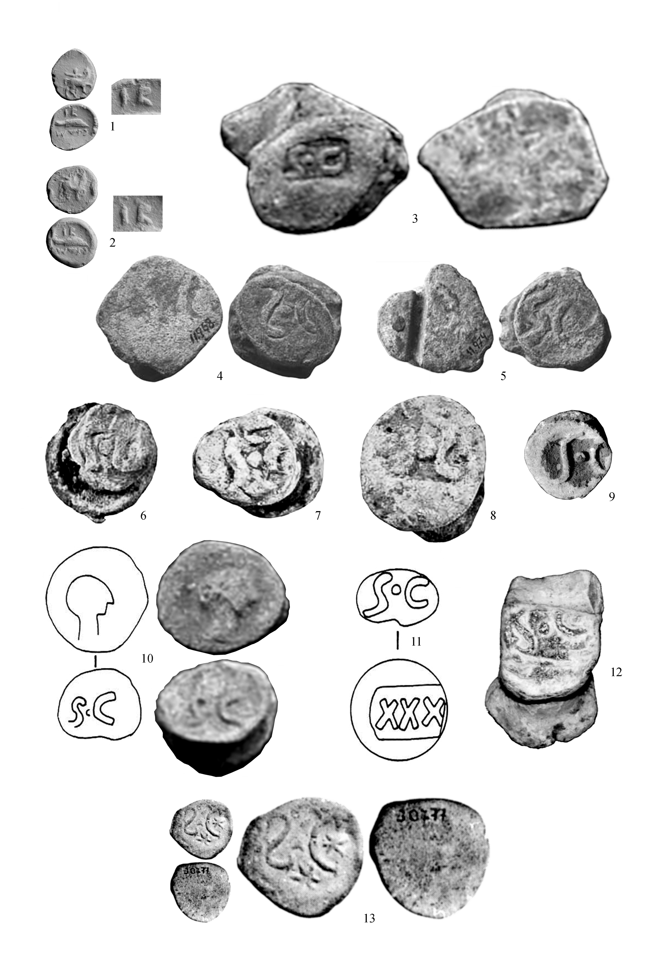

PLATE 2
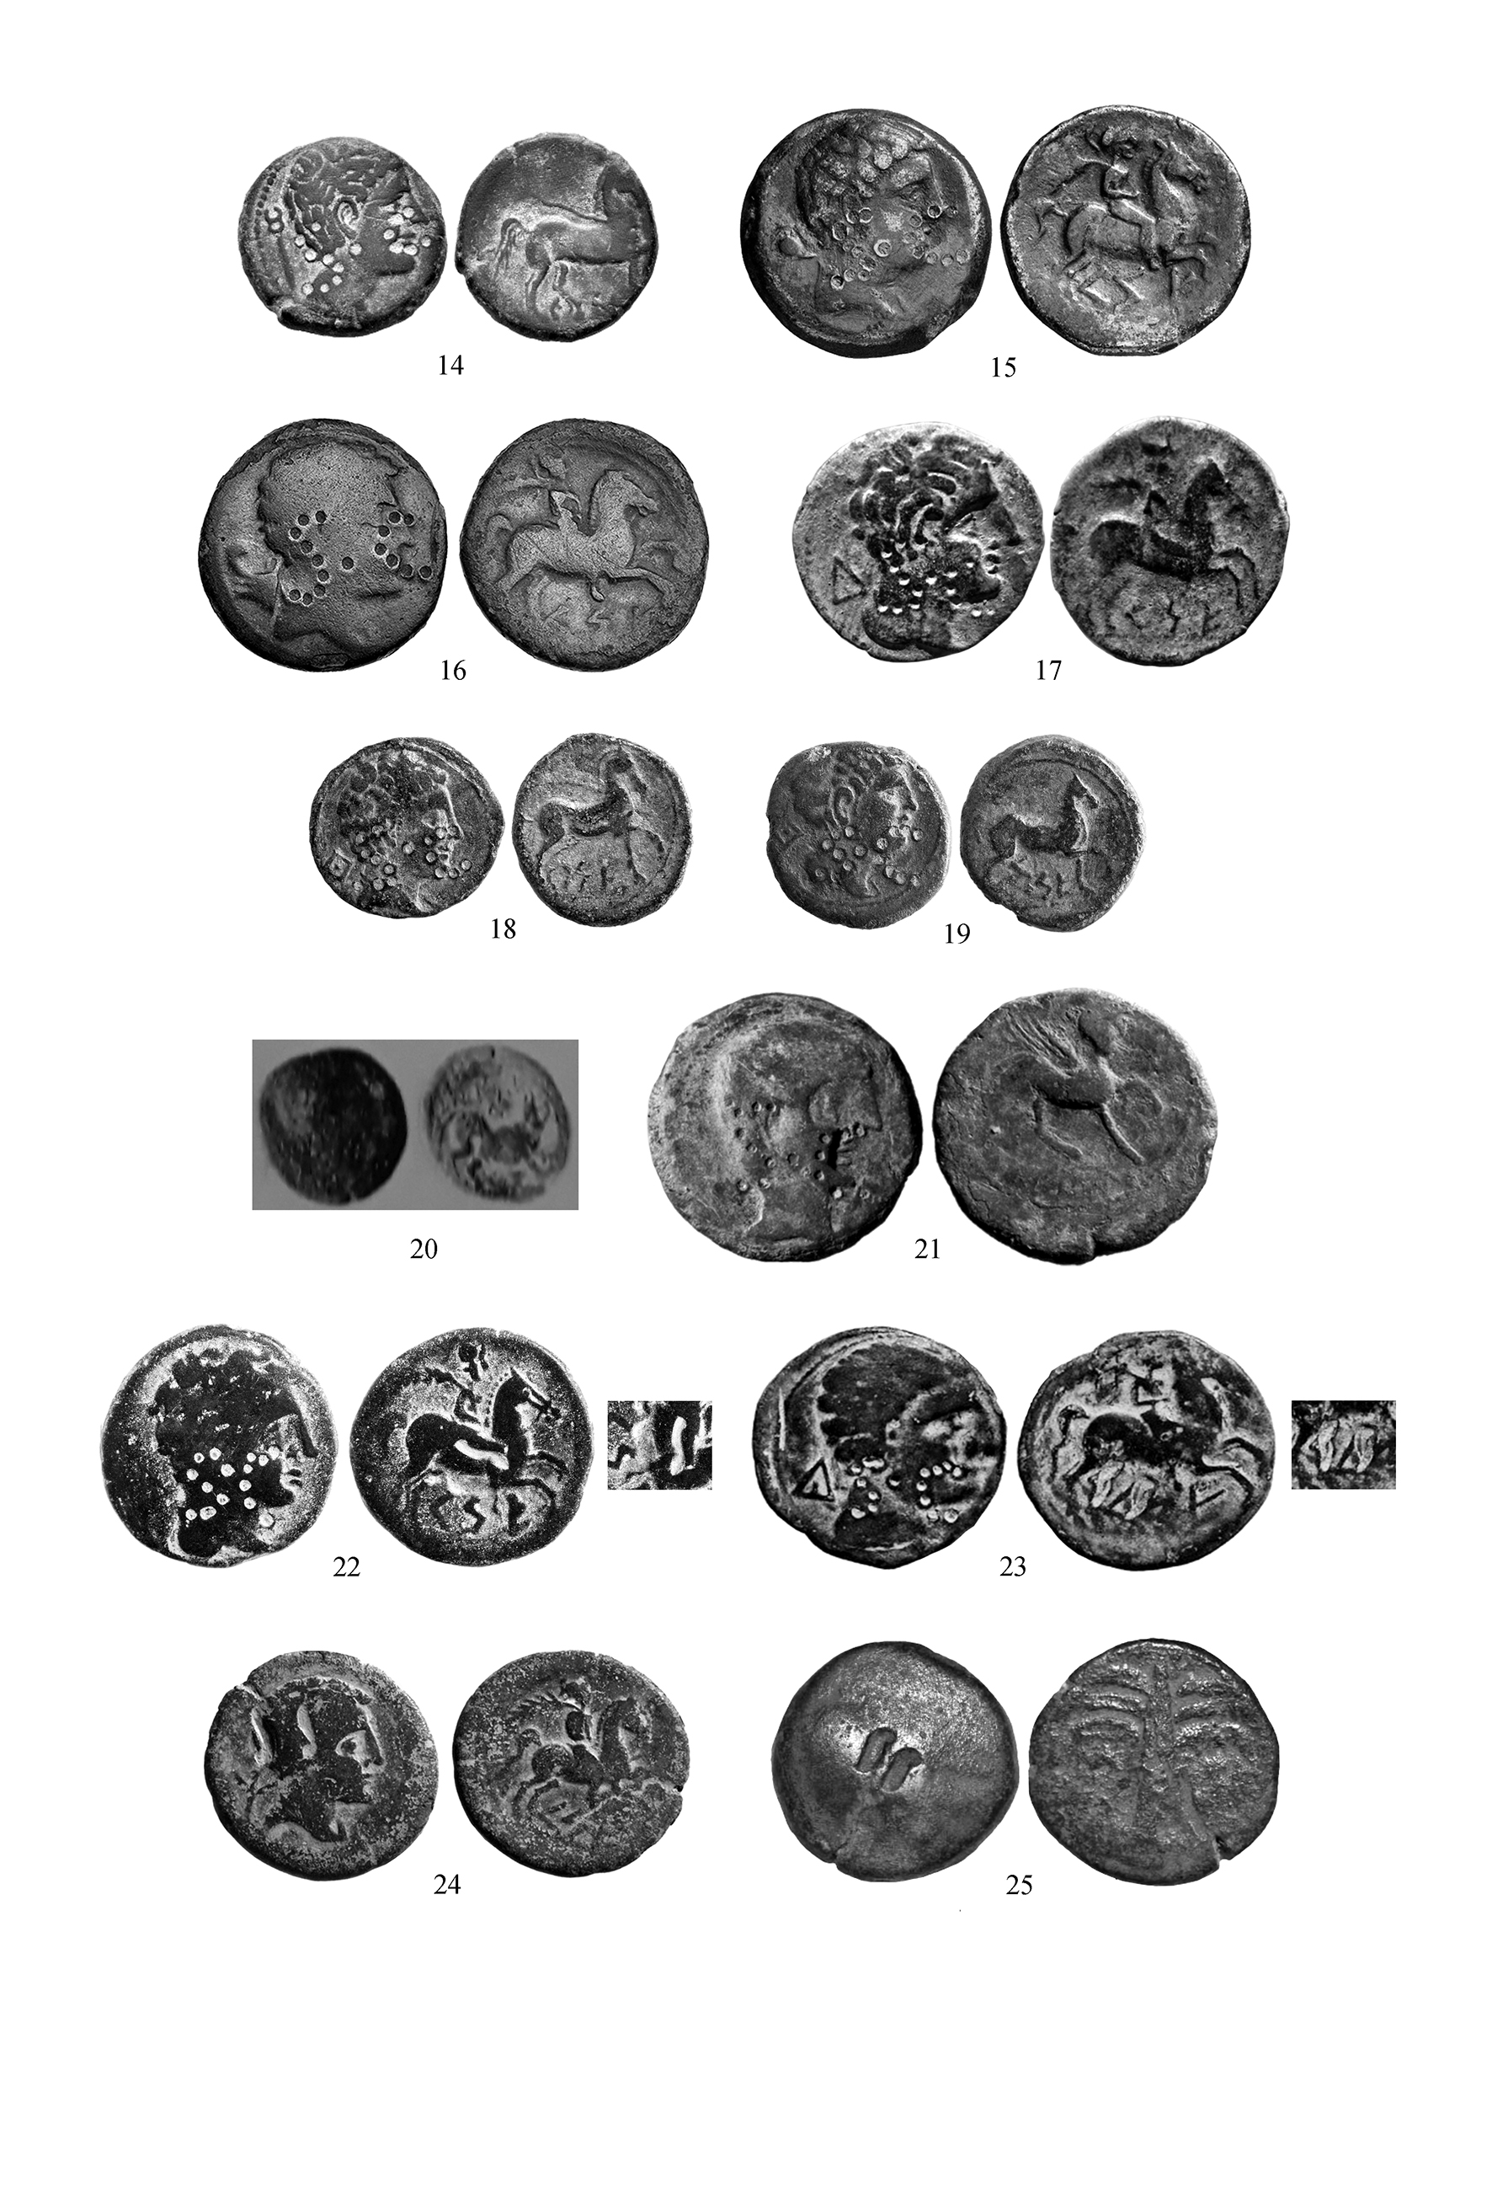

PLATE 3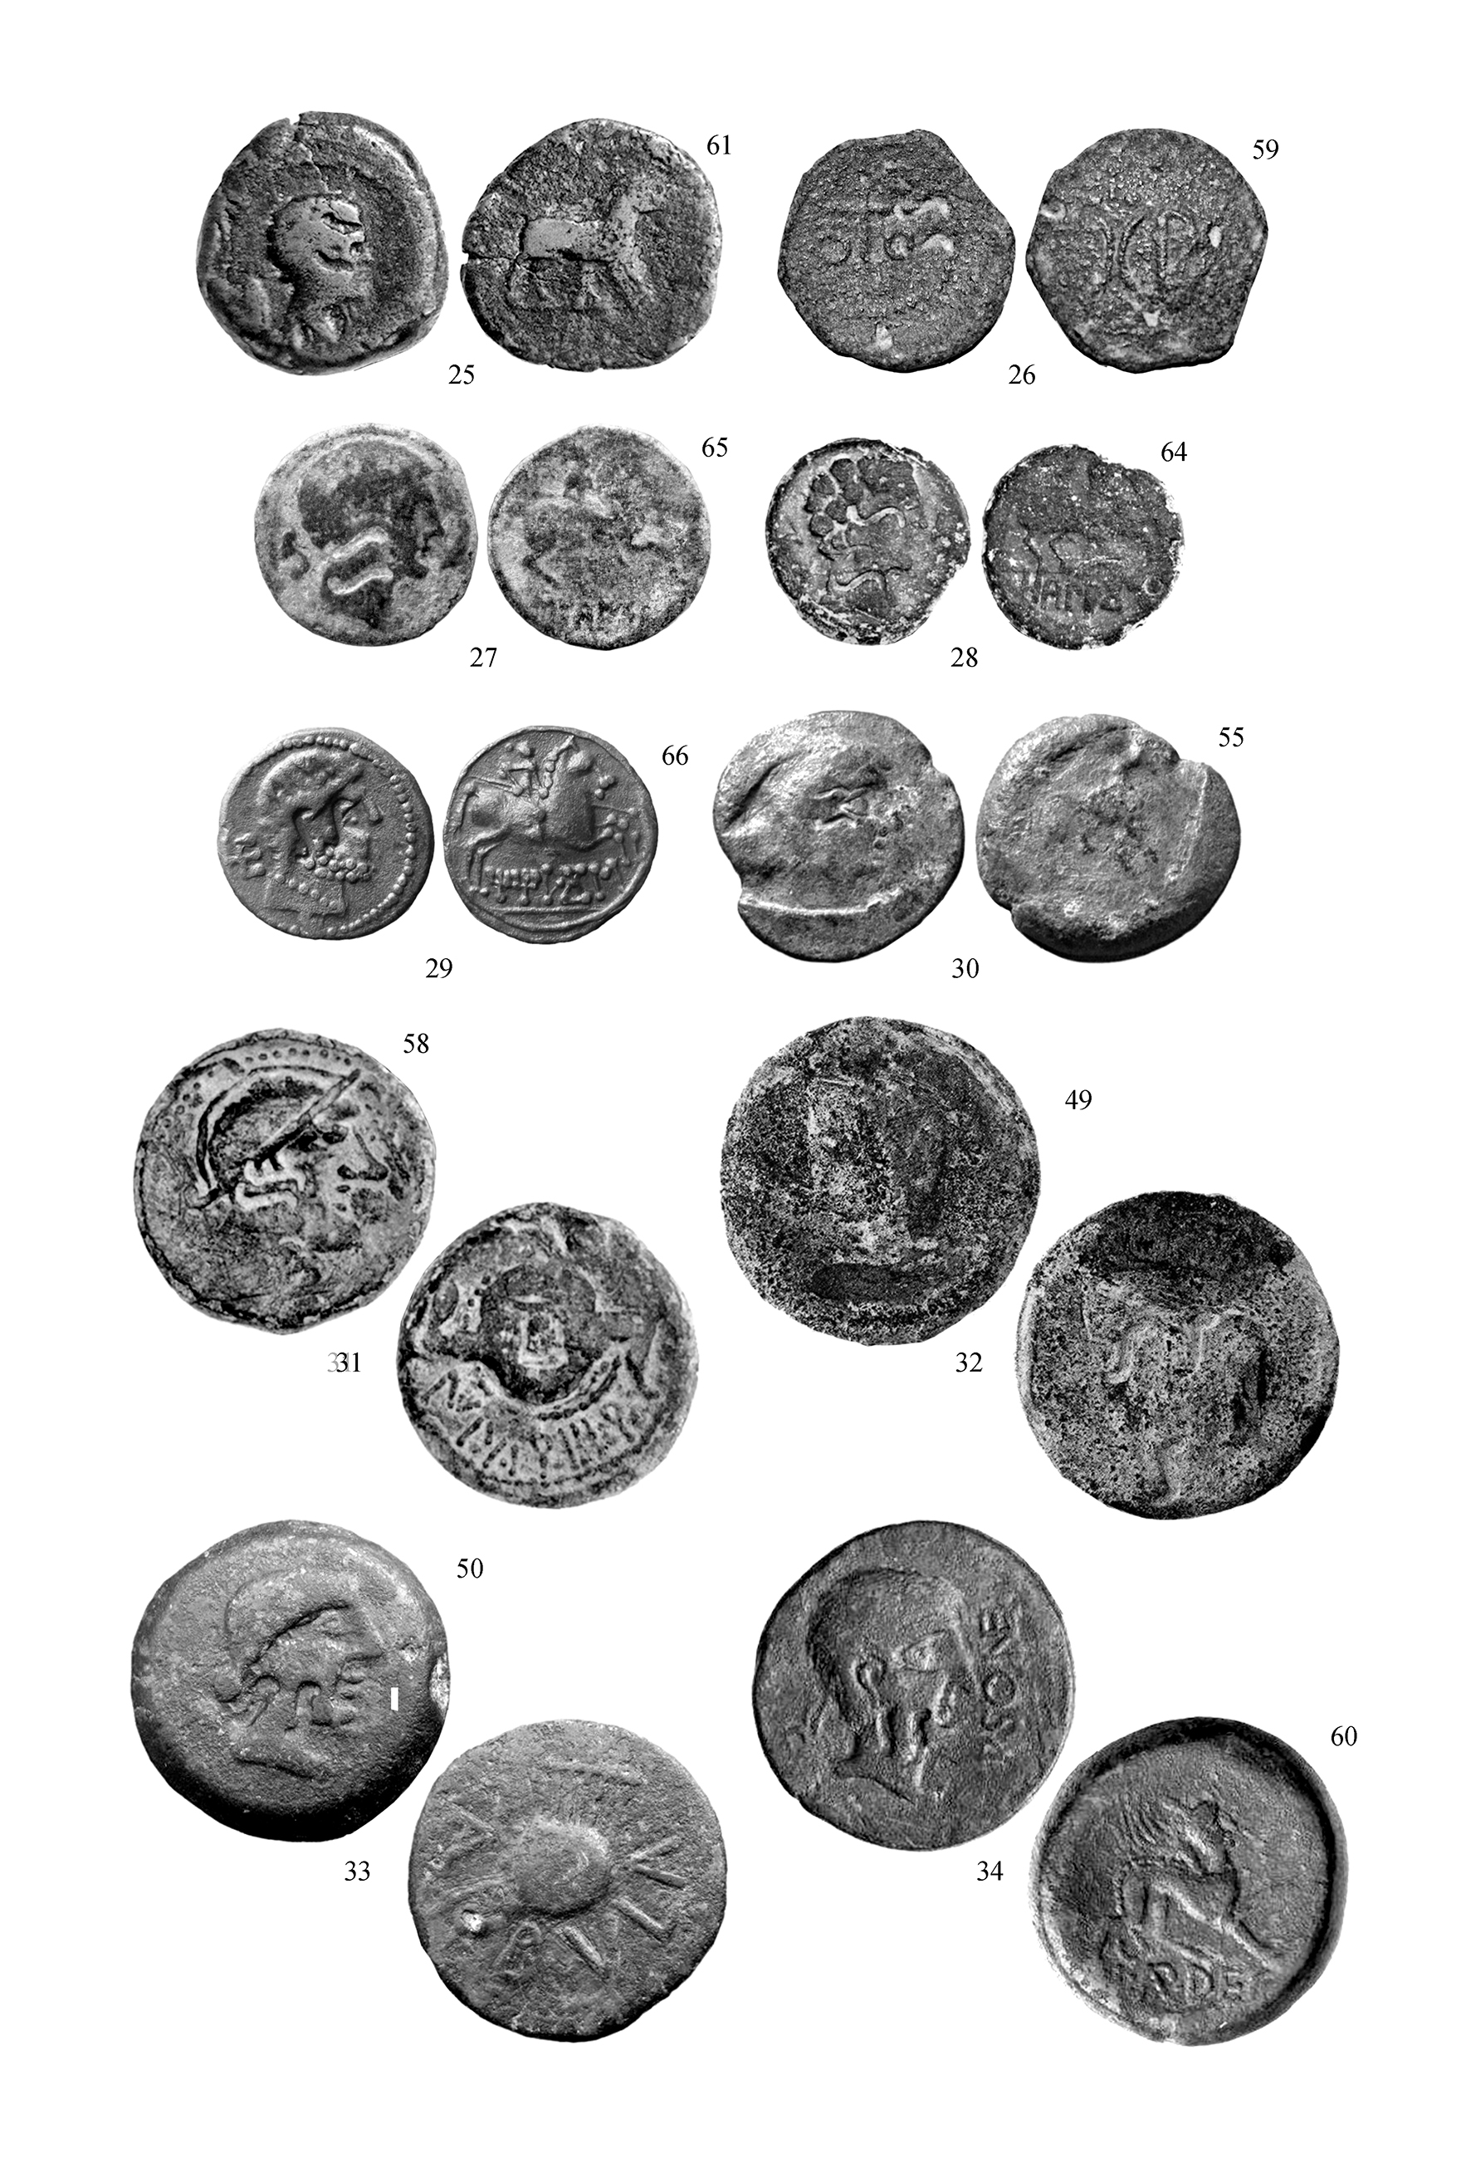

PLATE 4
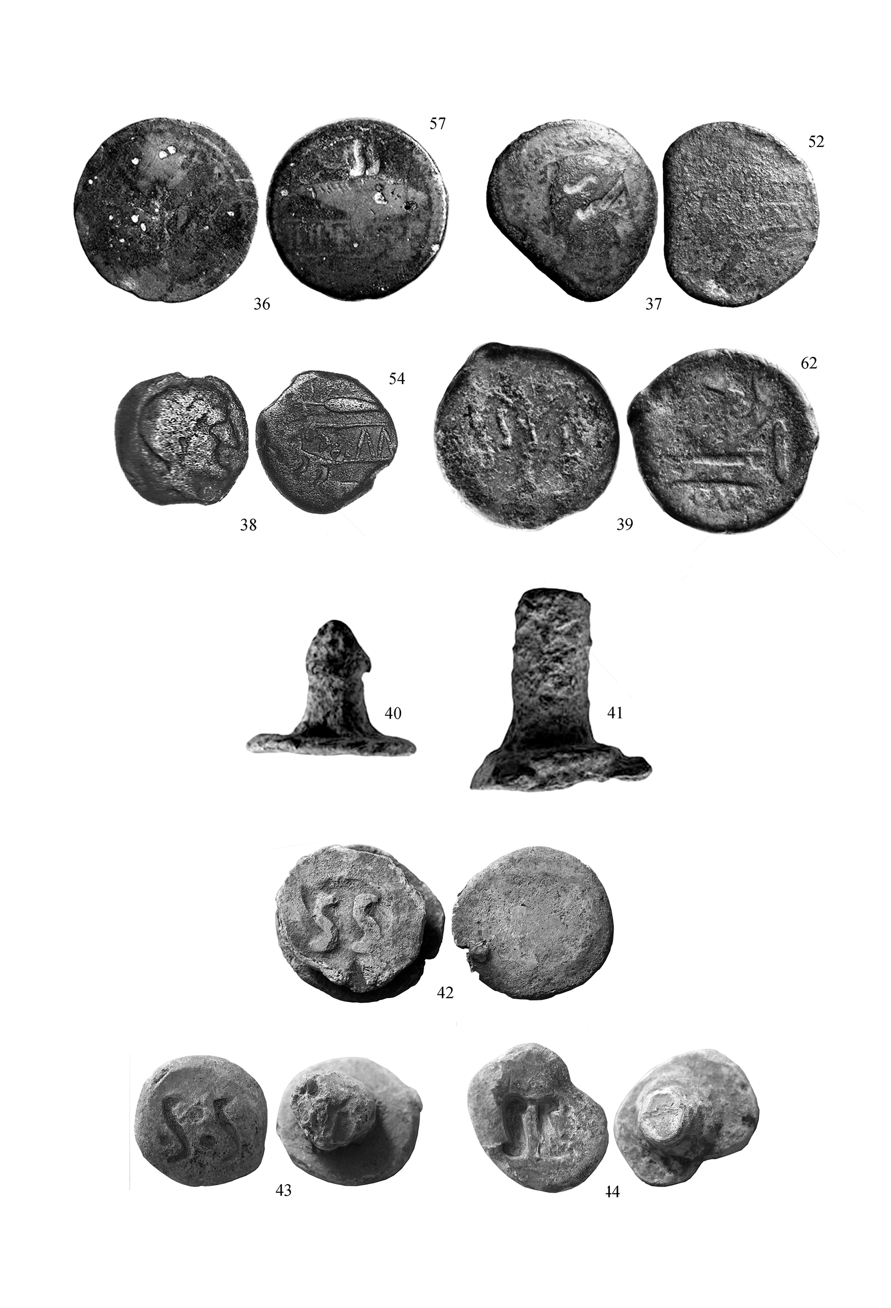

PLATE 5
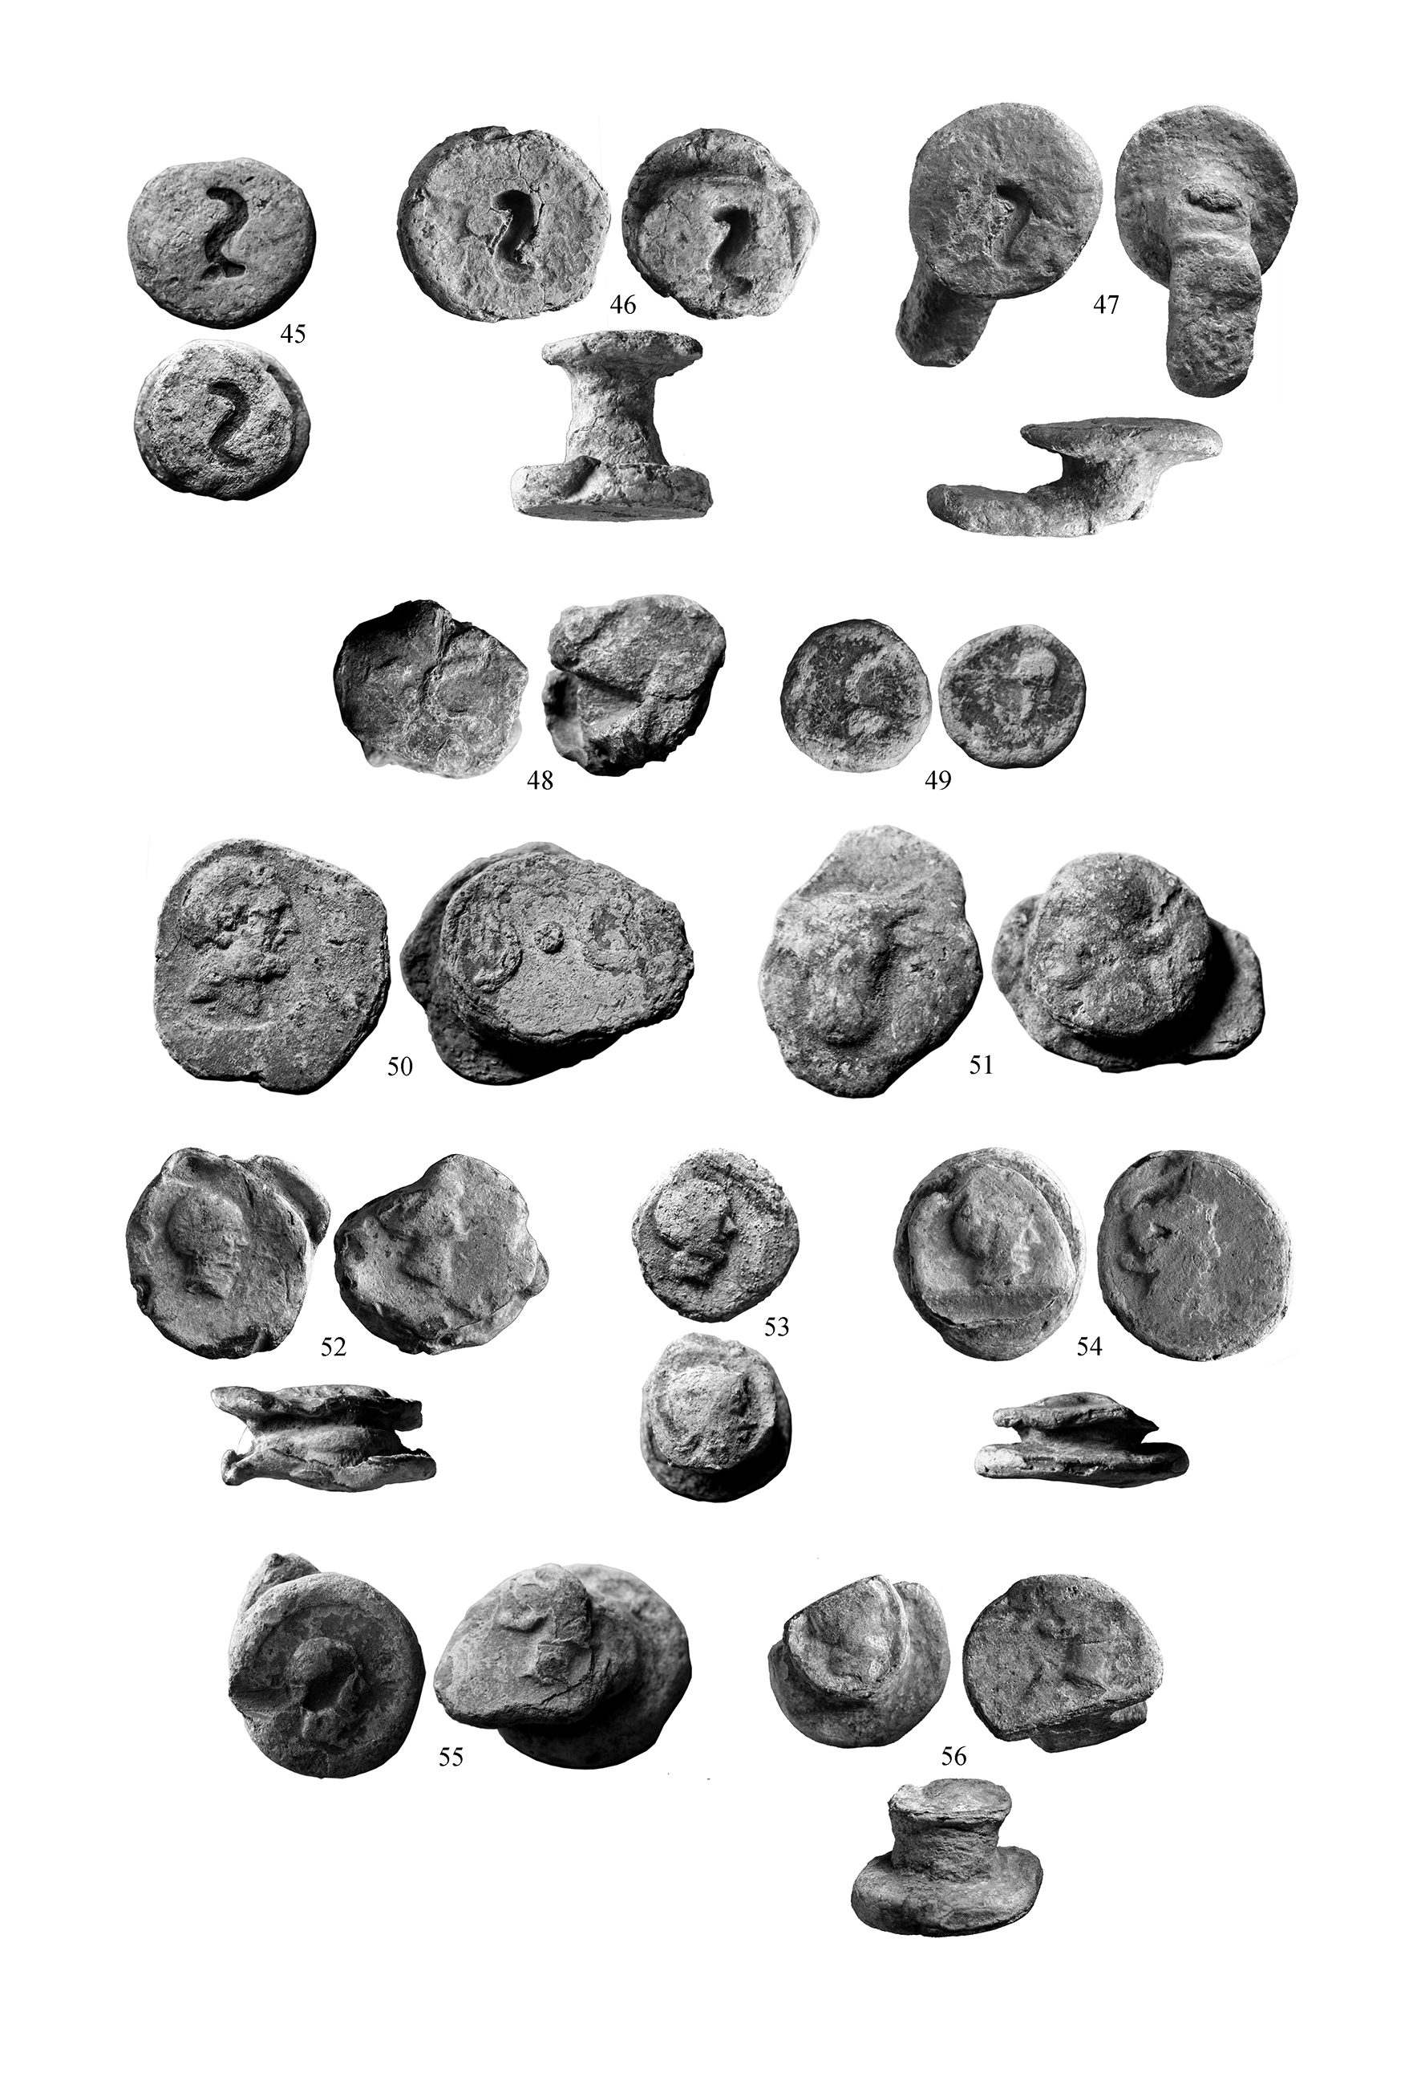

PLATE 6
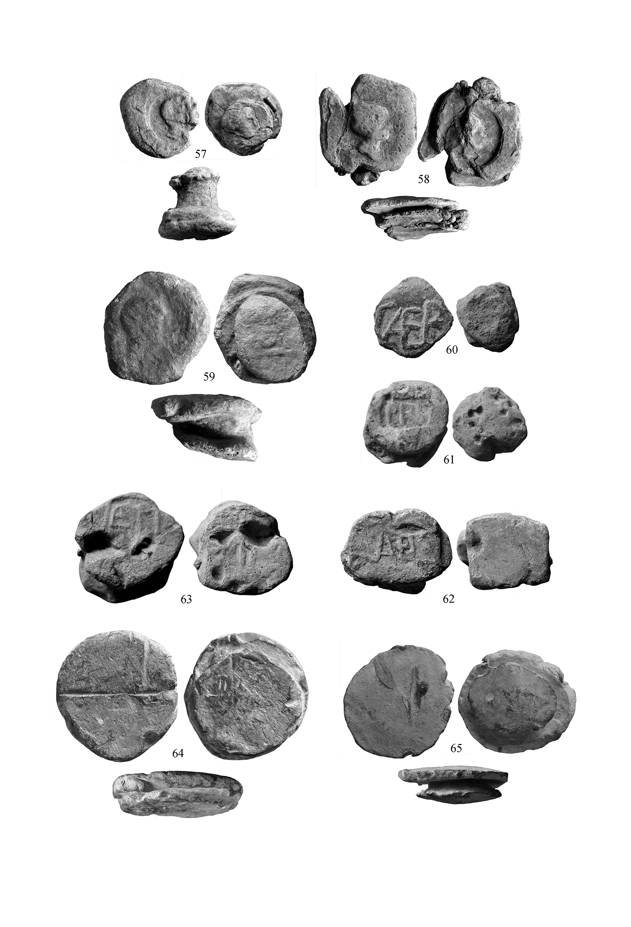

PLATE 7
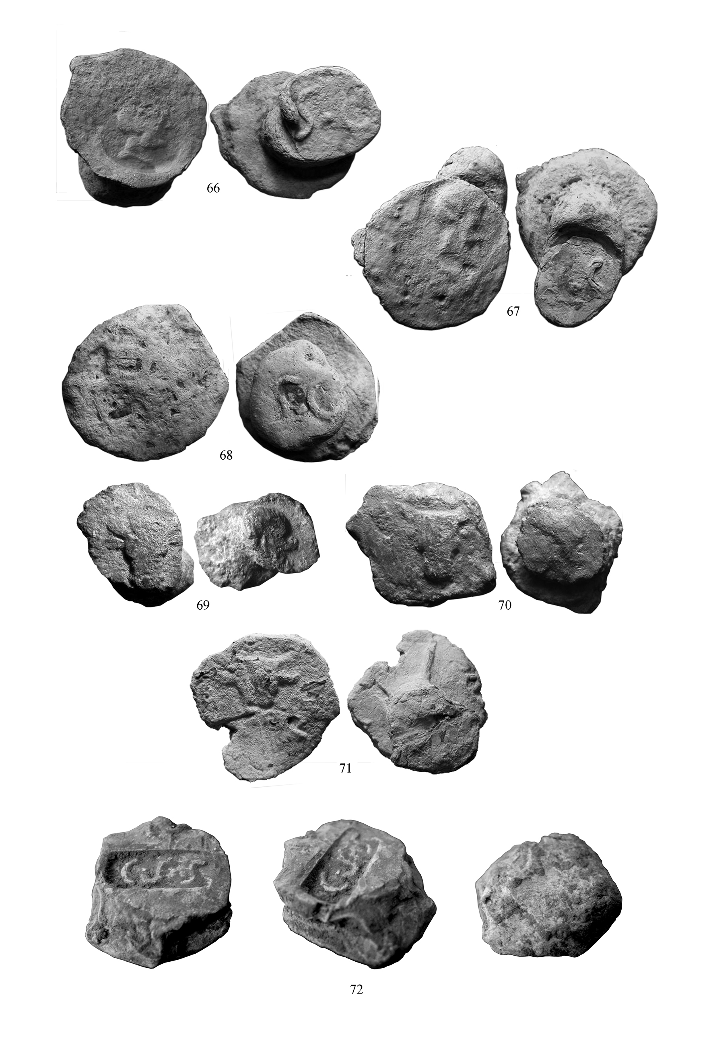

PLATE 8
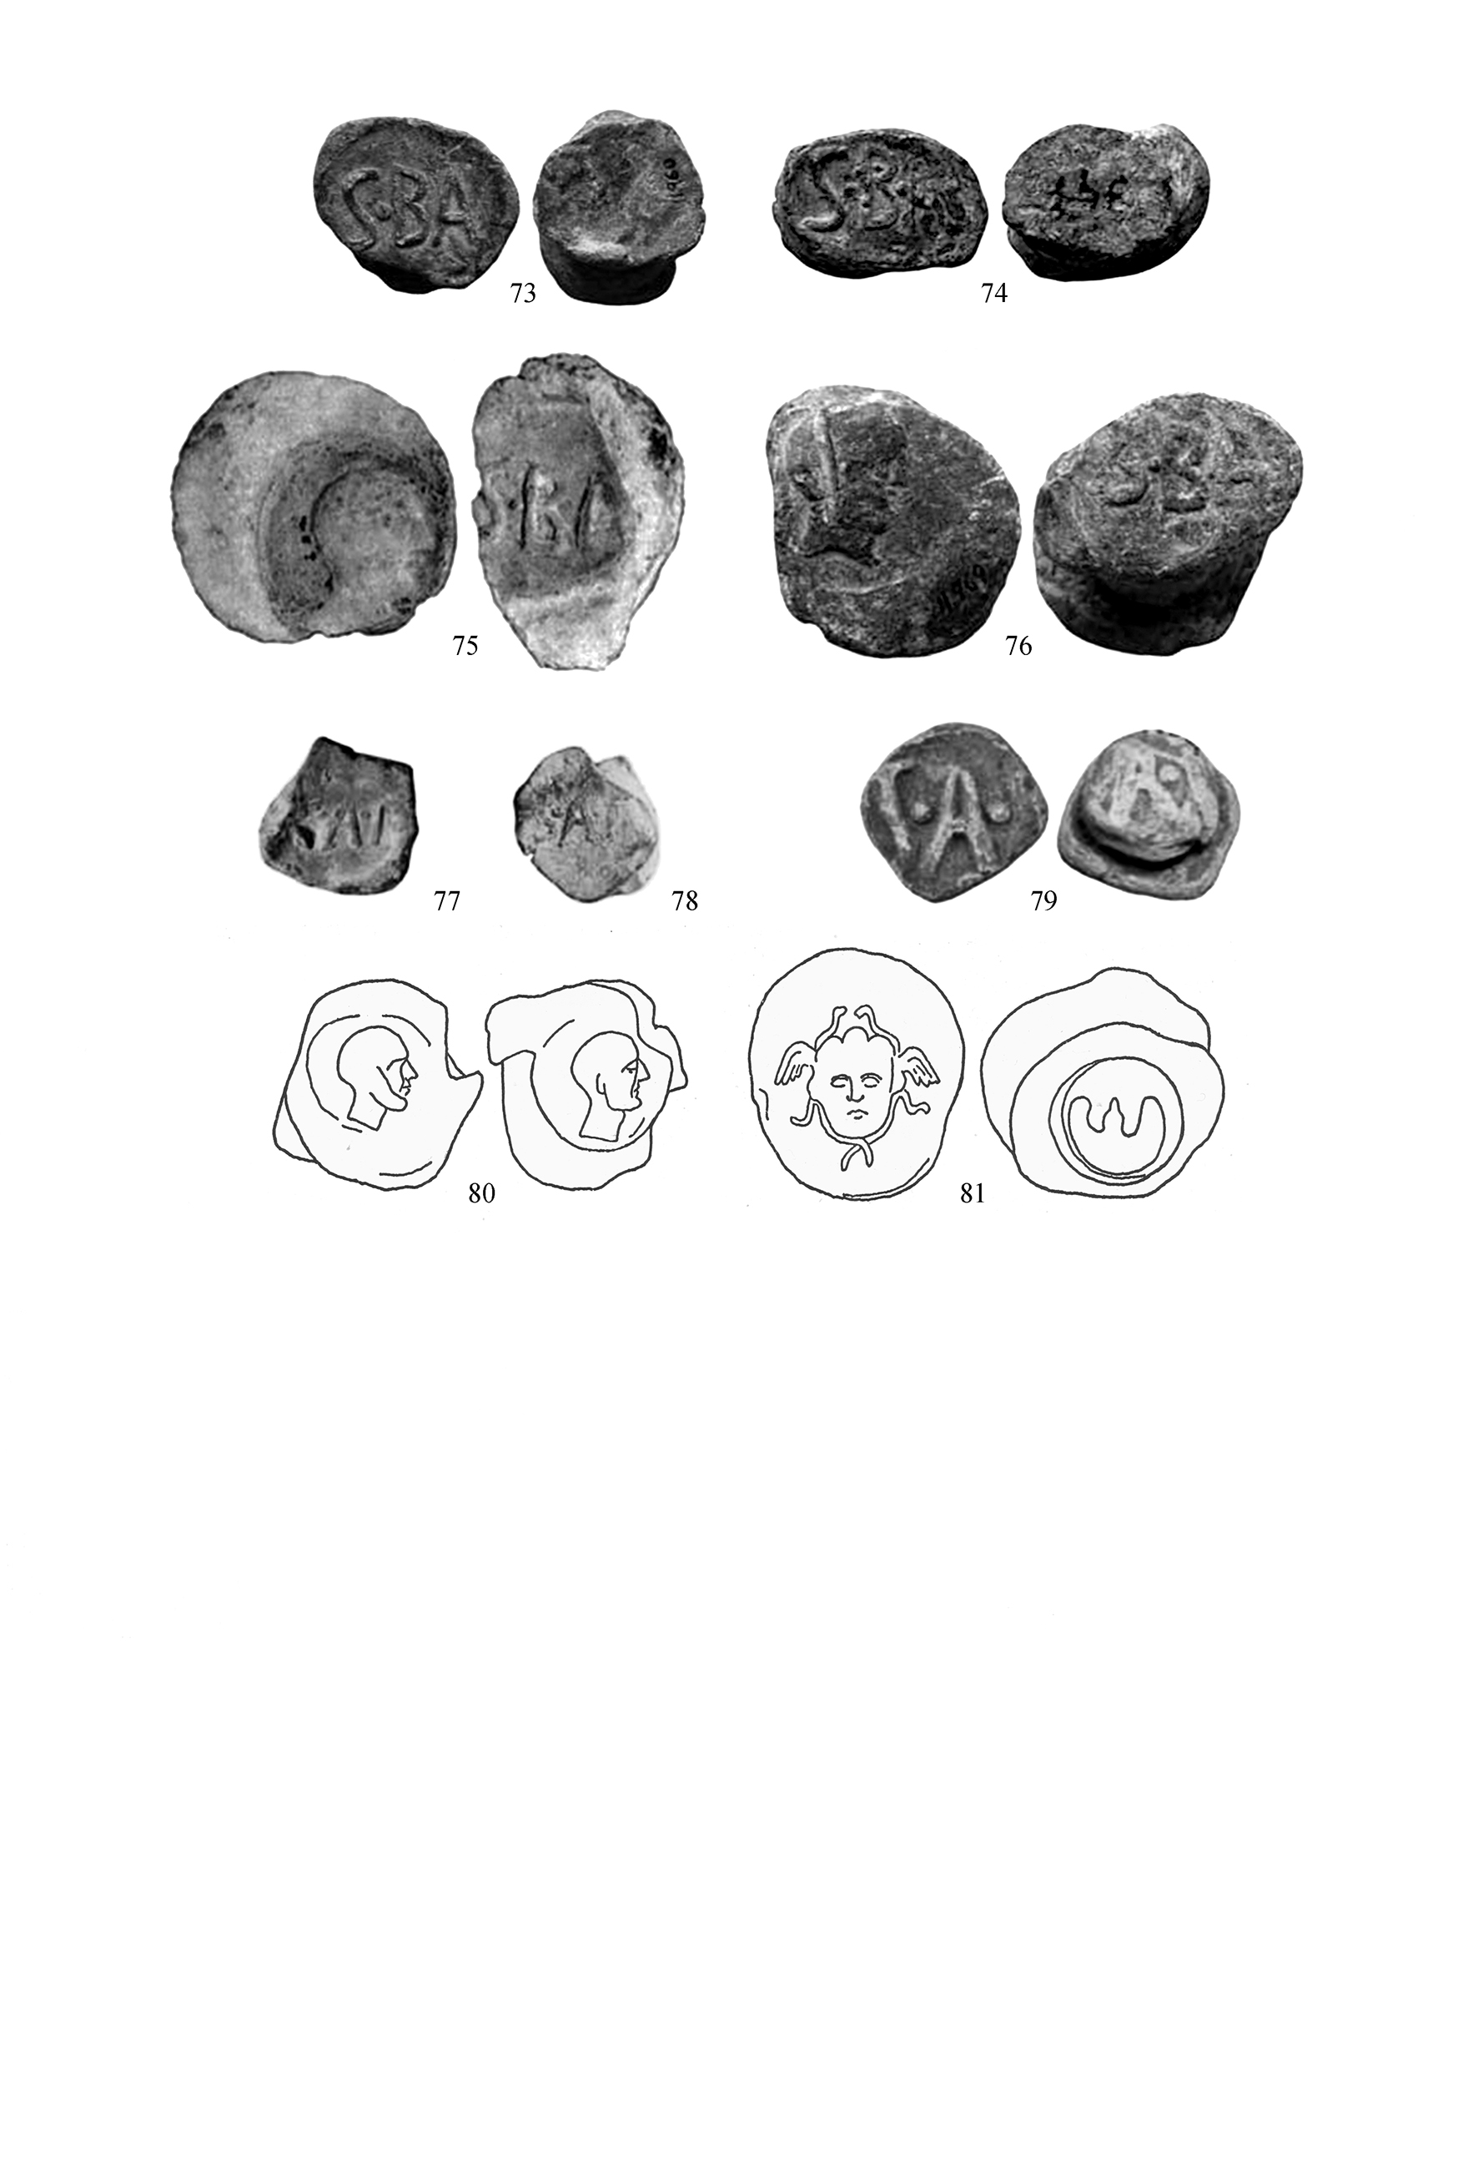

All dates are BC, unless otherwise noted. We thank Francisca Chaves Tristan and Claude Domergue for their help and advice, but they are not responsible for mistakes we may have made. Gonzalo was a Maecenas of Spanish numismatics, always generous with his knowledge and time, who put his vast collection at the disposal of scholars. The grandes plomos monetiformes were a special interest of his, and his book—Casariego, Cores, and Pliego 1987, cited here as CPM—is the bedrock of all subsequent research. He will be sorely missed.
Stannard, Sinner, and Ferrante 2019, cited here as Trade.
For a catalogue of these pieces, cited here as PLO: Stannard, Sinner, Moncunill Martí, and Ferrer i Jané 2017.
For a new analysis of this iconography: Stannard 2020.
Stannard forthcoming.
Stannard and Chevillon 2021.
Stannard and Sinner 2014, pp. 171–174.
Stannard 2020.
Trade, p. 127–128. Until the baths context was understood, the interpretation of the image as a miner—for example, in Maria Paz García-Bellido 1986—and their characterisation of these pieces as ‘plomos de la minas’—as in PLO—was very plausible.
Stannard, Sinner, Moncunill Martí, and Ferrer i Jané 2017.
Trade: p. 129 and pl. 28, B17, like PLO 16 ; and p. 129, pl. 25, B12 = PLO 75).
Trade, pp.157–161.
Stefanile 2015, 2017a, 2017b.
Trade, pp. 150–154, and pl. 26.
Luís Arboledas Martínez 2007, p. 952; Domergue 1990, pp. 261–263; Hirt 2010, pp. 275–279; Haley 2003, pp. 27–28. It also seems that in the interior, despite the Roman conquest, Iberians continued to be active as mine owners, in the late second or early first century, but it seems unlikely that they would have been members of Roman societates Publicanorum: ‘on ne s’étonnera pas d’y rencontrer, à l’époque de Posidonius, des Ibères qui, poursuivant une antique tradition, exploitent des mines de cuivre, d’or et d’argent dont le revenu semble être tout entier pour eux. S’y sont vraisemblablement ajoutés quelques-uns de ces Italiens avides qui ont fondu sur les mines d'Espagne après la conquête.’ (Domergue 1990, p. 234). (
Arboledas Mantínez, Orejas Saco del Valle, Antolinos Marín, and Rico 2017, pp. 883 & pp. 884-85. A soc(ietas) argent(ariarum) fod(inarum) mont(is) Ilucro(nensis?) or soc(ietas) montis argentari illucro(nensis?) may have mined for silver on mons Ilucro(nensis?), near the mine of Coto Fortuna, close to Mazarrón, where the mines were possibly exploited by a s(ocietas)m(ontis)F(icarensis) (Domergue 1990, pp. 254–256, nos. 1040, 1044 & 1045, and p. 260; Hirt 2010, pp. 274–275).
CIL X, 3964. Epaprha (!) socioru(m) / Sisapo[n]es[i]u[m] uilic(us). / O(ssa) h(ic) s(ita) s(unt).
Dondin-Payre and Tran 2016.
‘Parmi les cinq societates ainsi attestées, la S(ocietas) C(. . . .) paraît avoir une importance particulière : elle a contrôlé la mine El Centenillo et la fonderie de Fuente Espi dans la région de Castulo, ainsi qu’à 30 km de là des mines à Posadas, et d’autres encore à Santa Eufemia dans le Nord de la province de Cordoba. On voit donc qu’une société pouvait exploiter des mines dispersées sur une aire assez vaste.’ (Domergue 1990, p. 262).
Phil., 19.
Domergue 1990, pp. 261–262.
Hill and Sandars 1911, pp. 101-02 and pl. XIV, 5.
Ventura 1993; Melchor Gil 1999, p. 322; CIL II²/7, 699a; Haley 2003, pp. 19–20.
Information on the finds of objects with inscriptions referring to the mines is from Domergue 1971, p. 352, fig. 17 bis.
Trade, pp. 150–154, and pl. 26.
N.H: 165: ‘nuper id conpertum in Baetica Samariensi metallo, quod loctori solitum ± CC annuis, postquam obliteratum erat, ± CCLV loctum est. simili modo Antonianum in eadem provincia pari locatione pervenit ad HS CCCC vectualis’.
Mayhoff 1967, reprinting the edition of 1897, p. 163, lists Samiarensi, Samiarenci, Santarensi, Samiarensi; Le Bonniec and Gallet de Santerre 1953, p. 222, adds Saremienesi and Salutariensi; and Bostock and Riley 1857, pp. 216, fn. 13, remarks for Santarensi: ‘not in Baetica … but in Lusitania or Portugal, the modern Santarem’.
www.trismegistos.org/text/255985 (Depauw and Gheldof 2014): Caius Samiarius Cai filius Marci nepos An, of the second century. The inscription is from Praeneste, where the gens originated.
Domergue 1990, pp. 333, and p. 256, no. 1020.
Palaeographic criteria have proved of scant use on dating Hispanic coinages: ‘Estas y otras peculiaridades han condicionado una valoración pesimista de las leyendas monetales hispanas, también de las latinas, al centrar su atención en la contribución, por otra parte escasa, de los criterios paleográficos en la datación de la moneda hispana antigua’. (Mora Serrano 2004, p. 118).
Domergue 1990, p. 263.
‘Y avait-il des rapports directs entre certains commanditaires et les exploitants eux-mêmes? Un seul témoignage permet de la penser : le plomb marqué S·C.’ Claude Domergue, personal communication of 10 December 2020.
Surveyed in Chaves Tristán and Otero Morán 2002.
Chaves Tristán and Otero Morán 2002, tab. 99.
À La Loba, … l’étude des monnaies de bronze hispaniques paraît permettre de retrouver la trace des mineurs originaires de Celtibérie où les mines de fer étaient déjà en exploitation’ (Domergue and Sillières 2002, p. 403).
Domergue 1971, pp. 324–325; Maria Paz García-Bellido 1986, pp. 19–22; Hill and Sandars 1911, pp. 102–103.
Chaves Tristán and Otero Morán 2002, pp. 182, tab. 95.
Chaves Tristán and Otero Morán 2002, pp. 190, tab. 100b, & p. 193.
Chaves Tristán and Otero Morán 2002, pp. 193, tab. 101.
Stannard and Sinner 2014, pp. 168_169, fig. 5, and p. 171.
For the importation of blocks of ‘foreign’ coins in Antiquity, in general: Suzanne Frey-Kupper and Stannard 2018; Susanne Frey-Kupper and Stannard 2019.
‘El uso de las contramarcas, tanto en objetos diversos como en las monedas, parece que es un fenómeno constatado en plena mitad del s. I a.C, pero al que no se recurre ni a fines del s. II ni muy a principios del I a.C.’ (Maria Paz García-Bellido 1982, p. 155.
Hill and Sandars 1911, p. 102.
A counter-marked Kese ‘was found two years ago near another Roman mine in the neighbourhood of Posadas,4 to the south of Cordoba, and that four others with the same countermark are said to have been found near Granada. But coins can be and are transported with greater ease than almost any other objects ; and, after all, coins which had in the first instance come from Tarraco to Centenillo might easily wander a little farther afield’.
Ruiz Taboada and Azcárraga Cámara 2016, pp. 265–266.
ACIP, p. 657, 3343; Maria Paz García-Bellido 1986, pp. 20–21 & p. 46, fig. 34.
Hill and Sandars 1911, p. 11.n
Domergue 1971.
Antolinos Marín and Díaz Ariño 2015.
Antolinos Marín, Díaz Ariño, and Guillén Riquelme 2013.
The Internet has made many more images, and much more—but often incomplete and imperfect—information available, but one problem is that the size of objects pictured is usually uncertain. We have set our illustrations at what we think is most likely to be real size, but this is often no more than a guess.
Antolinos Marín and Díaz Ariño 2015, p. 219, convinces us that S·BA and S·B·A are not two different mines, but variants of the same name.
Díaz Ariño and Antolinos Marín 2013.
Díaz Ariño and Antolinos Marín 2013, pp. 113, fig. 22, no. 8, and 115.
Domergue 1971, pp. 351 and 352, fig. 17 bis.
CMP, pp. 25, no. 14, and 26, pl. 5, 1d.
Stannard, Sinner, and Ferrante 2019, pp. 129, fig. 4.
Stannard 2020.
Sample B11 (Stannard, Sinner, and Ferrante 2019, p. 142).
Stannard, Sinner, and Ferrante 2019, pp. 146–147, tab. 4.
‘Al menos un ejemplar de [PLO 42] apareció en la mina Madereros, junto a Almodóvar del Río, mina en la que han sido hallados otros plomos, entre ellos uno con cabeza de toro perteneciente a esta misma serie, y varios precintos. De éstos hay uno que lleva en una de sus caras una cabeza masculina bastante parecida a la del anverso del plomo.’ (García Romero 2002, p. 790)
Maria Paz García-Bellido and Blázquez 2001, p. 297; PLO, catalogue, p. 4, nos. 2–4, & pl. 27, nos. 2–5.
From Stannard and Sinner 2014, pp. 168–168, fig. 9, updated. For a map with these mints: Trade, p. 124, fig. 1.
Cortijo Cerezo 2008, pp. 295–296. Although the oldest known copy has been assigned to the time of Diocletian, it may incorporate information from a survey carried out under Augustus.
Campo 1976.
For the Liri database, Stannard and Ranucci 2016, pp. 158–161.
Costa Ribas 2007, p. 98.
Martínez Chico 2018.
Ripollès, Collado, Delegido, and Durá 2009, pp. 118, fig. 11, & 122, fig. 14.
Stannard 2013.
Feugère and Py 2011, pp. 399–400, report on 28 coins of earlier issues, and 40 of XIX.
Sillières 1990, pp. 401, 412–420.
Fortea Pérez and Bernier 1970, p. 135
Campo and Mora 1995, pp. 73–81.
Melchor Gil 1999, pp. 255–257; Mora Serrano and Pérez Plaza 2017, pp. 187–190.
Mateo 2016, pp. 381–382.
Melchor Gil 1999, p. 317.
Domergue 1998, pp. 203–208.
Feugère and Py 2011, p. 401.
Melchor Gil 1999, p. 314.
Stannard, Sinner, Moncunill Martí, and Ferrer i Jané 2017, pp. 76–77.
$$$.
Antolinos Marín and Díaz Ariño 2015
CPM, p. 27, pl. 5, no. 1a, from Madereros (Almódiovar) is probably one of these.
Mentioned without illustration or reference.
Mentioned without illustration or reference, and no description of the reverse.
Mentioned without illustration or reference, and no description of the reverse.

