SPRAY-GROWN HIGHLY ORIENTED ANTIMONY-DOPED TIN DIOXIDE TRANSPARENT CONDUCTING FILMS

Rodrigo Parra1,*, Dietmar Leinen2, José R. Ramos-Barrado2, Francisco Martín3.

1Instituto de Investigaciones en Ciencia y Tecnología de Materiales (INTEMA), CONICET-UNMdP, B7606BWV Mar del Plata, Argentina.
2Laboratorio de Materiales y Superficies. Departamento de Física Aplicada I, Universidad de Málaga, 29071 Málaga, Spain.
3Departamento de Ingeniería Química, Universidad de Málaga, 29071 Málaga, Spain.

ABSTRACT: Undoped and Sb-doped tin dioxide films of varying thickness with a remarkable crystallographic orientation in the [200] direction were grown by spray- pyrolysis from tin(II) chloride solutions. Films grown on silica-coated glass substrates were completely crystalline and showed a higher degree of orientation with respect to films that were grown on uncoated glass. The presence of the silica barrier was seen to have increased the degree of orientation and to have enhanced the resulting electrical properties. Transmission electron microscopy revealed that the silica layer may have played the crucial role of a nucleation layer. Moreover, the developed microstructures were correlated with the optical and electrical behaviour of the films. Dense conducting films with thicknesses between 280-450 nm and visible transmittances of 80-70 % showed resistivities of about 10-3 $Ω$cm.

KEYWORDS: Transparent conducting oxides, tin oxide, spray-pyrolysis, thin films

INTRODUCTION

A transparent electrode typically consists of a transparent substrate, such as glass, which is coated with a transparent conductive material, with tin-doped indium oxide (ITO) being the most common transparent conducting oxide (TCO). Because of the limited abundance of indium, there has been an increase in the demand for alternative TCOs [1-4]. TCOs are widely applied to a variety of devices, including gas sensors, FETs, touch screens, defogging or defrosting applications, and energy-saving technologies [3, 5-7]. Despite the shortcomings pointed out by Kurz et al. [8], antimony-doped tin dioxide (ATO) is one of the best candidates for the substitution of ITO.
Achieving low resistivity in transparent ceramic films requires both high carrier concentration (ne) and carrier mobility (μ). Whereas the maximum carrier concentration is limited by the solubility of dopant species, carrier mobility is limited by ionized impurity scattering processes [6, 9]. Therefore, in applications where transparency is a critical parameter, such as in solar cells, a reduction in resistivity must be achieved by increasing μ while maintaining a sufficiently high carrier density (≥1020 cm-3).
However, by increasing ne by means of doping also entails that transparency begins to decrease, a process which is due to the absorption by free carriers in the near infra-red range. A smart approach for improving both the mobility and conductivity in FTO (fluorine-doped tin dioxide) while keeping both carrier density and transparency at high levels, has been put forward by Wang et al. [10]. They showed that by texturing the film into the [200] direction (weakening the [110] preferred orientation), carrier mobility was
increased at a constant (high) carrier density. Additionally, Agashe et al. [11] has likewise reported on the electrical properties of highly [200] oriented FTO films grown by spraying SnCl4-based solutions on glass substrates. Spray-pyrolysis is a simple and affordable technique, which has been extensively treated throughout the existing literature [12-15]. In this technique, films may be textured by controlling processing variables such as temperature, solvent and precursor selection. However, the use of a nucleation layer seems to be the most promising way to control the crystallographic orientation of films grown on amorphous substrates [10]. Although Sn(IV) chloride has generally been preferred for the fabrication of SnO2-based TCO, in this research, films that were highly oriented in the [200] direction were obtained by spraying SnCl2.2H2O solutions on silica-coated glass substrates. The optical and electrical properties assessed on undoped and 1 at. % Sb-doped SnO2 films of varying thickness were correlated with the developed microstructures.

EXPERIMENTAL SECTION

Tin dioxide (SnO2) films were grown by spray-pyrolysis on soda-lime glass substrates (40 x 25 mm2), some of which had been previously coated with a silica (SiO2) film. For this purpose, 10 ml of tetraethoxysilane (TEOS, Fluka, 99 %) was dissolved in 40 ml of 2-propanol. Then, 3.5 ml of a 4.2 % nitric acid aqueous solution was added to the TEOS sol. Microscope glass slides were dip-coated in the resulting sol with a withdrawal speed of 3 cm/min. In order to densify the silica film and to improve its barrier properties against the diffusion of alkaline ions from the substrate to the active film, coated substrates were heat-treated in a furnace at 450 C for 40 minutes with heating and cooling rates of 3 ºC/min.

Tin dioxide films were grown by spraying 50 ml of tin(II) solutions at a rate of 60 ml/h onto uncoated and SiO2-coated substrates at 450 ºC with compressed air (1.5 bar, 19 ml/min) used as carrier gas and applied at a distance of 15 cm between the nozzle and the substrate. Tin(II) chloride dihydrate (SnCl2.2H2O, Sigma Aldrich, 98 %) was dissolved in absolute ethanol (99.5 %, Biopack) in order to obtain solutions of different concentrations as shown in Table 1. The concentration of the tin(II) solution was chosen to act as the selected variable to control film thickness. Next, an 8.6 mM solution of the doping agent was prepared by the dissolution of 0.86 mmol of antimony chloride (SbCl3, Panreac, 98 %) and 0.2 ml of anhydrous acetic acid in 2-propanol resulting in a final volume of 100 ml. From our previous experiments, a doping level of 1 % at. Sb was selected as adequate for obtaining films with good optical and electrical properties.

Table 1. Film identification according to the tin(II) solution concentration ([Sn]) and antimony content (% at. Sb)
[Sn] / M | % at. Sb  0 | 1.0
0.050 | TO-050 | ATO-050
0.087 | TO-087 | ATO-087
0.125 | TO-125 | ATO-125
0.162 TO-162 ATO-162

The microstructure of the obtained films was characterized by means of grazing incidence-X-ray diffraction (GI-XRD) in a PANalytical X’Pert diffractometer running with K$α$-Cu radiation at a diffraction angle range from 20° to 80° 2θ. XPS was carried out with a Versaprobe II equipment from PHI provided with a focused monochromatic X-ray source (Al-K$α$ 1486.6 eV) with scanning and imaging capabilities.
Photoelectrons were recorded at a take-off angle of 45° from an analysis area of 100 $μ$m in diameter with dual beam charge compensation at a pass energy of 23.5 eV or 11.75 eV (valence band region) and an energy step of 0.1 eV. Ar+ sputtering (33°) of 0.5 kV with Zalar rotation was applied in order to eliminate the surface contamination due to exposure to air.
Film thicknesses were measured from cross sectional scanning electron microscopy (SEM) images using a FEI Helios NanoLab 650 Dual-Beam. High resolution transmission electron microscopy (HRTEM) analyses were carried out in a Talos F200X instrument operating at 200 kV on cross-sectional lamella that were prepared with the dual-beam SEM. Optical transmittance and reflectance spectra were recorded in the 2500-200 nm range with a Cary-5000 Varian spectrophotometer equipped with an integrating sphere (DRA 2500). Sheet-resistance was measured with an Ossila Xtralien X-100. Being the Hall mobility a relevant figure-of-merit for conductive films, the density (ne) and mobility () of charge carriers (free electrons) were determined from Hall-effect measurements using the van der Pauw technique at room temperature, at both 0.5 and 1 T.

RESULTS AND DISCUSSION

  - Films grown on uncoated and silica-coated glass substrates

A thin SiO2 film is usually used to prevent the diffusion of sodium from the soda lime glass substrate at the high temperatures of TCO deposition [16, 17]. However, the optimum deposition method and parameters oriented toward obtaining the best diffusion barrier are not clearly identified [18]. In order to evaluate the efficiency of the silica layer used in this work, ATO-125 films were grown on uncoated (ATO125/Glass) and on SiO2-coated (ATO125/SiO2/Glass) glass slides. As observed in the XRD patterns in Fig. 1, the obtained films were indexed to the tetragonal phase of SnO2 (JCPDS 79- 6888). The (110) peak is commonly the most intense peak in the diffractograms of SnO2-based materials. However, Fig. 1 shows the peak corresponding to the (200) plane as the most intense one, revealing the predominance of anisotropic crystalline growth in the [200] direction. This is a particularly beneficial orientation for TCO applications, which has been observed to enhance the mobility of free carriers in tin dioxide [19].

Figure 1. XRD patterns of ATO-125 films grown on silica-coated (ATO125/SiO2/Glass) and uncoated (ATO125/Glass) glass substrates.

Preferential crystalline growth in the [200] direction is significantly more intense in the ATO125/SiO2/Glass film, yielding a I(200)/I(110) ratio of approximately 5 compared to 2, which is what the ATO125/Glass film yields. This ratio is known to be dependent on film thickness (increasing with thicker films) [20, 21] and substrate temperature (increasing for T >380 C) [22]. However, the fact that both films are of almost equal thickness, anticipates the assumption that the silica layer plays an influential role in crystalline growth. The preferential orientation of the films was estimated calculating the texture coefficient (TC) according to the following expression [23, 24],
${TC}_{(hkl)}=\frac{{I_{(hkl)}/I}_{0(hkl)}}{1/N\sum_{i=1}^{N}{{{[I}_{\left(hkl\right)}/I_{0\left(hkl\right)}]}_{i}}}$ (1)
where the measured normalized (I(hkl)) and standard (I0(hkl)) intensities of each (hkl) diffraction peak, as well as the number of diffraction peaks (N), were considered. TC(200) values of 5.2 and 3.5 were obtained for ATO125/SiO2/Glass and ATO125/Glass, respectively, indicating a significantly stronger orientation in the [200] direction for the ATO125/SiO2/Glass film. The corresponding values for TC(110) were 0.1 and 0.4, in the same order. In order to verify the observed trend, ATO-125 films doped with 0.5 % at. Sb (ATO125-b) were grown on both types of substrates. Their corresponding XRD patterns are shown in Fig. S1, along with the texture coefficient for the (200) crystallographic plane. Again, this research demonstrates that the film grown on SiO2- coated glass shows a stronger orientation in the [200] direction.
Figure 2A visualizes the TEM image of the cross section of the ATO125/SiO2/Glass film, where the silica layer cannot be distinguished in the interface zone between the film and the substrate. The image shows a dense ~450 nm thick ATO film, the grains of which are columnar, due to clear anisotropic growth. Vertical grain boundaries and grains with a pyramidal top, as reported for SnO2 films grown at 400-450 ºC [25], are observed in this image. High-resolution TEM (Fig. S2) revealed the presence of crystalline particles of 5-10 nm at the bottom of the film, which are the first SnO2 grains onto which nucleation and film growth followed normal to the substrate, leading to highly oriented films [26].

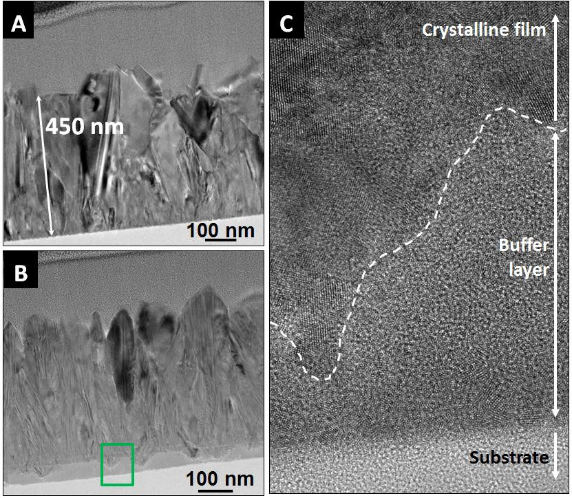

Figure 2. TEM images of (A) ATO125/SiO2/Glass and (B) ATO125/Glass films, and

(C) detail of the amorphous buffer layer in ATO125/Glass (green rectangle in (B)).

Figure 2B, which corresponds to the cross-section of the ATO125/Glass sample, also shows a 450 nm-thick dense film build up of columnar shaped crystalline grains. A 40 nm-thick layer with a different texture is observed at the bottom of the film. The high-resolution image of this region (Fig. 2C) reveals a disordered structure or “buffer layer” between the film and the first deposited particles of less than 10 nm in contact with the substrate. Thanachayanont et al. [27] reported a similar amorphous buffer layer on undoped 3.5 m-thick SnO2 films. The EDS images, which correspond to the ATO125/Glass film in Figures 3A and 3C, confirm that the amorphous or low- crystallinity buffer layer is part of the SnO2 film, and Figures 3B and 3D show that the 5-10 nm particles at the film/substrate interface in the ATO125/SiO2/Glass film are also

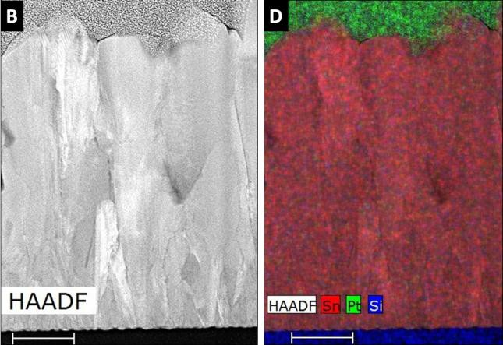
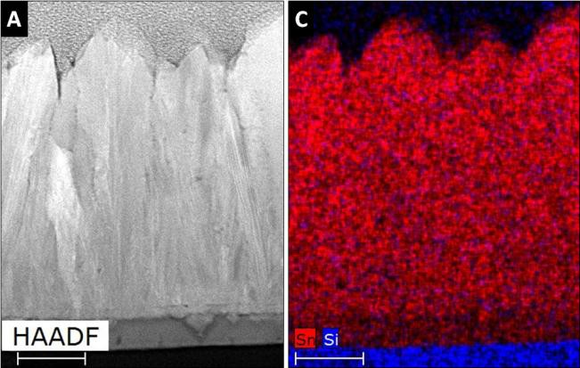
SnO2 grains. Therefore, the analysis of the images shown in Figs. 2 and 3 indicate that an amorphous or low-crystallinity tin dioxide buffer layer may develop on glass substrates that are not coated with SiO2, even though small crystalline domains were detected within this layer. It is known that the presence of Na+ in SnO2 films hinders the crystal growth of the rutile phase [16, 28]. A plausible explanation for the development of such disordered buffer zone of tin dioxide on glass substrates is the effusion of sodium ions from the substrate to the growing film.

Figure 3. High-angle annular dark-field (HAADF) images (A, B) and EDS analyses (C, D) of (A, C) ATO125/Glass and (B, D) ATO125/SiO2/Glass films. Scale bars are 100 nm. In EDS images, red is Sn, blue is Si and green is Pt.

The optical transmittances of these films are very alike (Fig. S3), but the electrical properties differ significantly. The sheet-resistance (Rs) of the ATO125/SiO2/Glass film

film was of 50.5 $Ω$sq-1 (resistivity $ρ$= 2.27x10-3 $Ω$cm). The higher Rs measured for the ATO125/Glass film is associated with the smaller I(200)/I(110) ratio (or lower TC(200)) with respect to that of the film grown on silica-coated glass. The smaller I(200)/I(110) ratio is due to the existence of the amorphous or low-crystallinity buffer layer, which ultimately leads to a film whose effective crystalline thickness is of 390-400 nm, below the previously mentioned 450 nm “whole film thickness”. Experimental evidence that has been reported in the existing literature supports this finding and content that the resistivity of SnO2 films is directly influenced by the crystallographic orientation [29].
It is clear that no amorphous SnO2 buffer layer was observed to grow on the silica- coated substrate. However, further research is needed in order to figure out whether the SiO2 layer plays a significant role in this regard. The silica layer may provide the necessary roughness for the nucleation of cassiterite in the early stage of the spraying process, and this observation may open an entirely new avenue of research for the silica barrier as two-purpose film. That is, it may be found to serve both to block Na+ effusion from the substrate to the film as well as to favour the crystallisation of tin dioxide, thereby enhancing the I(200)/I(110) intensity ratio.

Undoped and Sb-doped films of different thickness on SiO2-coated substrates

After the preceding discussion, undoped and Sb-doped SnO2 films of varying thicknesses were grown on SiO2-coated glass substrates. The film nomenclature in Table 1 will be used from here onward. The XRD patterns in Fig. 4 show that both undoped and doped films are crystalline and single phase within the resolution of the technique. Patterns are assigned to the tetragonal phase of tin dioxide (JCPDS 79-6888) and (110) were calculated and represented as a function of thickness in Fig. S4.
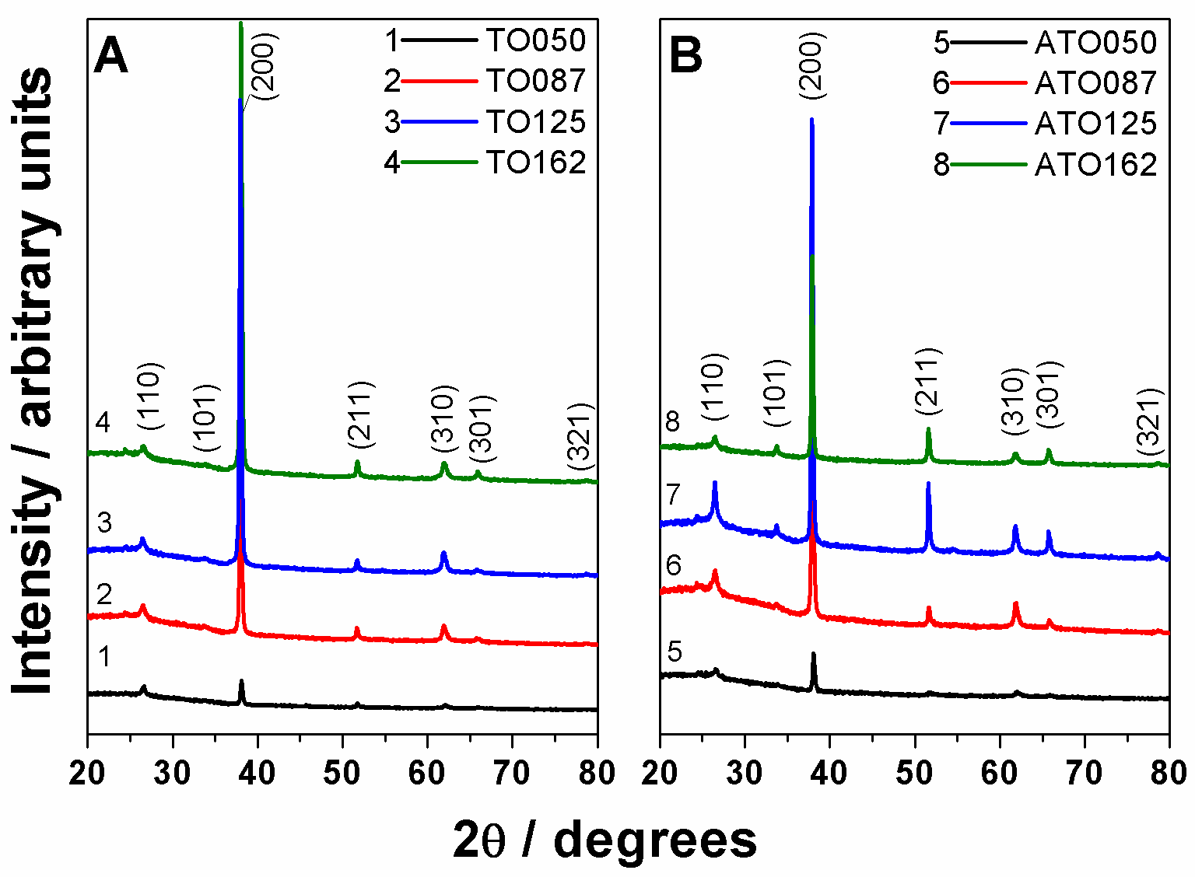
Figure 4. XRD patterns of (A) undoped and (B) Sb-doped SnO2 films grown on silica- coated glass substrates from Sn(II) solutions of different concentrations.

Table 2. Visible transmittance (%Tvis, 380-770 nm), thickness (d), sheet-resistance (Rs), resistivity ($ρ$), charge-carrier density (ne), mobility ($μ$) and figure of merit (FoM).
Film | % Tvis | d (nm) | Rs ($Ω$/sq) | $ρ$($Ω$cm) | ne (cm-3) | $μ$ (cm2/Vs) | FoM
TO-050 | 83 | 180 | 6409 | 1.15x10-1 | 2.7x1019 | 2 | 0.3
ATO-050 | 80 | 170 | 76.4 | 1.3x10-3 | 2.4x1020 | 20 | 21
TO-087 | 82 | 340 | 1204 | 4.0x10-2 | 2.1x1019 | 7 | 1.5
ATO-087 | 80 | 280 | 44.2 | 1.24x10-3 | 2.9x1020 | 17 | 36
TO-125 | 79 | 500 | 511 | 2.55x10-2 | 2.4x1019 | 10 | 3
ATO-125 | 70 | 450 | 27.1 | 1.22x10-3 | 3.0x1020 | 17 | 36
TO-162 | 81 | 700 | 202 | 1.42x10-2 | 2.9x1019 | 15 | 8.4
ATO-162 | 65 | 600 | 24.9 | 1.49x10-3 | 3.0x1020 | 14 | 31

Surface SEM images of undoped (TO) and doped (ATO) films shown in Figures 5 and S5 reveal uniform surfaces composed of crystalline orthorhombic grains. As the concentration of the Sn(II) solution increased from film TO-050 to TO-162, thickness

antimony-doped films increased in the same trend. The cross sectional SEM images of doped films is represented in Fig. S6, which shows dense microstructures with quite uniform thicknesses.

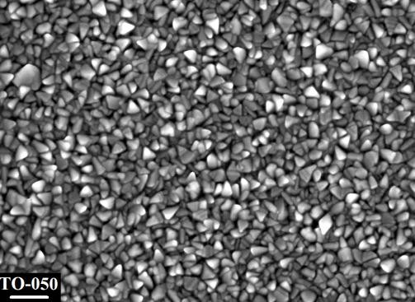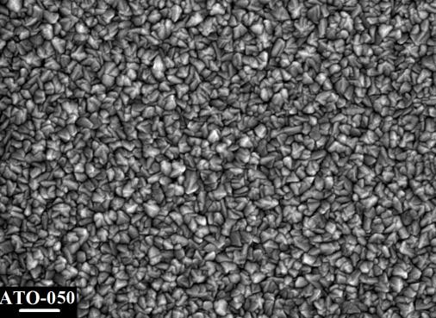

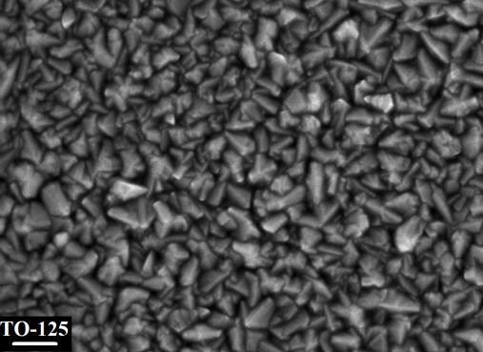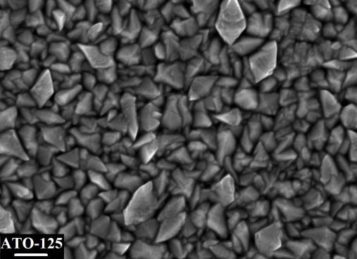

Figure 5. SEM surface images of undoped (TO-050 and TO-125) and doped (ATO-050 and ATO-125) tin dioxide films. Scale bar: 200 nm.

The optical properties of films were analysed on the basis of the transmittance and reflectance spectra, as shown in Fig. 6A-C and Fig. 6B-D, respectively. Undoped films revealed transparencies in the visible region of about 80% (Table 2), which suffer a slight decrease alongside their increasing thickness. Concerning Sb-doped films, transmittance curves in Fig. 6C reveal a decrease in (visible) transparency with respect to undoped films, as was also reported in Table 2. To achieve optimal performance, the optical band gap Eg must be greater than 3.2 eV to provide transparency in the visible from Tauc plots in Fig. S7. Undoped films have a large fundamental band-gaps of 3.9 eV [30]. The values obtained for doped films range from 3.9 to 3.6 (Fig. S6), and are similar to those found by other authors [24, 31-34]. However, the key feature is the decrease in transmittance that is observed in the near infrared region (~700-2500 nm), which takes place due to the absorbance (oscillations) by free carriers.
As shown in the reflectance curves in Fig. 6B, pure tin dioxide films have a very low reflectivity in the spectral range analysed. However, Sb-doped samples present an increase in reflectance in the near infrared zone, with an onset near 1500 nm (Fig. 6D). This reflection of NIR solar radiation is exploited in heat-mirrors or heat-shields in smart windows [35, 36].

Figure 6. Transmittance (A, C) and reflectance (B, D) curves of undoped (A, B) and Sb-doped (C, D) films. The shaded zone corresponds to the visible region of the spectrum.

Undoped films showed relatively high sheet-resistance values in the k$Ω$/sq-range or hundreds of Ohm/sq, parameter that decreased significantly with increasing thickness, as reported in Table 2. Non-stoichiometry is the reason for the low intrinsic resistivity of SnO2 with respect to other metal-oxide semiconductors [37, 38]. The resistivity of tin dioxide is further decreased by means of extrinsic doping. Defects created after the substitution of Sn(IV) by Sb(III) or Sb(V) would be compensated by oxygen vacancies or free electrons in the conduction band, respectively [39, 40]. In this sense, XPS analysis has been carried out on sample TO-050 and three ATO films in order to determine the oxidation states of antimony in the tin dioxide matrix. Figure S10 shows Sn3d5/2, O1s, Sb3d3/2 and C1s XPS multiregion spectra of TO-050 and ATO-162 samples after 4 minutes 0.5 kV Ar+ etching. In this case, Sb3d3/2 has been selected since Sb3d5/2 coincides with the O1s peak. The binding energy scale is referenced to Sn3d5/2 at 486.85 eV for all samples.
Table S2 shows the Sb percentages that were determined from XPS measurements and photoelectron Sn3d5/2, O1s, Sb3d3/2 and C1s peak binding energies and FWHM values. The similar Sb percentage for all ATO samples reveals good reproducibility in antimony doping for samples of varying thickness. The binding energies of photoelectron peaks of the TO sample demonstrate good agreement with those documented for SnO2 in literature [41]. The energy difference between O1s and Sb3d5/2 of 43.9 eV is exactly the same. However, our binding energy values are 0.15 eV higher, which is likely due to a more exact binding energy calibration (gold dot versus adventitious carbon). Furthermore, it can be seen in Table S2 and Fig. S10 that Sb doping does not lead to chemical shifts but rather broadens Sn3d5/2 and O1s photoelectron peaks on the high binding energy side. This effect is also observed for the

S11 normalized in intensity to the Sn4d peak.

Peak broadening, which is observed at the high binding energy side of any strong photoelectron peak, is due to energy losses that occur through scattering of the emerging photoelectrons with occupied states in the conduction band; this reveals that Sb doping can act to fill up those states in the conduction band. This peak broadening is shown in further detail in Fig. 7, which represents intensity normalized Sn3d5/2 spectra of TO-050 and all ATO samples.

Figure 7. Sn3d5/2 intensity normalized XPS spectra of TO-050 and all ATO samples after 2 – 4 min 0.5 kV Ar+ etching.

As it has been shown, the broadening at the high binding energy side is similar for all three ATO films since Sb doping is similar for all three ATO samples. It is worth noting that curve fitting (not shown) has also been applied to the Sn3d5/2 peak. Whereas a perfect fit can be made with only one Gaussian/Lorentzian (80/20) band of 1.37 eV FWHM for the TO film, this is not possible for ATO films where a tail on the high binding energy side of the fitting band is needed. Those tails, which are very pronounced, are used for fitting photoelectron peaks of metals where tail length and simply points to the fact that in ATO samples, Sb doping leads to occupied states in the conduction band, which is to say that Sb is built in SnO2 as Sb(V), and thus leaves one electron free for the conduction band. Regarding the binding energies measured for Sb3d3/2 in ATO samples of about 540.2 eV (see Table S2) supports the assumption that Sb is built in SnO2 as Sb(V) when comparing our results with those documented in the literature [42].
Similar values of carrier density (ne) were measured among undoped films, but it was the mobility () that was significantly increased along with film thickness, which had its effect on the sheet resistance and the resistivity of these films, as shown in Fig. 8 and Table 2. The linear increase in mobility is related to the enhanced preferential orientation of the crystalline structure in the [200] direction. Figure S4 shows the increasing and decreasing trends of TC(200) and TC(110), respectively, with film thickness for undoped TO films. It has been reported that in nonstoichiometric SnO2, Sn2+ trap- states exist along all directions except [200] and [400] [19, 43]. Therefore, in films oriented in the [200] direction, high carrier mobility is expected. In fact, inducing the change in orientation from [110] to [200] has been suggested as a means of improving the electrical properties (carrier mobility, specifically) of SnO2-based TCO [10].
An apparently different behaviour was observed for doped (ATO) films. The carrier density increased with film thickness, reaching a saturation value of 3x1020 cm-3, whereas the mobility decreased from 20 to 14. Interestingly, the TC(200) decreased markedly (see Fig. S4) for the thickest doped film with the lowest $μ$, ATO-162, which is in agreement with the previous discussion. Despite the lower mobility of carriers in thicker films (ATO-125 and ATO-162), the sheet-resistance showed a continuous decrease with increasing thickness. However, the thickness increased at a higher rate (Fig. 8D). The scattering mechanism due to long-range electrostatic fields that develop around dopants and ionized impurities and interferes with the movement of carriers, could have been the reason for the mobility drop that was observed in the ATO films [10].
It is worth noting the contrast between the electrical behaviour of TO and ATO films. Although Sb-doping led to conductive films, the defects that were created also jeopardize the desired electrical properties (minimum resistivity). In this context, more work is needed in order to achieve transparent films textured in the [200] direction along with an efficient doping that allows the attainment of high mobilities with carrier densities above 1020. Nevertheless, the electrical properties registered for the 450 nm– thick ATO-125 film ($ρ$= 1.22x10-3$Ω$cm; ne = 3x1020 cm-3; $μ$= 17) are close to those of the 420 nm-thick FTO film ($ρ$~ 1x10-3 $Ω$cm; ne ~ 2.8x1020 cm-3; $μ$= 20) as reported by Agashe et al. [11].
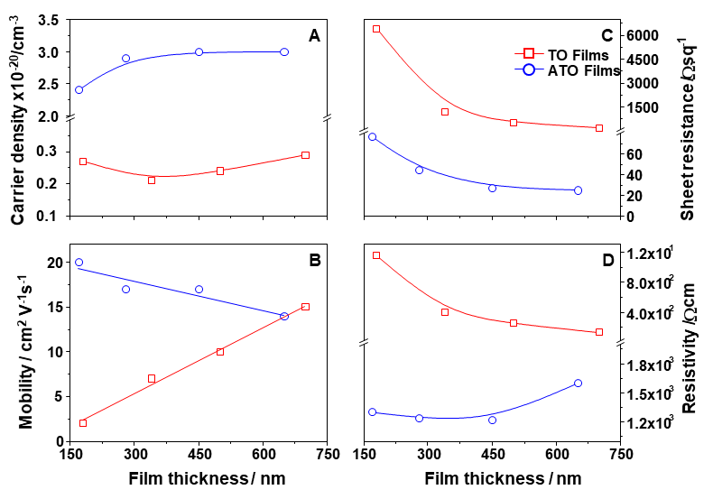
Figure 8. Carrier density (A), mobility (B), sheet resistance (C) and resistivity (D) of undoped (TO) and Sb-doped (ATO) films represented against film thickness.

For the sake of comparison, a figure of merit (FoM) was calculated using the following expression, which is based on both visible-range transmittance (Tvis) and sheet
resistance [44]:

$FoM=\frac{188.5}{\left(1/{\sqrt{T_{vis}}}-1\right) R_{s}}$ . (6)

where the average transmittances shown in Table 2, were used. Although the requirements related to the performance of a TCO depend on the application for which it has been selected, a minimum FoM of 34 has been suggested as necessary for industrial applications [44]. Thus, the calculated values for the FoM (Table 2) indicate that films ATO-087 and ATO-125 are both promising films that may be utilized in applications where transparent electrodes are needed.

CONCLUSION

Antimony-doped tin dioxide transparent conducting films highly oriented in the [200] crystalline direction were grown on silica-coated glass substrates. The silica layer may not only have acted as a barrier against the diffusion of alkaline ions but may also have provided nucleation sites for tin dioxide. The latter possibility, in particular, should be further explored. The crystallisation of the film in the early stages of the spraying process offers benefits in that it enables the achievement of high TC(200) and carrier mobility. Additionally, XPS results have demonstrated asymmetric photoelectron peak broadening and a Sb3d3/2 binding energy position, which indicates that Sb(V) is the main contribution for Sb doping in SnO2. However, the decreasing trend in mobility with increasing thickness, which is associated with ionised impurity scattering, remains a challenge with regard to attaining resistivities below 10-3 cm.

Declaration of interests

The authors declare that they have no known competing financial interests or personal relationships that could have appeared to influence the work reported in this paper.
The authors declare the following financial interests/personal relationships which may be considered as potential competing interests:

ACKNOWLEDGEMENTS
This work was supported by means of a Beca Externa Postdoctoral for young researchers from CONICET, Argentina, by Ministerio de Ciencia e Innovación del Reino de España (Project TEC2014- 53906-R), and by ANPCyT, Arg. (PICT’15 2305). The authors are grateful to the technical assistance and collaboration of R. Romero, L. León Reina, D. García Gil and E. Villegas.

REFERENCES

- T. Minami, Transparent conducting oxide semiconductors for transparent electrodes, Semicond. Sci. Technol. 20 (2005) S35–S44.
- T. Minami, Substitution of transparent conducting oxide thin films for indium tin oxide transparent electrode applications, Thin Solid Films 516 (2008) 1314-1321.
- S. Panigrahi, R. Martins, E. Fortunato, Progress of indium-free transparent conducting oxides, in Towards Oxide Electronics: a Roadmap, Appl. Surf. Sci. 482 (2019) 1-93.
- G. U. Kulkarni, S. Kiruthika, R. Gupta, K. D. M. Rao, Towards low cost materials and methods for transparent electrodes, Curr. Opin. Chem. Eng. 8 (2015) 60-68.
- P. P. Edwards, A. Porch, M. O. Jones, D. V. Morgan, R. M. Perks, Basic materials physics of transparent conducting oxides, Dalton Trans. 0 (2004) 2995-3000.
- K. Ellmer, Past achievements and future challenges in the development of optically transparent electrodes, Nature Photonics 6 (2012) 809-817.
- J. H. Baek, H. Seol, K. Cho, H. Yang, J. K. Jeong, Comparative study of antimony doping effects on the performance of solution-processed ZIO and ZTO field-effect transistors, ACS Appl. Mater. Interfaces 9 (2017) 10904−10913.
- A. Kurz, K. Brakecha, J. Puetz, M. A. Aegerter, Strategies for novel transparent conducting sol–gel oxide coatings, Thin Solid Films 502 (2006) 212-218.
- S. C. Dixon, D. O. Scanlon, C. J. Carmalt, I. P. Parkin, n-Type doped transparent conducting binary oxides: an overview, J. Mater. Chem. C 4 (2016) 6946-6961.
- J. T. Wang, X. L. Shi, W. W. Liu, X. H. Zhong, J. N. Wang, L. Pyrah, K. D. Sanderson, P. M. Ramsey, M. Hirata, K. Tsuri, Influence of preferred orientation on the electrical conductivity of fluorine-doped tin oxide films, Sci. Rep. 4 (2014) 3679.
- C. Agashe, J. Hüpkes, G. Schöpe, M. Berginski, Physical properties of highly oriented spray-deposited fluorine-doped tin dioxide films as transparent conductor, Solar Energy Mater. Solar Cells 93 (2009) 1256-1262.
- J. B. Mooney, S. B. Radding, Spray pyrolysis processing, Ann. Rev. Mater. Sci. 12
(1982) 81-101.
- H. Bisht, H.-T. Eun, A. Mehrtens, M. A. Aegerter, Comparison of spray pyrolyzed FTO, ATO and ITO coatings for flat and bent glass substrates, Thin Solid Films 351 (1999) 109-114.
- E. Elangovan, K. Ramesh, K. Ramamurthi, Studies on the structural and electrical properties of spray deposited SnO2:Sb thin films as a function of substrate temperature, Solid State Comm. 130 (2004) 523–527.
- G. Korotcenkov, B. K.Cho, Spray pyrolysis deposition of undoped SnO2 and In2O3 films and their structural properties, Prog. Cryst. Growth Charact. Mater. 63 (2017) 1-47.
- F. B. Ellis, J. Houghton, Chemical vapor deposition of silicon dioxide barrier layers for conductivity enhancement of tin oxide films, J. Mater. Res. 4 (1989) 863-872.

- B. M. Davies, K. H. Pannell, S. P. Albright, Diffusion barrier of sol-gel derived silica for sprayed tin oxide film on soda-lime glass, J. Mater. Res. 9 (1994) 226- 228.
- K. Bange, C. R. Otterman, O. Anderson, Properties and characterization of dielectric thin films. In Thin films on glass. Eds. H. Bach, D. Krause, Springer- Verlag (2003) Berlin, Heidelberg.
- C. Agashe, M. G. Takwale, V. G. Bhide, S. Mahamuni, S. K. Kulkarni, Effect of Sn incorporation on the growth mechanism of sprayed SnO2 films, J. Appl. Phys. 70 (1991) 7382-7386.
- V. Brinzari, G. Korotcenkov, V. Golovanov, J. Schwank, V. Lantto, S. Saukko, Morphological rank of nano-scale tin dioxide films deposited by spray pyrolysis from SnCl45H2O water solution, Thin Solid Films 408 (2002) 51-58.
- A. A. Yadav, Influence of film thickness on structural, optical, and electrical properties of spray deposited antimony doped SnO2 thin films, Thin Solid Films 591 (2015) 18-24.
- V. Consonni, G. Rey, H. Roussel, B. Doisneau, E. Blanquet, D. Bellet, Preferential orientation of fluorine-doped SnO2 thin films: The effects of growth temperature, Acta Materialia 61 (2013) 22-31.
- R. Romero, D. Leinen, E. A. Dalchiele, J. R. Ramos-Barrado, F. Martín, The effects of zinc acetate and zinc chloride precursors on the preferred crystalline orientation of ZnO and Al-doped ZnO thin films obtained by spray pyrolysis, Thin Solid Films 57 (2006) 1942–1949.
- M. Kumar, A. Kumar, A. C. Abhyankar, Influence of texture coefficient on surface morphology and sensing properties of W-doped nanocrystalline tin oxide thin films, ACS Appl. Mater. Interfaces 7 (2015) 3571−3580.
- G. Korotcenkov, A. Cornet, E. Rossinyol, J. Arbiol, V. Brinzari, Y. Blinov, Faceting characterization of tin dioxide nanocrystals deposited by spray pyrolysis from stannic chloride water solution, Thin Solid Films 471 (2005) 310-319.
- K. Murakami, K. Nakajima, S. Kaneko, Initial growth of SnO2 thin film on the glass substrate deposited by the spray pyrolysis technique, Thin Solid Films 515 (2007) 8632-8636.
- C. Thanachayanont, V. Yordsri, C. Boothroyd, Microstructural investigation and SnO nanodefects in spray-pyrolyzed SnO2 thin films, Mater. Lett. 65 (2011) 2610- 2613.
- A. Osaka, S. Takao, K. Oda, J. Takada, Y. Miura, The diffusion of sodium ions into tin oxide thin films from glass substrates, Memoirs of the Faculty of Engineering, Okayama University,Vol.24, No.1, November 1989.
- G. Gordillo, L. C. Moreno, W. de la Cruz, P. Teheran, Preparation and characterization of SnO2 thin films deposited by spray pyrolysis from SnC12 and SnC14 precursors, Thin Solid Films 252 (1994) 61-66.
- A. M. Ganose, D. O. Scanlon, Band gap and work function tailoring of SnO2 for improved transparent conducting ability in photovoltaics, J. Mater. Chem. C 4 (2016) 1467-1475.

- S. Gürakar, T. Serin, N. Serin, Studies on optical properties of antimony doped SnO2 films, Appl. Surf. Sci. 352 (2015) 16–22.
- R. F. Martinez-Gazoni, M. W. Allen, R. J. Reeves, Conductivity and transparency limits of Sb-doped SnO2 grown by molecular beam epitaxy, Phys. Rev. B 98 (2018) 155308.
- L. Liu, T. Kawaharamura, G. T. Dang, E. K. C. Pradeep, S. Sato, T. Uchida, S. Fujita, T. Hiramatsu, H. Kobayashi, H. Orita, Study on fabrication of conductive antimony doped tin oxide thin films (SnOx:Sb) by 3rd generation mist chemical vapor deposition, Jpn. J. Appl. Phys. 58 (2019) 025502.
- W. Zhou, Y. Liu, Y. Yang, P. Wu, Band gap engineering of SnO2 by epitaxial strain: Experimental and theoretical investigations, J. Phys. Chem. C 118 (2014) 6448−6453 .
- J. Rockenberger, U. zum Felde, M. Tischer, L. Tröger, M. Haase, H. Weller, Near edge X-ray absorption fine structure measurements (XANES) and extended X-ray absorption fine structure measurements (EXAFS) of the valence state and coordination of antimony in doped nanocrystalline SnO2, J. Chem. Phys. 112 (2000) 4296-4304.
- T. Abendroth, B. Schumma, S. A. Alajlan, A. M. Almogbel, G. Mäder, P. Härtel,
H. Althues, S. Kaskel, Optical and thermal properties of transparent infrared blocking antimony doped tin oxide thin films, Thin Solid Films 624 (2017) 152– 159.
- Kílíç, A. Zunger, Origins of coexistence of conductivity and transparency in SnO2,
Phys. Rev. Lett. 88 (2002) 095501.
- M. Batzill, U. Diebold, The surface and materials science of tin oxide, Surface Science 79 (2005) 47-154.
- W. Mao, B. Xiong, Y. Liu, C. He, Correlation between defects and conductivity of Sb-doped tin oxide thin films, Appl. Phys. Lett. 103 (2013) 031915.
- S. D. Ponja, B. A. D. Williamson, S. Sathasivam, D. O. Scanlon, I. P. Parkin, C. J. Carmalt, Enhanced electrical properties of antimony doped tin oxide thin films deposited via aerosol assisted chemical vapour deposition, J. Mater. Chem. C 6 (2018) 7257-7266.
- A. W. C. Lin, N. R. Armstrong, T. Kuwana, X-ray photoelectron/auger electron spectroscopic studies of tin and indium metal foils and oxides, Anal. Chem.
49 (1977) 1228-1235.
- R. Izquierdo, E. Sacher, A. Yelon; X-ray photoelectron spectra of antimony oxides;
Appl. Surf. Sci. 40 (1989) 175-177.
- Bélanger, J. P. Dodelet, B. A. Lombos, J. I. Dickson, Thickness dependence of transport properties of doped polycrystalline tin oxide films, J. Electrochem. Soc. 132 (1985) 1398-1405.
- A. I. Hofmann, E. Cloutet, G. Hadziioannou, Materials for transparent electrodes: From metal oxides to organic alternatives, Adv. Electron. Mater. (2018) 1700412.

