Activated carbon monoliths from lignocellulosic biomass waste for electrochemical applications

J.M. Rosas, P.O. Ibeh, F.J. García-Mateos, J. Rodríguez-Mirasol, T. Cordero
Universidad de Málaga, Departamento de Ingeniería Química, Andalucía Tech, Facultad de Ciencias, Campus de Teatinos s/n, 29010 Málaga - Spain
jmrosas@uma.es
Introduction
Activated carbons monoliths (ACMs) have shown promising results as electrodes for supercapacitors, due to their high volumetric density and large porosity. However, they are usually, made by compressing the corresponding activated carbon in the presence of a binder, which usually implies a reduction of pore sizes due to partial blocking, or in less extent in absence of any type of additive by applying a very high pressure In this work, different binderless ACMs were prepared and tested for electrochemical applications.
Experimental
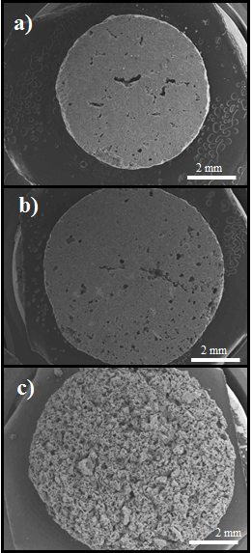
Figure 1. Activated carbon disk from: a) Olive stone; b) Alcell lignin; c) Kraft lignin.

Cylindrical activated carbon disk were prepared from olive stone, Alcell® and Kraft lignin by chemical activation with H₃PO₄ by extrusion without any kind of binder. Activated carbon disk were activated under inert atmosphere at 700 ºC and washing with distilled water. N₂ and CO₂ adsorption, XPS and CO-CO₂ TPD techniques were used to characterize the carbon electrodes. Their electrochemical performances were evaluated by cyclic voltammetry and galvanostatic charge-discharge at different current densities, without using binder and conductive promoter.
Results and discussion
Figure 1 shows the activated carbon disks used in this work. Carbon electrodes presented pore size distributions in the micro and mesopore range, with high surfaces areas (c.a. 1500 m²/g) and relatively high mesopore volume (0.35 cm³/g). The bulk density of the monoliths is also very high (~1.1 g/cm³ for ACM from Alcell lignin), with compressive strength of 7.6 MPa. The activated carbon disk from olive stones presents the highest specific capacitance, with approximately 217 F/g and 205 F/cm³. The values of specific capacitances for these ACMs are comparable or even better than others reported in the literature with similar porosity, but their volumetric capacitances are considerably higher than the values obtained at similar conditions by other authors.
Conclusions
Binderless ACMs from lignocellulosic waste were prepared by a simple preparation method from biomass waste precursors. These ACMs showed significantly high bulk densities and volumetric capacitances.
Acknowledgements
The authors acknowledge the support by MINECO/FEDER (CTQ2015-68654-R)
References
[1] P.O. Ibeh, F.J. García-Mateos, J.M. Rosas, J. Rodríguez-Mirasol, T. Cordero. Activated carbon monoliths from lignocellulosic biomass waste for electrochemical appliations. J. Taiwan Inst. Chem. Eng. 97 (2019) 480-488.

