Bricked subwavelength structures: a flexible metamaterial topology

J.M. Luque-González*, A. Ortega-Moñux, R. Halir, Í. Molina-Fernández, J.G. Wangüemert-Pérez,
ETSI Telecomunicación, Universidad de Málaga, Spain
*jmlg@ic.uma.es
Pavel Cheben, Jens H. Schmid
Information and Communications Technologies
National Research Council Canada, Ottawa, Canada

Abstract—Subwavelength gratings (SWG) are periodic structures that synthesize lithography tailorable metamaterials with desired permittivity, dispersion, and anisotropy, enabling the design of a myriad of high-performance devices. Here we present our latest SWG geometrical topology which not only provide more control over the synthesized material but also alleviate the required fabrication resolution to fabricate SWG structures.
Keywords—Silicon-on-Insulator; Subwavelength grating structures; dielectric metamaterial; Multimode interferometer
Subwavelength grating (SWG) metamaterials are periodic structures arranged with a periodicity shorter than the wavelength of the propagating light. Under that condition, SWG structures behave as anisotropic homogeneous structures, providing to the designers with the capability to implement a wide range of equivalent metamaterials with controllable permittivity, dispersion, and anisotropy [1]. The engineering of such optical properties has promoted a new paradigm in the field of silicon photonics, designing the optimum metamaterial for each device [2,3]. In this talk we present our latest topology to engineer the metamaterial properties: Bricked subwavelength grating structures [4].
In conventional SWG-based designs, the synthesized metamaterial is defined by the material refractive indices n₁ and n₂ of the periodic structure, the arranging period Λ, and the amount of each material per period, known as duty cycle DC=a/ Λ, where a is the length of the material n₁ in a period [See Fig. 1(a)]. Under the anisotropic homogenization theory, this structure is defined by a permittivity tensor ε=diag[ε_{xx}, ε_{yy}, ε_{zz}], which depends on the aforementioned geometrical parameters [5]. Although the optimization of the implemented metamaterial is possible only by tuning the period and duty cycle, advanced features can be achieved by augmenting the control over the tensor components. Recently proposed bricked SWG structures [See Fig. 1(b)] provide a direct control over some of the tensor components of the synthesized metamaterial. This new topology is obtained by periodically partitioning a conventional SWG structure along the transversal direction and alternately shifting the resulting blocks. In this talk we overview the foundations of such bricked SWG metamaterials, focusing on what they offer to the designer, including the engineering of the refractive index, dispersion, and anisotropy. Moreover, we discuss how bricked SWG structures are a potential solution to facilitate the mass production of SWG-based devices as they allow longer period compared with conventional SWG.
By exploiting the properties of bricked SWG structures we have designed two 2x2 Multimode Interferometers [See Fig. 1(c)] with a simulated 1-dB bandwidth of 400 nm, experimentally demonstrated over a 140 nm bandwidth [See Fig.1(d)]. These designs not only show the control over the metamaterial properties enabled by bricked SWG structures but also the augmentation on the pixel size dimensions required to fabricate the structures, from a fabrication resolution of 95 nm using a conventional SWG metamaterial up to 150 nm by using a bricked SWG metamaterial.

Disclosures: This work is protected under patent No. P202030367.

REFERENCES

- P. Cheben, R. Halir, J. H. Schmid, H. A. Atwater, and D. R. Smith, "Subwavelength integrated photonics," Nature 560, 565–572 (2018).
- R. Halir, P. J. Bock, P. Cheben, A. Ortega-Moñux, C. Alonso-Ramos, J. H. Schmid, J. Lapointe, D. Xu, J. G. Wangüemert-Pérez, and S. Janz, "Waveguide subwavelength structures: a review of principles," Laser Photon. Rev. 49, 25–49 (2015).
- R. Halir, A. Ortega-Moñux, D. Benedikovic, G. Z. Mashanovich, J. G. Wangüemert-Pérez, J. H. Schmid, I. Molina-Fernández, and P. Cheben, "Subwavelength-Grating Metamaterial Structures for Silicon Photonic Devices," Proc. IEEE 106, 2144–2157 (2018).
- J. M. Luque-González, A. Ortega-Moñux, R. Halir, J. H. Schmid, P. Cheben, Í. Molina-Fernández, and J. G. Wangüemert-Pérez, "Bricked subwavelength gratings: A tailorable on-chip metamaterial topology," Laser Photon. Rev. Accepted for publication, (2021)
- S. M. Rytov, "Electromagnetic properties of a finely stratified medium," Sov. Phys. JETP 2, 466–475 (1956)

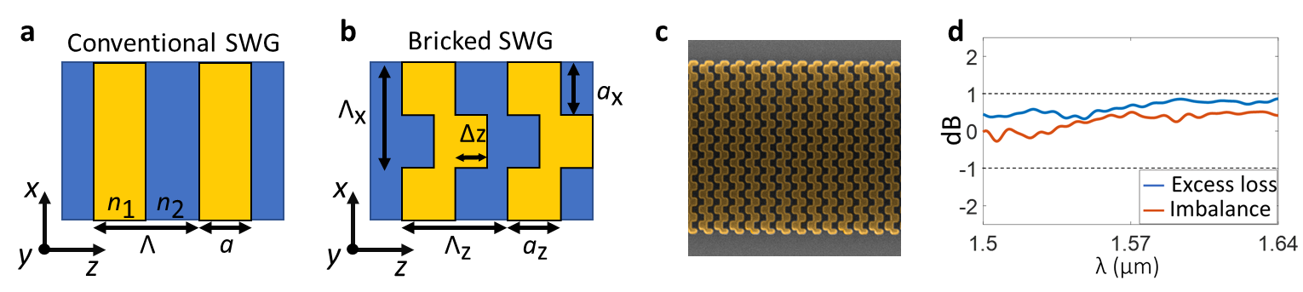
Figure 1. (a),(b) Schematic representation of a conventional SWG structure (a) and a bricked SWG structure (b). (c) Scanning electron microscope (SEM) image of a bricked SWG waveguide. (d) Measured performance of a 2x2 multimode interferometer based on a bricked SWG metamaterial.
Funding from Universidad de Málaga, MCIU (PID2019-106747RB-I00), CECEU (UMA18-FEDERJA-219, PY18-1453, PY18-793), MECD( FPU16/06762).

